Genetic alterations and expression patterns of genes coding for FGF, FGFR, and FGFBP proteins in urothelial cancers

Short analysis report

Piotr Tymoszuk for the Department of Urology, Medical University of Innsbruck

2024-12-07

# Analysis summary

* Fibroblast growth factor receptor (FGFR) signaling has emerged as a promising cancer therapy target with approval of the pan-FGFR inhibitor erdafitinib for treatment of urothelial carcinoma (1). However, effects of genetic alterations and modulation of expression of FGF- and FGFR-coding genes in urothelial carcinoma on tumor biology, therapy response, and clinical outcome are still not fully understood. In particular, it is still not completely clear how and to which extent development and aggressiveness is driven by FGFR signaling in various form of urothelial carcinoma reflected by e.g. consensus molecular subtypes (2).
* The primary goal of the current project was to characterize frequency, co-occurrence, and clinical implications of genetic alterations and differential expression of FGF-, FGFR-, and FGF binding protein (FGFBP) coding genes (**Table 1**) (1,3–13) in large publicly available cohorts of urothelial cancers. The secondary goal was an attempt to establish subsets of urothelial cancer specimens based on differences in their profiles of somatic mutations and gene copy number variants.
* Five genetic and transcrional collectives of urothelial cancer patients were evaluated: the GENIE BLCA cohort, an urothelial carcinoma subset of the large GENIE project (n = 3164) (14), the predominantly muscle-invasive MSK IMPACT cohort (n = 906) (15), the muscle-invasive TCGA BLCA collective (n = 402) (16,17), the IMvigor cohort of late stage, platinum-refractory cancers subjected to an anti-PD-L1 treatment (n = 179) (18), and the BCAN cohort of metastatic urothelial cancers (n = 174) (19). Detailed information on somatic mutations and their effects on protein sequence was provided for the GENIE BLCA, MSK IMPACT, TCGA BLCA, and BCAN cohorts. Binarized indexes of presence/absence of somatic mutations in selected genes were available for the IMvigor cohort. Binarized data on gene amplifications and deletions were obtained for the GENIE BLCA, MSK IMPACT, and TCGA BLCA collectives. Gene expression quantification by RNA sequencing and assignment to consensus molecular classes (2) were retrieved for the TCGA BLCA, IMvigor, and BCAN cohorts. Overall survival information was available for the MSK IMPACT, TCGA BLCA, IMvigor, and BCAN cohorts; data on disease-specific and relapse-free survival was provided for the TCGA BLCA collective. Approximate overall survival was calculated for the GENIE BLCA project participants based on age at enrollment in years and follow-up time in days. Validation of expression of the genes of interest was done with immunohistochemistry data retrieved from the [Human Protein Atlas](https://www.proteinatlas.org/). Characteristic of the investigated collectives is presented in **Table 2**.
* Somatic mutations of *FGFR3* belonged to the most common genetic features of urothelial cancers and were found in 15 to 27% of cancer samples. Somatic mutations of the remaining *FGFR1*, *FGFR2*, and *FGFR4* receptor genes were less frequent (0 to 3.6% of cancer samples). Amplifications of the *FGF3*, *FGF4*, and *FGF19* genes in urothelial cancers result from multiplication of the *11q13* chromosome region, which codes also for an essential oncogene *CCDN1*. Amplifications of *FGF3*, *FGF4*, and *FGF19* were detected in 6.3 to 10% of specimens (**Figure 1** and **2**, **Table 3** and **4**).
* Mutations of *FGFR1*, *FGFR2*, *FGFR3*, and *FGFR4* were predominantly classified as missense mutations caused by single nucleotide polymorphisms (**Figure 3** and **4**, **Table 5**). For *FGFR1*, the mutation hot-spots were located in the Ig-like domain 1 and kinase domain. The kinase domain was the prime target of mutations of *FGFR2*. For *FGFR3*, they affected protein residues were located between Ig-like domains 1 and 2 responsible for ligand biding, or at the membrane-spanning hinge between the ligand-binding region and the kinase domain responsible for activation of the downstream signaling. In case of *FGFR4*, the Ig-like domain 1, the hinge region between the Ig-like domain 3 and kinase domain, as well as the kinase domain were prime targets of mutations of *FGFR4* (**Figures 5**  - **9**, **Table 5**). It can be hence speculated, that somatic mutations of the *FGFR* genes may affect both the kinase activity and the conformation of the protein resulting in a higher affinity towards ligands or ligand-independent signaling.
* Co-occurrence and exclusivity of genetic features was investigated by analysis of pairwise Jacquard similarity coefficients for pairs of genetic alterations in urothelial cancer samples. Such analysis revealed little overlap between somatic mutations of *FGFR3* and other common alterations such as *TP53* and *RB1* mutations, amplification of the 11q13 chromosome region hallmarked by copy number variants of *FGF3/4/19* and *CCND1*, as well as deletion of the 9p21 chromosome region with the *MTAP*, *CDKN2A*, and *CDKN2A* genes (**Figures 10**  - **Figure 13**).
* At mRNA level, *FGFR3*, *TGFBR3*, and *FGFR1* were the strongest expressed receptor genes. *FGF7*, *FGF11*, followed by *FGF2* were the most abundant ligand transcripts; *HSPG2*, *SDC1*, and *CD44* were the binding protein genes with the highest mRNA counts in the urothelial cancer tissue. Out of 45 genes of interest, 31 proteins were quantified by immunohistochemistry (IHC) in the Human Protein Atlas (HPA). The protein quantities were expressed as IHC scores defined as products of staining intensity (1: negative to 4: strong) and quantity of positive cells (1: none to 4: >75%). In the HPA data set, `r 19 FGFR, FGF, and FGFBP proteins had median IHC scores $≥$ 2, and were hence detectable in cancer specimens. At the protein/IHC level, FGFR1, FGFR3, FGFRL1, and FGFR4 were the most abundant receptors. FGF7, FGF10, FGF3, FGF19, and FGF17 were the strongest expressed ligand proteins. SDC2, SDC1, GPC4, CD44, and SDC4 were the most abundant FGFBP proteins (**Figures 14** - **17**, **Table 6**).
* Co-expression of FGFR-, FGF-, and FGFBP-coding genes was explored by correlation and network analyses, which revealed a high degree co-regulation of the ligands, receptors, and binding proteins in the urothelial cancer tissue (**Figure 18** and **Figure 19**). Especially the network analyses point towards strong co-regulation of expression of *FGFR1* with genes of its ligands (*FGF2*, *FGF7*, *FGF10*), and co-receptors such as *SDC2*, *DCN* or *HSPG2*. Importantly, *FGFR1* (hub score: 0.93 to 1, general correlation strength with maximum of 1, degree: 17 to 18), *FGF2* (hub score: 0.84 to 0.95, degree: 17), *FGF7* (hub score: 0.95 to 1, degree: 15 to 16), and *FGF10* (hub score: 0.67 to 0.94, degree: 14 to 17) were identified as candidate highly connected hubs of the co-expression networks, which suggests that FGFR1 signaling as a critical player in urothelial cancer biology. In turn, *FGFR2* was found to be weakly co-regulated with the non-canonical FGF receptor gene, *TGFBR3*. *FGFR3* levels correlated weakly with levels of *SDC1* and *GPC1* transcripts that code for proteoglycan FGF binding proteins.
* In a differential gene expression analysis of cancers with and without *FGFR3* mutations, presence of *FGFR3* mutations translated to significantly and strongly increased *FGFR3* mRNA levels, and, to a lesser extent, upregulation of the syndecan gene *SDC1*. By contrast, cancers with *FGFR3* mutations had significantly lower expression of *FGFR1*, *FGF2*, *FGF5*, and *FGF7* (**Figure 20** and **21**, **Table 7**). No consistent differences in counts of protein-affecting somatic mutations, or counts of gene deletions were found for urothelial cancers with and without *FGFR3* mutations. Gene amplification numbers were in turn significantly lower in *FGFR3* mutated neoplasms as compared with *FGF3* wild-type tumors. Effect size of this difference was moderate (**Figure 22**).
* There were no significant differences in age and gender distribution between patients with wild-type and *FGFR3*-mutated cancers. *FGFR3* mutant cancers tended towards lower pathological stages, this effect was significant in the MSK IMPACT cohort but not in the TCGA BLCA collective (**Table 8**). In the GENIE BLCA and MSK IMPACT cohorts, patients with *FGFR3* mutated tumors demonstrated improved overall survival as compared with bearers of WT neoplasms. This phenomenon was also evident in the TCGA BLCA collective and was statistically significant upon exclusion of pT4 cancer patients (entire cohort: p = 0.06, without pT4 cancers: p = 0.0499). There were no significant differences in disease-specific or relapse-free survival between the *FGFR3* mutation strata in the TCGA BLCA and BCAN cohorts, which may, however, result from insufficient number of relapses and tumor-related deaths (**Figures 23** and **Figure 24**).
* Amplification of the *11q13* chromosome region was one of the most frequent genetic alterations in urothelial cancers and led to multiplication of *FGF3*, *FGF4*, and *FGF19* genes. Analysis of effects of this amplification expression of FGFR-, FGF- and FGFBP-coding genes was possible solely for the TCGA BLCA collective. Cancer samples with the *11q13* amplification had significantly higher levels of *FGF3*, *FGF4*, and *FGF19* mRNA in the cancer tissue. *FGFR1* was downregulated without formal statistical significance (**Figure 25**). Effect sizes of those differences were weak or moderate, and, in case of *FGF3* and *FGF4*, the expression levels were extremely low as compared with other FGF-coding genes. Hence, biological relevance of the *11q13* amplification for FGFR signaling remains unclear.
* Basal/squamous-like cancers followed by luminal papillary and stroma-rich tumors constituted the largest consensus molecular classes of urothelial cancers (2) in the TCGA BLCA, IMvigor, and BCAN cohorts. In all three collectives, *FGFR3* mutations were found to be significantly enriched in luminal papillary cancer (TCGA: 37%, IMvigor: 56%, BCAN: 48 of specimens). In the TCGA BLCA cohort, amplifications of *FGF3*, *FGF4*, and *FGF19* genes resulting from multiplication of the *11q13* chromosome region were found in luminal papillary (18 to 19%), stroma-rich (9.8 to 12%), and basal/squamous-like cancers (10% of specimens) (**Figure 26** and **27**, **Table 9**).
* Analysis of differential expression of FGFR-, FGF-, and FGFBP-coding genes was conducted for the major consensus molecular subtypes of the TCGA BLCA, IMvigor, and BCAN cohort. Transcript levels of n = 24 out of 45 investigated genes (**Table 10**). Among them, *FGFR3*, *SDC1*, *TGFBR3*, *GPC3*, and *SDC3* were upregulated specifically in luminal papillary cancers. Overexpression of *KL*, a gene coding for [Klotho](https://www.genecards.org/cgi-bin/carddisp.pl?gene=KL) FGF-binding protein, was characteristic for luminal unstable tumors. Genes coding for FGFR protein, its ligands (*FGF7*, *FGF14*, *FGF10*, *FGF2*, *FGF9*, *FGF18*), and interaction partners (*DCN*, *HSPG2*, *SDC2*, *PTX3*) peaked in the stroma-rich class. High expression of *FGF5*, *FGF11*, and genes coding for binding proteins and FGF co-receptors, *CD44*, *FGFBP1*, *GPC1* and *TNFAIP6*, was a hallmark of basal/squamous-like cancers (**Figures 29** - **Figure 33**).
* Encouraged by the profound and widespread differences in expression of FGFR-, FGF-, and FGFBP-coding genes, we asked if and to which extent expression of those genes can explain or emulate the consensus molecular subsets proposed by Kamoun and colleagues (2). To answer this intricate question, we resorted to machine learning with two unrelated algorithms, Elastic Net regularized linear regression (20,21) and Random Forest tree ensemble (22,23). The models were trained in a synthetic data set of ComBat-processed $log_{2}$-transformed gene expression derived from the TCGA BLCA cohort. To improve identification of the minority molecular classes, LumU and stroma-rich cancers, their observations were amplified (over-sampled) in the training data set with the SMOTE algorithm (24–26). Performance and calibration of the machine learning models was evaluated by comparison of the model-predicted with the actual consensus molecular classes computed by a classification tool of *consensusMIBC* R package (ground truth) (2) in the unmodified TCBA BLCA data set and the independent validation IMvigor and BCAN cohorts.
* As presented in **Figure 34A** and **Table 11**, the machine learning models predicted the molecular class assignment with very high accuracy, independently of the algorithm. Notably, fractions of correctly predicted cancer samples were lower for the luminal unstable class as compared with the remaining molecular classes (**Figure 34B**). Slightly worse reliability of the models at predicting luminal unstable and stroma-rich samples in the validation cohorts was also evident in results of the calibration analyses (**Figure 35** and **36**). **Collectively, the machine learning data suggests that the consensus molecular classification by Kamoun et al. can be reproduced by differences in expression of 38 genes coding for FGFR, FGF, and FGFBP proteins.** Notably, the classification tool developed by Kamoun and colleagues and distributed via *consensusMIBC* R package employs 857 gene variables. Among them, only *CD44*, *GPC3*, *TNFAIP6*, *DCN*, *FGF11*, *FGF7*, and *FGFBP1* were shared with our machine learning models. The most influential genes for prediction of consensus molecular subtypes in our machine learning approach are presented in **Figure 37**, and **Tables 12** - **13**.
* Furthermore, we asked about prognostic significance of differences in FGFR, FGF, and FGFBP gene expression. To answer it, we constructed a multi-parameter Elastic Net Cox model (20,21) in the TCGA BLCA cohort (**Table 14** and **15**). ComBat-adjusted $log_{2}$-transformed expression levels were fed into the model as first- and second-order terms. Among them, 19 genes had non-zero coefficients, i.e. contributed substantially to prediction of overall survival (**Figure 38A**). The model delivered reliable predictions in the TCGA BLCA training collective and in the IMvigor validation cohort, but not in the BCAN data set (**Figure 38BC**). In an univariable, model-free screening of the genes of interest as potential prognostic markers, we found reproducibly shorter overall survival of patients with high expression of *TNFAIP6*, *GPC1*, *FIBP*, *FGF11*, and *FGFBP1* in the tumor tissue as compared with low expressors (**Figure 39** and **40**, **Table 16**). Taken together, the FGFR, FGF, and FGFBP transcriptome bears some potential for prediction of overall survival in urothelial cancer, but the models and standalone markers need additional validation, especially with inclusion of confounders such as age, gender, and staging.
* By latent class analysis (LCA, called also latent class modeling), we could establish a classification scheme of urothelial cancers based on presence/absence of 19 most frequent genetic alterations detected in at least 5% of cancer specimens. This classification scheme with six ‘genetic subsets’ was developed in the GENIE BLCA training cohort and technically validated in the MSK IMPACT and TCGA BLCA cohort (**Figures 41** and **42**). The ‘mutRB1’ subset (19 to 26% of specimens) was characterized by highly frequent *TP53*, *RB1* and *ARID1A* mutations, *E2F3* amplifications, and near absence of *FGFR3* mutations, *11q13* amplifications and *9p21* deletions. The ‘oligoMut’ subset was hallmarked by frequent mutations of *TP53* and the lowest overall mutation count. The key features of ‘hyperMut’ subset were the highest total mutation count, as well as frequent somatic mutations of *ARID1A*, *FGFR3*, *CREBBP*, *ERBB2*, *FBXW7*, and nearly absent copy number variants of *11q13* and *9p21*. The ‘del9p21’ subset was characterized by relatively common deletions of the chromosome region *9p21*, amplification of the 11q13 chromosome region, and highly frequent mutations of *TP53* and *KDM6A*. In the ‘mutFGFR3’ subset, mutations of *FGFR3* and *KDM6A*, and deletions of *9p21* were common, while mutations in *TP53*, *RB1*, and *ERBB2*, and gene amplifications were virtually absent. Finally, the ‘ampMDM2’ subset was characterized by the highest percentage of *MDM2* amplifications, highly common copy number variants of the *11p13* and *9p21* chromosome regions; mutations of *TP53* and *RB1* were essentially absent (**Figures 43** - **48**, **Table 17**).
* Numbers of mutations differed significantly between the genetic subsets with large effect size and were the highest in hyperMut cancers and the lowest in oligoMut and mutFGFR3 tumors. Gene deletion numbers were significantly higher in del9p21 and ampMDM2 than in the remaining genetic subsets in the GENIE BLCA and MSK IMPACT collectives (large effect size). Amplification counts were the highest in del9p21, ampMDM2, and mutRB1 subsets and the lowest in mutFGFR3 cancers; those differences were large and significant in all collectives (**Figures 49** and **50**).
* We observed significant differences in expression of *FGFR1*, *FGFR3*, *FGFR3*, *FGF5*, as well as genes coding for the binding proteins, *PTX3*, *SDC1*, *GPC1* and *TNFAIP6* genes between the genetic subsets of the TCGA BLCA cohort (**Table 18**). Interestingly, mutFGFR3 cancers were found to over-express *FGFR3* and, at the same time, to suppress *FGF5*. The highest expression levels of *FGFR1* were observed in mutRB1 and ampMDM2 genetic subsets; *FGFR2* was expressed at the highest levels in oligoMut, del9p21, and ampMDM2 subsets (**Figures 51** and **Figure 52**). At this point it has to be noted, that the significant differences in expression of the FGFR-, FGF-, and FGFBP-coding genes between genetic clusters were mostly of moderate effect size, and hence way smaller as in the case of consensus molecular subsets proposed by Kamoun and colleagues.
* There were no significant differences in age and gender of cancer patients between the genetic clusters that were shared by the GENIE BLCA, MSK IMPACT, and TCGA BLCA collectives (**Figure 53**). Significantly lower pathological staging was observed in mutFGFR3 subset in the MSK IMPACT cohort, but this difference could not be corroborated in the TCGA BLCA collective. In the TCGA BLCA data set, mutFGFR3 and ampMDM2 genetic subsets comprised predominantly cancers assigned to the luminal papillary consensus class. Basal/squamous-like consensus class cancers predominated in mutRB1, oligoMut, hyperMut, and del9p21 genetic subsets (**Figure 54**). Notably, consensus molecular classes of muscle-invasive urothelial carcinomas were established with bulk cancer transcriptome (2,17). The disparity between the molecular consensus classes and the genetic subsets proposed by us suggests that phenotypically similar cancers may exploit highly dissimilar sets of driver genetic alterations and arise from unrelated evolutionary processes.
* Significant differences in overall survival were observed between the genetic subsets in the GENIE BLCA and MSK IMPACT cohorts with the worst survival in mutRB1 subset and favorable prognosis inferred for mutFGFR3 and hyperMut cancers. No significant differences in overall survival were found in the TCGA cohort, which may, however, attributed to insufficient number of deaths in the genetic subsets (**Figure 55**). As investigated by univariable Cox regression, patients assigned to hyperMut subset were at roughly 50 - 75% significantly lower death risk, and patients in mutFGFR3 were at approximately 43 - 45% significantly lower death risk as compared with mutRB1 subset in both the GENIE BLCA and MSK IMPACT cohort. The general effect of genetic cluster assignment was found to be independent from age, sex, and pathological tumor stage (likelihood ratio test GENIE BLCA: χ²(2) = 51, p < 0.001, MSK IMPACT: χ²(3) = 56, p < 0.001). At the levels of single genetic subsets, hyperMut subset as favorable survival marker remained significant upon adjustment for age, sex, and pathological tumor stage. mutFGFR3 subset assignment was found independent from age and gender in the GENIE BLCA cohort but was confounded by age, sex, and pathological cancer stage in the MSK IMPACT collective (**Figure 56**). We could not discern significant differences in disease-specific and relapse-free survival between the genetic subsets of the TCGA BLCA cohort (not shown).
* In summary, our analysis results suggest several modes of triggering of the oncogenic FGFR signaling highly specific for consensus molecular subsets of urothelial cancers (**Figure 57**). In papillary neoplasms, mutations of the *FGFR3* gene affecting the hinge regions of the protein product and overexpression of co-receptors and binding proteins TGFB3, SDC1, GPC3, and SDC4 may culminate in a largely ligand-independent signaling. Such ligand-independent FGFR3 signaling was indeed reported for germ line mutations in the hinge region (27). In stroma-rich cancers, the tightly coordinated overexpression of FGFR1, its ligands (FGF2, FGF7, FGF9, FGF10, FGF14, FGF18) and interacting proteins (DCN, SDC1, HSPG2, ANOS1, and PTX3) may fuel ligand-dependent para- and autocrine signaling. In basal/squamous tumors, overexpression of FGF5 along with co-activators like FGFBP1, CD44, or GPC1, may trigger ligand-dependent signaling via FGFR1. Interestingly, the elevated FGFPB1 in basal/squamous cancers may overcome the low availability of other FGFR1 ligands, such as FGF2 or FGF5, by forming complexes with high affinity for the receptor (28,29). In luminal unstable cancers, overexpression of the *KL* gene was observed, which codes for a co-receptor of FGF19, FGF21, and FGF23 (30,31). Yet, those FGF-coding genes were expressed in bulk cancer samples at nearly undetectable levels (TCGA BLCA, *FGF23*: median: 0 counts, IQR: 0 to 0 counts, 95th percentile: 0.94738 copies). Hence, the overexpression of *KL* in the luminal unstable subset has likely no relevance for FGFR signaling. **Importantly, we could demonstrate that variability of expression of the FGFR-, FGF-, and FGFBP-coding genes emulates nearly completely the consensus molecular classification system by Kamoun et al. This reflects the immense importance of FGFR signaling for phenotypical variability of urothelial cancers. It also puts forward this signaling pathway as an Achilles’ heel of all urothelial cancers independent of the molecular phenotype that can be exploited by FGFR inhibitors.**
* Furthermore, we put forward a relatively simple classification scheme of urothelial cancers based on the most common somatic mutations, gene and chromosome region deletions and amplifications established in the large GENIE BLCA collective. The key genetic features of those six genetic clusters such as subset-defining mutations and copy number variants, mutation and variant numbers could be reproduced in the independent MSK IMPACT and TCGA BLCA validation cohorts. Of clinical importance, the genetic subset classification bears consequences for overall survival in an age-, gender-, and stage-independent manner. **In particular, the hyperMut genetic subset characterized by numerous somatic mutations had the most favorable prognosis. We hypothesize, that the especially high mutation burden may render those tumors vulnerable to anti-cancer immunity, which may be additionally bolstered by immune checkpoint blockade. The discordance of consensus molecular subtypes and genetic subsets suggests that there are likely no strong genetic drivers specific for single consensus molecular subtypes. Instead, the phenotypical variability of urothelial neoplasms may be shaped by non-tumor intrinsic factors such as anatomical location, inflammatory milieu, immune response, or even microbiome of the urinary tract.**
* Our analysis bears limitations. Incompleteness of clinical information in the GENIE BLCA cohort precluded an in-depth characteristic of the FGFR3 mutation strata and genetic subsets. Unavailability of exact overall survival in this collective may have interfered with significant results of survival analyses. Copy number information was not provided for the IMvigor and BCAN collectives, which made validation of the genetic subsets impossible in those cohorts of late stage cancers with immuno- and chemotherapy. Finally, gene expression data were not available for the largest GENIE BLCA and MSK IMPACT cohorts, which precluded detailed analyses of differential gene expression, biological phenotype, and consensus molecular classification based on transcriptome.

# Results

## Characteristic of investigated cohorts

Table 1: FGFR-, FGF-, and FGFBP-coding genes investigated in the current report.

| **Protein type** | **Gene symbol** | **Entrez ID** |
| --- | --- | --- |
| receptors | *FGFR1* | 2260 |
| *FGFR2* | 2263 |
| *FGFR3* | 2261 |
| *FGFR4* | 2264 |
| *FGFRL1* | 53834 |
| *TGFBR3* | 7049 |
| ligands | *FGF1* | 2246 |
| *FGF2* | 2247 |
| *FGF3* | 2248 |
| *FGF4* | 2249 |
| *FGF5* | 2250 |
| *FGF6* | 2251 |
| *FGF7* | 2252 |
| *FGF8* | 2253 |
| *FGF9* | 2254 |
| *FGF10* | 2255 |
| *FGF11* | 2256 |
| *FGF12* | 2257 |
| *FGF13* | 2258 |
| *FGF14* | 2259 |
| *FGF17* | 8822 |
| *FGF18* | 8817 |
| *FGF19* | 9965 |
| *FGF20* | 26281 |
| *FGF21* | 26291 |
| *FGF22* | 27006 |
| *FGF23* | 8074 |
| binding proteins | *FGFBP1* | 9982 |
| *FGFBP2* | 83888 |
| *FGFBP3* | 143282 |
| *KL* | 9365 |
| *KLB* | 152831 |
| *PTX3* | 5806 |
| *SDC1* | 6382 |
| *SDC2* | 6383 |
| *SDC4* | 6385 |
| *DCN* | 1634 |
| *CD44* | 960 |
| *HSPG2* | 3339 |
| *GPC1* | 2817 |
| *GPC3* | 2719 |
| *GPC4* | 2239 |
| *TNFAIP6* | 7130 |
| *FIBP* | 9158 |
| *ANOS1* | 3730 |

Table 2: Characteristic of the investigated cohorts. Numeric features are presented as medians with interquartile ranges and ranges. Qualitative variables are shown as percentages and observation counts of the categories.

| **Variable** | **GENIE BLCA** | **MSK IMPACT** | **TCGA BLCA** | **IMvigor** | **BCAN** | **HPA** | **Significancea** | **Effect sizea** |
| --- | --- | --- | --- | --- | --- | --- | --- | --- |
| Age, years | 69 [IQR: 62 - 76] range: 18 - 89 complete: n = 3159 | 66 [IQR: 58 - 73] range: 28 - 92 complete: n = 906 | 69 [IQR: 60 - 76] range: 34 - 90 complete: n = 402 |  | 67 [IQR: 59 - 73] range: 28 - 85 complete: n = 174 | 70 [IQR: 60 - 78] range: 35 - 91 complete: n = 80 | p < 0.001 | η² = 0.013 |
| Gender | female: 27% (846) male: 73% (2313) complete: n = 3159 | female: 24% (215) male: 76% (690) complete: n = 905 | female: 26% (105) male: 74% (297) complete: n = 402 | female: 23% (41) male: 77% (138) complete: n = 179 | female: 24% (41) male: 76% (132) complete: n = 173 | female: 32% (26) male: 68% (54) complete: n = 80 | ns (p = 0.26) | V = 0.036 |
| Tissue | bladder: 82% (2610) non-bladder: 18% (554) complete: n = 3164 | bladder: 98% (888) non-bladder: 2% (18) complete: n = 906 | bladder: 100% (402) non-bladder: 0% (0) complete: n = 402 | bladder: 88% (158) non-bladder: 12% (21) complete: n = 179 | bladder: 74% (129) non-bladder: 26% (45) complete: n = 174 |  | p < 0.001 | V = 0.22 |
| Invasiveness |  | non-muscle invasive: 6.2% (56) muscle invasive: 94% (850) complete: n = 906 | non-muscle invasive: 1.1% (4) muscle invasive: 99% (366) complete: n = 370 | non-muscle invasive: 0% (0) muscle invasive: 100% (179) complete: n = 179 | non-muscle invasive: 32% (56) muscle invasive: 68% (118) complete: n = 174 |  |  |  |
| pT stage |  | T1: 6.2% (56) T2: 21% (190) T3: 72% (651) T4: 0.99% (9) T0: 0% (0) Ta: 0% (0) Tis: 0% (0) complete: n = 906 | T1: 0.81% (3) T2: 32% (117) T3: 52% (192) T4: 15% (57) T0: 0.27% (1) Ta: 0% (0) Tis: 0% (0) complete: n = 370 |  | T1: 5.3% (7) T2: 34% (45) T3: 40% (53) T4: 15% (20) T0: 0.76% (1) Ta: 3% (4) Tis: 1.5% (2) complete: n = 132 |  | p < 0.001 | V = 0.29 |
| pN stage |  |  | N0: 65% (233) N1: 12% (45) N2: 21% (74) N3: 2.2% (8) complete: n = 360 |  | N0: 59% (63) N1: 15% (16) N2: 18% (19) N3: 7.5% (8) complete: n = 106 |  | ns (p = 0.058) | V = 0.13 |
| pM stage |  |  | M0: 95% (191) M1: 5.4% (11) complete: n = 202 |  | M0: 67% (12) M1: 33% (6) complete: n = 18 |  | p < 0.001 | V = 0.29 |
| Mutation burden, mutations/MB or fraction of genome | 0.16 [IQR: 0.044 - 0.33] range: 0 - 1 complete: n = 2247 | 9.5 [IQR: 5.5 - 16] range: 0 - 400 complete: n = 906 | 5.8 [IQR: 3.1 - 10] range: 0.033 - 120 complete: n = 402 | 8 [IQR: 5 - 14] range: 0 - 59 complete: n = 177 |  |  |  |  |
| Best overall response |  |  |  | SD/PD: 73% (115) CR/PR: 27% (42) complete: n = 157 |  |  |  |  |
| Mortality | 37% (1136) complete: n = 3109 | 30% (276) complete: n = 905 | 44% (177) complete: n = 402 | 64% (114) complete: n = 179 | 43% (75) complete: n = 174 |  | p < 0.001 | V = 0.13 |
| aNumeric variables: Kruskal-Wallis test with η² effect size statistic. Categorical variables: χ² test with Cramer V effect size statistic. | | | | | | | | |

## The most frequent genetic alterations and genetic alterations of genes coding for FGFR, FGF, and FGFBP proteins

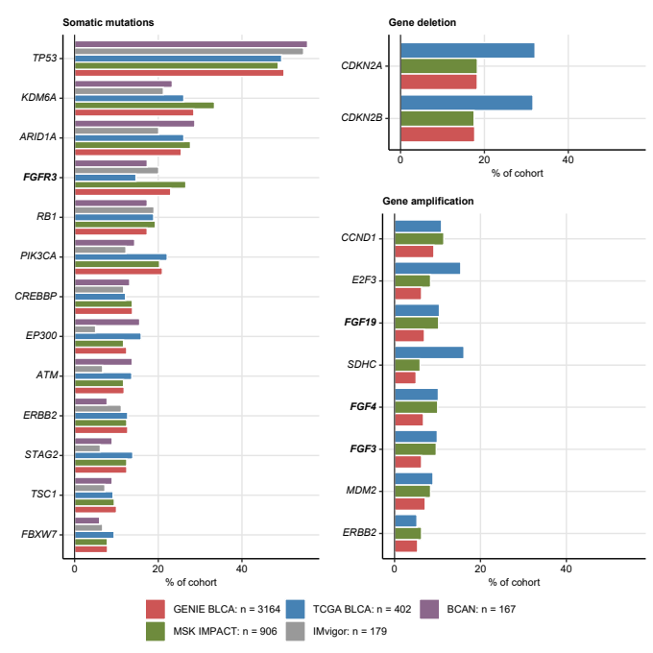

Figure 1: The most frequent somatic mutations and gene copy alterations in urothelial cancers.

**Figure 1. The most frequent somatic mutations and gene copy alterations in urothelial cancers.**

*Percentages of somatic mutations, gene deletions and amplification present in at least 5% of cancers samples in all investigated cohorts (GENIE BLCA, MSK IMPACT, TCGA BLCA, IMvigor, BCAN, and HPA, note: gene amplification and deletion data were not available for the IMvigor and BCAN cohorts) are presented in bar plots. Alterations affecting FGF-, FGFR-, and FGFBP-coding genes are highlighted with bold font. Numbers of analyzed cancer samples are indicated in the plot legend.*

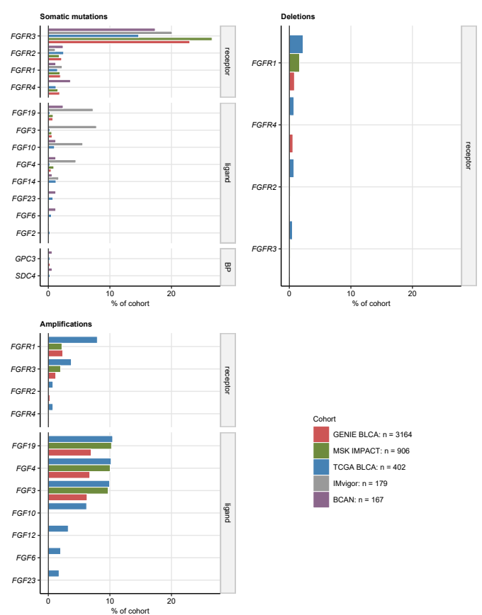

Figure 2: Frequency of somatic mutations and copy number alterations of FGFR-, FGF-, and FGFBP-coding genes.

**Figure 2. Frequency of somatic mutations and copy number alterations of FGFR-, FGF-, and FGFBP-coding genes.**

*Percentages of somatic mutations, deletions and amplifications of FGFR-, FGF-coding genes found to be affected in at lest two out of the investigated cohorts are presented in bar plots. Note that amplification and deletion data were not available for the IMvigor and BCAN collectives. Numbers of analyzed cancer samples are indicated in the plot legend.*

Table 3: Frequency of the most common somatic mutations and copy number variants in the investigated cohorts. Frequencies of alterations present in at least 5% of cancer samples are displayed. Statistical significance for differences between the cohorts was assessed by chi-squared test with Cramer's V effect size statistic. P values were corrected for multiple testing with the false discovery rate method. The table is available as a supplementary Excel file.

|  |
| --- |
|  |

Table 4: Frequency of somatic mutations and copy number variants of FGFR-, FGF-, and FGFBP-coding genes in the investigated cohorts. Statistical significance for differences between the cohorts was assessed by chi-squared test with Cramer's V effect size statistic. P values were corrected for multiple testing with the false discovery rate method. The table is available as a supplementary Excel file.

|  |
| --- |
|  |

## Classification of mutations in FGFR-coding genes, and their possible effects on protein structure and function

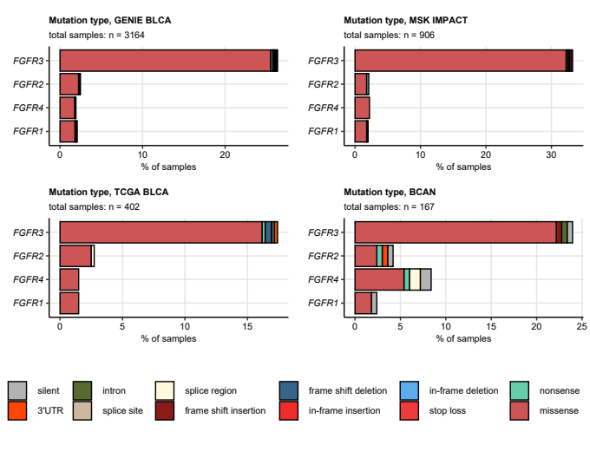

Figure 3: Frequency of somatic mutations in FGFR1/2/3/4 genes split by mutation type.

**Figure 3. Frequency of somatic mutations in FGFR1/2/3/4 genes split by mutation type.**

*Mutations in FGFR1, FGFR2, FGFR3, and FGFR4 genes in the GENIE BLCA, MSK IMPACT, TCGA BLCA, and BCAN cohorts were classified by their effects on the coding sequence. Their frequency was expressed as percentage of cancer samples and presented in stack plots. Numbers of analyzed cancer samples are displayed in the plot captions.*

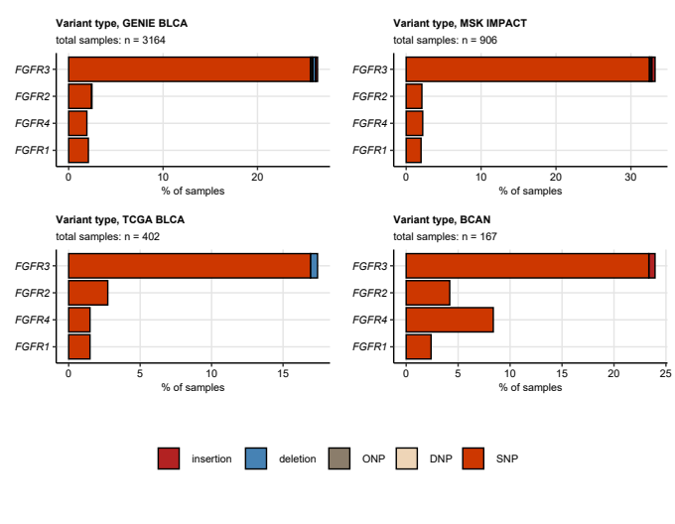

Figure 4: Frequency of somatic mutations in FGFR1/2/3/4 genes split by variant type.

**Figure 4. Frequency of somatic mutations in FGFR1/2/3/4 genes split by variant type.**

*Mutations in FGFR1, FGFR2, FGFR3, and FGFR4 genes in the GENIE BLCA, MSK IMPACT, TCGA BLCA, and BCAN cohorts were classified by variant type. Their frequency was expressed as percentage of cancer samples and presented in stack plots. Numbers of analyzed cancer samples are displayed in the plot captions. SNP: single nucleotide polymorphism, DNP: di-nucleotide polymorphism; ONP: oligo-nucleotide polymorphism.*

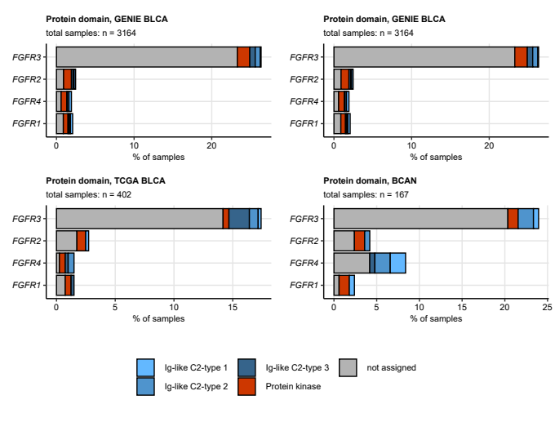

Figure 5: Frequency of somatic mutations in FGFR1/2/3/4 genes split by protein domain.

**Figure 5. Frequency of somatic mutations in FGFR1/2/3/4 genes split by protein domain.**

*Mutations in FGFR1, FGFR2, FGFR3, and FGFR4 genes in the GENIE BLCA, MSK IMPACT, TCGA BLCA, and BCAN cohorts were classified by protein domain. Their frequency was expressed as percentage of cancer samples and presented in stack plots. Numbers of analyzed cancer samples are displayed in the plot captions.*

Table 5: Frequency of mutations in the FGFR1/2/3/4 genes in the GENIE BLCA, MSK, TCGA BLCA, IMvigor, and BCAN cohorts classified by mutation type, variant type, and protein domain. The table is available as a supplementary Excel file.

|  |
| --- |
|  |

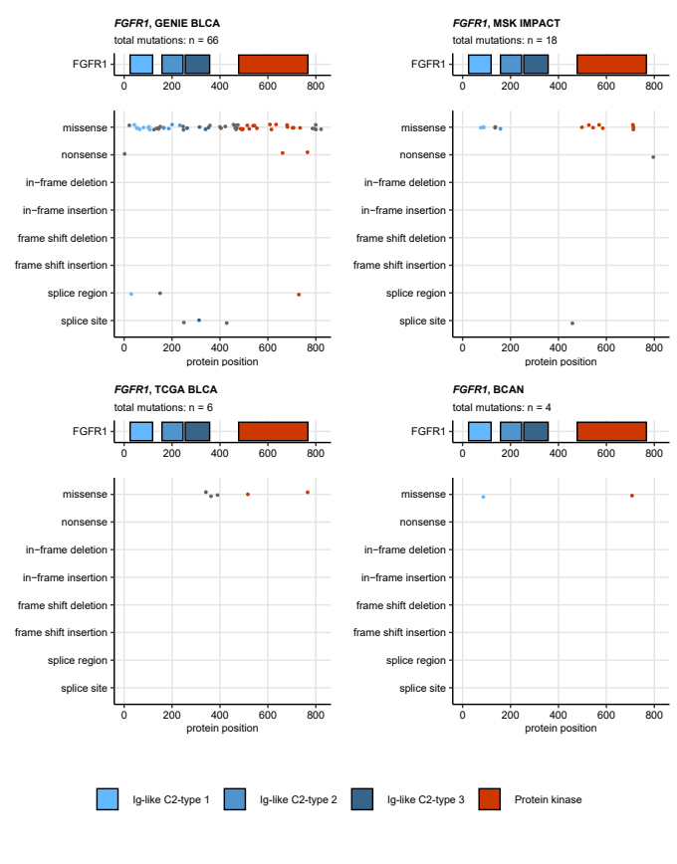

Figure 6: Residues of FGFR1 protein affected by somatic mutations.

**Figure 6. Residues of FGFR1 protein affected by somatic mutations.**

*Somatic mutations in the FGFR1 gene in the GENIE BLCA, MSK IMPACT, TCGA BLCA, and BCAN were classified by their effects on nucleotide sequence and mapped to amino acids of the FGFR1 protein. Mutation localization and type are visualized in scatter plots below the FGFR1 protein domain schemes. Each point represents a single somatic mutation. Point color codes for protein domain. Total mutation numbers are displayed in the plot captions.*

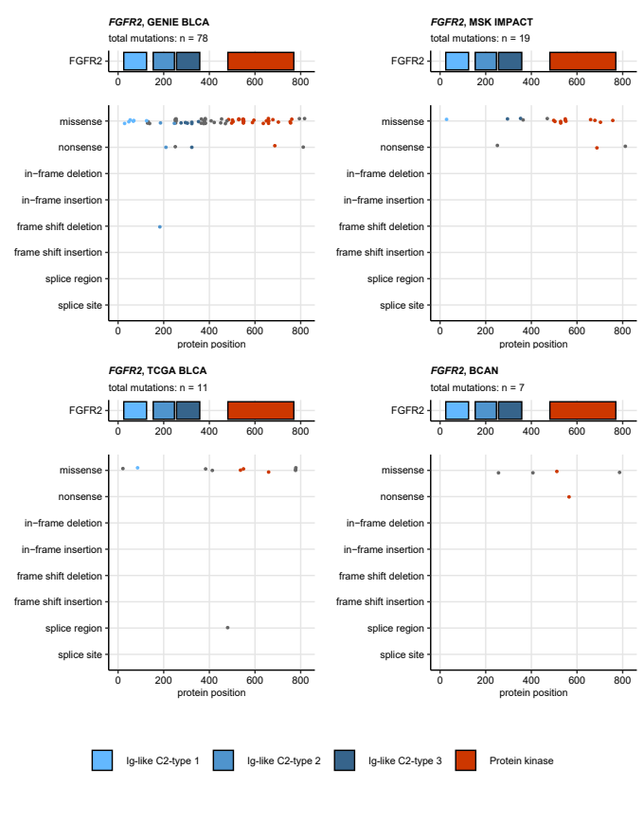

Figure 7: Residues of FGFR2 protein affected by somatic mutations.

**Figure 7. Residues of FGFR2 protein affected by somatic mutations.**

*Somatic mutations in the FGFR2 gene in the GENIE BLCA, MSK IMPACT, TCGA BLCA, and BCAN were classified by their effects on nucleotide sequence and mapped to amino acids of the FGFR2 protein. Mutation localization and type are visualized in scatter plots below the FGFR2 protein domain schemes. Each point represents a single somatic mutation. Point color codes for protein domain. Total mutation numbers are displayed in the plot captions.*

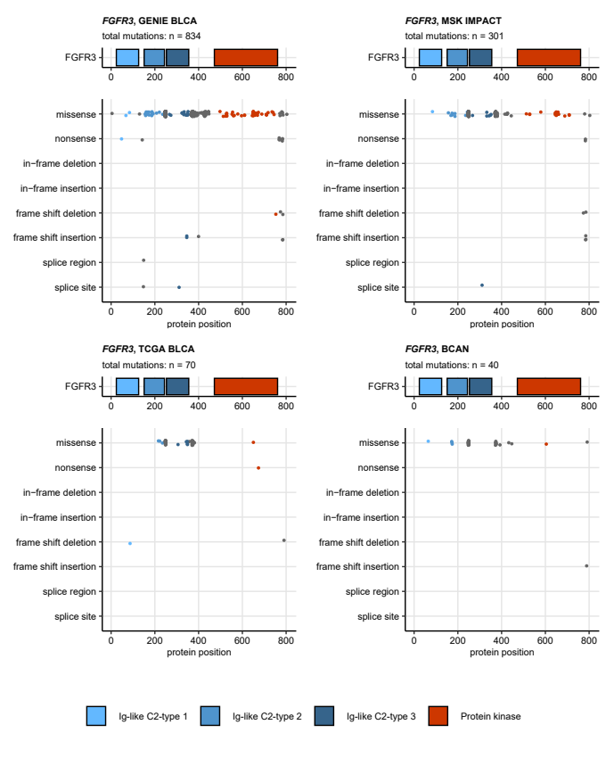

Figure 8: Residues of FGFR3 protein affected by somatic mutations.

**Figure 8. Residues of FGFR3 protein affected by somatic mutations.**

*Somatic mutations in the FGFR3 gene in the GENIE BLCA, MSK IMPACT, TCGA BLCA, and BCAN were classified by their effects on nucleotide sequence and mapped to amino acids of the FGFR3 protein. Mutation localization and type are visualized in scatter plots below the FGFR3 protein domain schemes. Each point represents a single somatic mutation. Point color codes for protein domain. Total mutation numbers are displayed in the plot captions.*

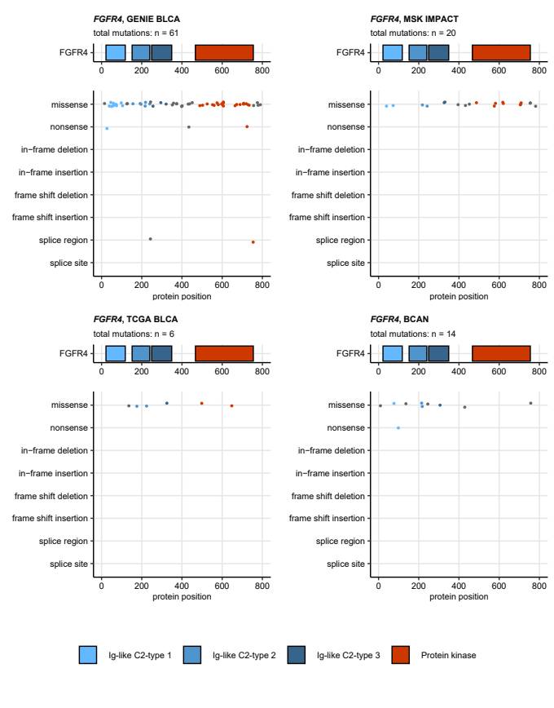

Figure 9: Residues of FGFR4 protein affected by somatic mutations.

**Figure 9. Residues of FGFR4 protein affected by somatic mutations.**

*Somatic mutations in the FGFR4 gene in the GENIE BLCA, MSK IMPACT, TCGA BLCA, and NA were classified by their effects on nucleotide sequence and mapped to amino acids of the FGFR4 protein. Mutation localization and type are visualized in scatter plots below the FGFR4 protein domain schemes. Each point represents a single somatic mutation. Point color codes for protein domain. Total mutation numbers are displayed in the plot captions.*

## Co-occurrence of genetic alterations in FGFR-, FGF-, and FGFBP-coding genes with the most frequent genetic features of urothelial cancers

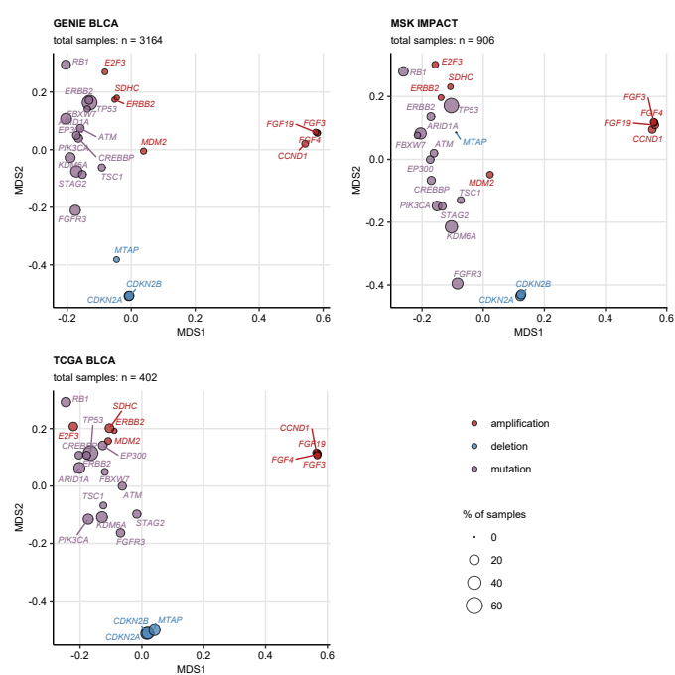

Figure 10: Co-occurrence of the most common genetic alterations in urothelial cancer.

**Figure 10. Co-occurrence of the most common genetic alterations in urothelial cancer.**

*Co-occurrence of the most common genetic alterations in urothelial cancers (at least 5% of cancer samples) was investigated in the GENIE BLCA, MSK IMPACT, and TCGA BLCA cohorts by two-dimensional MDS (multi-dimensional scaling) of pairwise Jaccard’s distances.* *MDS results are visualized in scatter plots with single genetic alterations depicted as points. Point color codes for alteration type (somatic mutation, deletion, amplification), point size represents frequency of the alteration in the data set. Note that genetic features displayed in the plots close to each other are expected to co-occur in a high fraction of cancer samples. Total numbers of samples are indicated in the plot captions.*

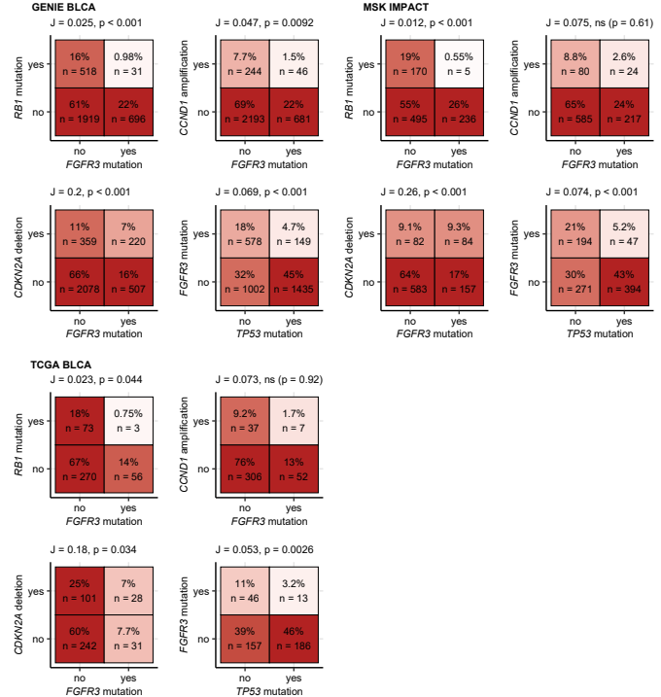

Figure 11: Co-occurrence of selected genetic alterations in urothelial cancer.

**Figure 11. Co-occurrence of selected genetic alterations in urothelial cancer.**

*Co-occurrence of the most common genetic alterations in urothelial cancers (at least 5% of cancer samples) was investigated in the GENIE BLCA, MSK IMPACT, and TCGA BLCA cohorts by pairwise Jaccard’s similarity coefficients J. Statistical significance of co-occurrence, i.e. , was assessed by false discovery rate-adjusted bootstrap tests.* *Frequencies of samples with and without genetic alterations are visualized as heat maps of contingency tables for selected pairs of genetic features. Sample percentages and counts within the total sample sets are indicated in the heat map tiles. J and p values are presented in the plot captions.*

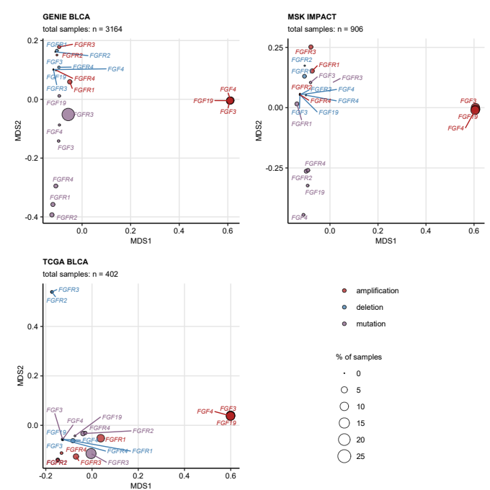

Figure 12: Co-occurrence of genetic alterations of FGFR-, FGF-, and FGFBP-coding genes in urothelial cancer.

**Figure 12. Co-occurrence of genetic alterations of FGFR-, FGF-, and FGFBP-coding genes in urothelial cancer.**

*Co-occurrence of somatic mutations, deletions, and amplifications of FGFR-, FGF-, and FGFBP-coding genes was investigated in the GENIE BLCA, MSK IMPACT, and TCGA BLCA cohorts by two-dimensional MDS (multi-dimensional scaling) of pairwise Jaccard’s distances.* *MDS results are visualized in scatter plots with single genetic alterations depicted as points. Point color codes for alteration type (somatic mutation, deletion, amplification), point size represents frequency of the alteration in the data set. Note that genetic features displayed in the plots close to each other are expected to co-occur in a high fraction of cancer samples. Total numbers of samples are indicated in the plot captions.*

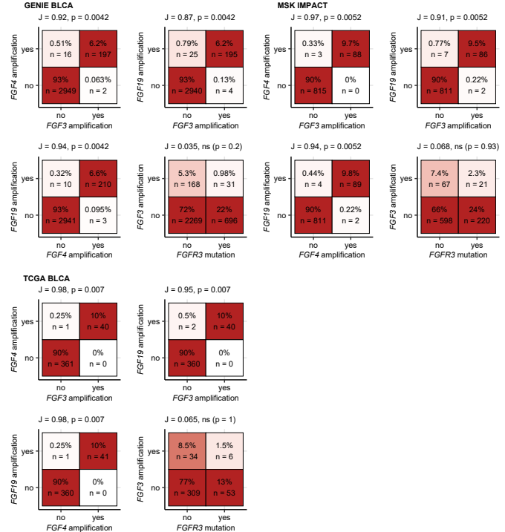

Figure 13: Co-occurrence of genetic alterations selected FGFR-, FGF-, and FGFBP-coding genes in urothelial cancer.

**Figure 13. Co-occurrence of genetic alterations selected FGFR-, FGF-, and FGFBP-coding genes in urothelial cancer.**

*Co-occurrence of somatic mutations, deletions, and amplifications in FGFR-, FGF-, and FGFBP-coding genes was investigated in the GENIE BLCA, MSK IMPACT, and TCGA BLCA cohorts by pairwise Jaccard’s similarity coefficients J. Statistical significance of co-occurrence, i.e. , was assessed by false discovery rate-adjusted bootstrap tests.* *Frequencies of samples with and without genetic alterations are visualized as heat maps of contingency tables for selected pairs of genetic features. Sample percentages and counts within the total sample sets are indicated in the heat map tiles. J and p values are presented in the plot captions.*

## Expression and co-regulation of genes coding for FGFR, FGF, and FGFBP proteins

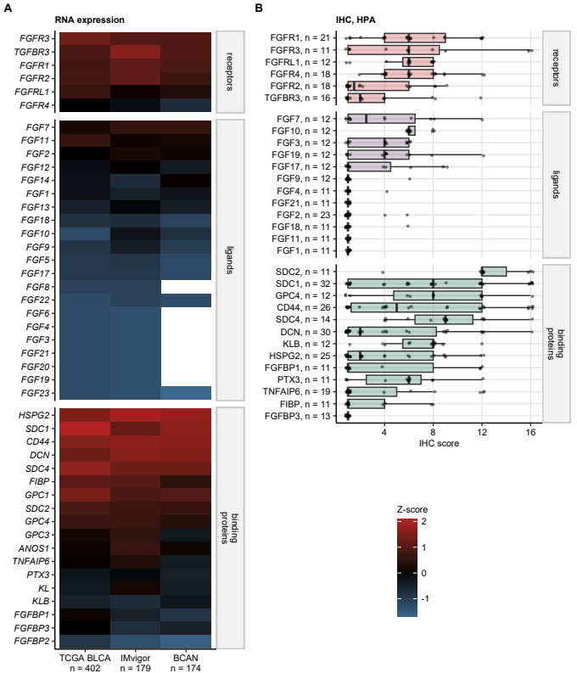

Figure 14: Expression of genes coding FGFR, FGF, and FGFBP at mRNA and protein level.

**Figure 14. Expression of genes coding FGFR, FGF, and FGFBP at mRNA and protein level.**

*(A) Transcript levels of FGFR-, FGF-, and FGFBP-coding genes were determined in cancer tissue samples in the TCGA BLCA, IMvigor, and BCAN by RNA sequencing and published as $log_{2}$ gene counts (TCGA BLCA and IMvigor) or Z-scores of $log_{2}$ gene counts (BCAN). Median Z-scores of $log_{2}$ mRNA expression are shown in a heat map. Each tile represents median expression Z-score of a gene in one cohort. Numbers of cancer samples are indicated in the X axis. White tiles represent genes not detected in a given cohort.*

*(B) Protein expression of FGFR-, FGF-, and FGFBP-coding genes 31 FGFR-, FGF-, and FGFBP-coding genes in the Human Protein Atlas (HPA) repository was quantified by immunohistochemistry (IHC). The protein expression is shown as IHC scores defined as a product of intensity (1: negative, 4: strong) and quantity of positive cells (1: none to 4: >75%). Median IHC scores with interquartile ranges are visualized as boxes with whiskers spanning over 150% of the interquartile ranges. Single IHC specimens are visualized as points. Numbers of IHC samples are indicated in the Y axis.*

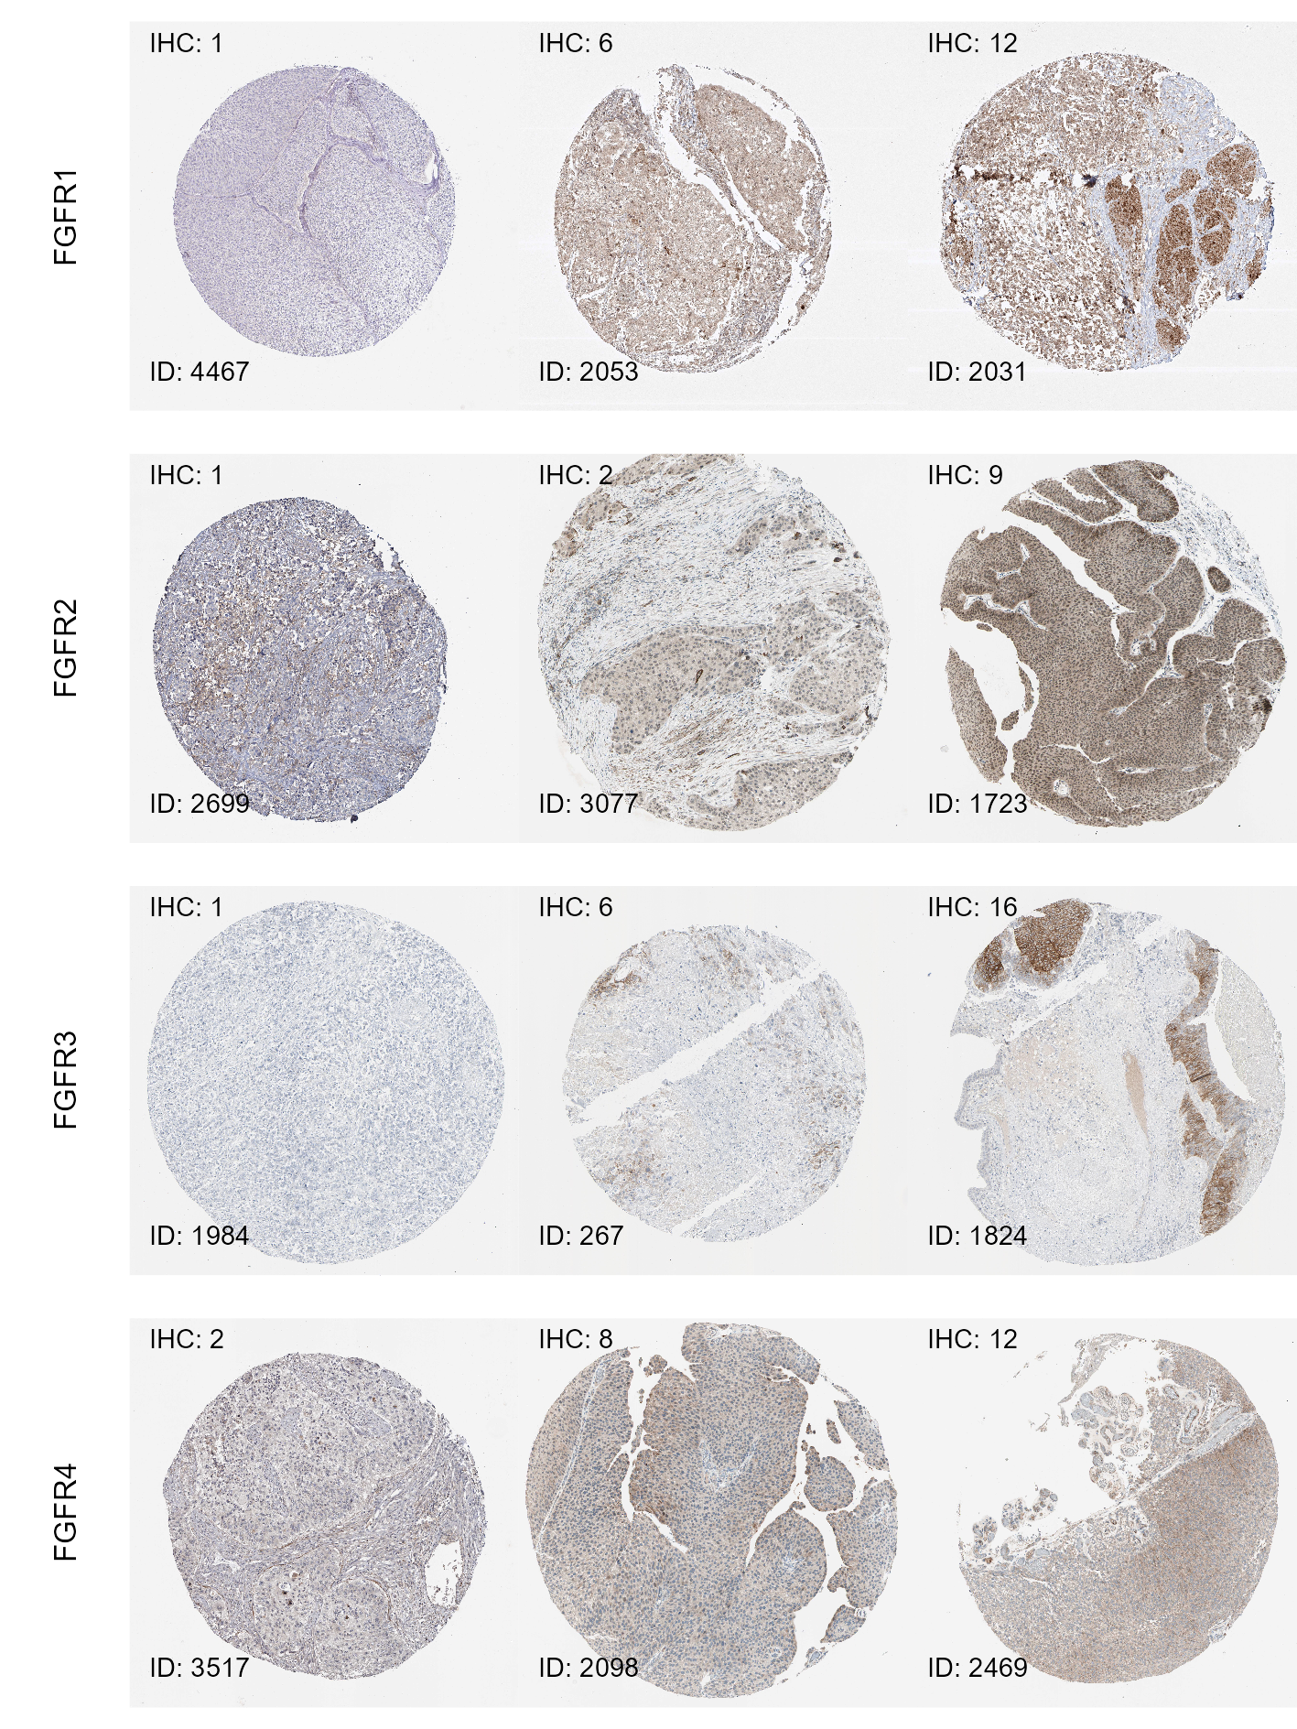

Figure 15: Representative immunohistochemistry staining images for FGFR proteins retrieved from the Human Protein Atlas.

**Figure 15. Representative immunohistochemistry staining images for FGFR proteins retrieved from the Human Protein Atlas.**

*Images of immunohistochemistry (IHC) staining for FGFR, FGF, and FGFBP in urothelial cancer samples were retrieved from the Human Protein Atlas (HPA). The staining was quantified by the IHC score which was defined as a product of intensity (1: negative, 4: strong) and quantity of positive cells (1: none to 4: >75%).* *For each protein, representative images of immunohistochemistry (IHC) staining were selected; the left image corresponds to the minimum IHC score, the middle image shows the staining close to the median IHC score, the right image corresponds to the maximal IHC score.* *The images are labeled with HPA patient identifiers (ID) and IHC scores.*

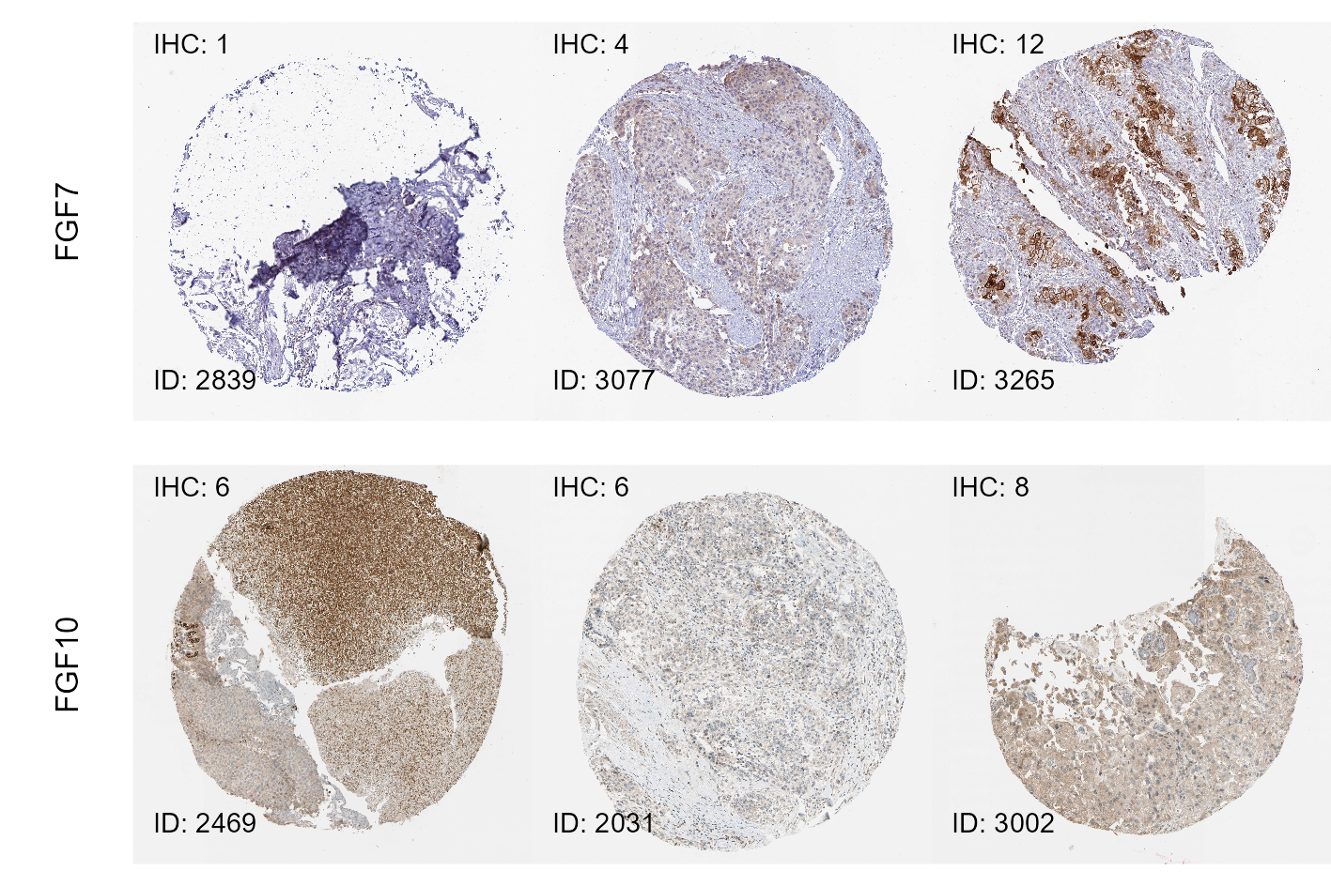

Figure 16: Representative immunohistochemistry staining images for FGF proteins retrieved from the Human Protein Atlas.

**Figure 16. Representative immunohistochemistry staining images for FGF proteins retrieved from the Human Protein Atlas.**

*Images of immunohistochemistry (IHC) staining for FGFR, FGF, and FGFBP in urothelial cancer samples were retrieved from the Human Protein Atlas (HPA). The staining was quantified by the IHC score which was defined as a product of intensity (1: negative, 4: strong) and quantity of positive cells (1: none to 4: >75%).* *For each protein, representative images of immunohistochemistry (IHC) staining were selected; the left image corresponds to the minimum IHC score, the middle image shows the staining close to the median IHC score, the right image corresponds to the maximal IHC score.* *The images are labeled with HPA patient identifiers (ID) and IHC scores.*

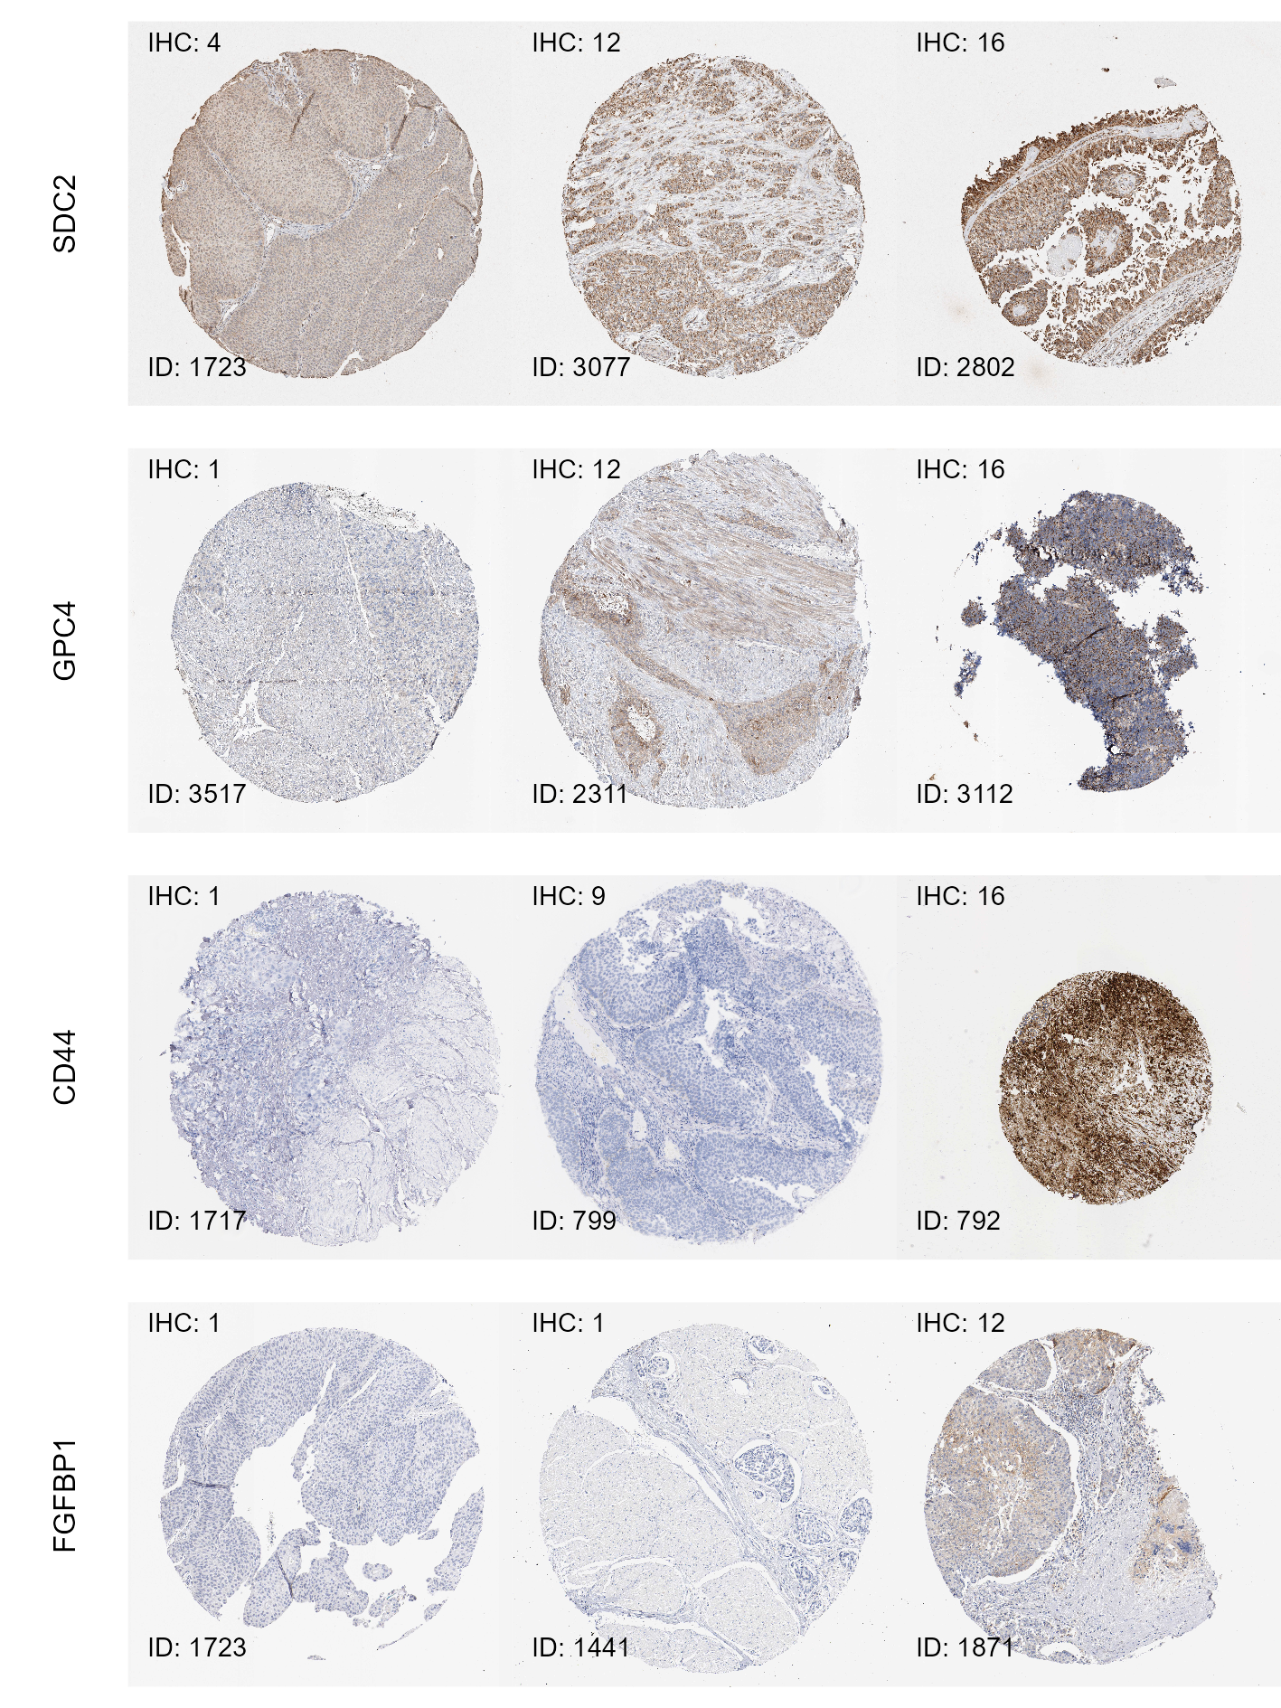

Figure 17: Representative immunohistochemistry staining images for FGFBP proteins retrieved from the Human Protein Atlas.

**Figure 17. Representative immunohistochemistry staining images for FGFBP proteins retrieved from the Human Protein Atlas.**

*Images of immunohistochemistry (IHC) staining for FGFR, FGF, and FGFBP in urothelial cancer samples were retrieved from the Human Protein Atlas (HPA). The staining was quantified by the IHC score which was defined as a product of intensity (1: negative, 4: strong) and quantity of positive cells (1: none to 4: >75%).* *For each protein, representative images of immunohistochemistry (IHC) staining were selected; the left image corresponds to the minimum IHC score, the middle image shows the staining close to the median IHC score, the right image corresponds to the maximal IHC score.* *The images are labeled with HPA patient identifiers (ID) and IHC scores.*

Table 6: Expression of FGFR-, FGF-, and FGFBP-coding genes at mRNA level was quantified in the TCGA BLCA, IMvigor, and BCAN cohort by RNA sequencing. The mRNA amounts were provided as log2-transformed gene counts (TCGA BLCA and IMvigor) or Z-scores of log2 gene counts (BCAN). Protein expression of the genes of interest was measured in the Human Protein Atlas (HPA) by immunohistochemistry (IHC). The protein amounts are metered by the IHC score defined as a product of staining intensity and quantity of positive cells. Median mRNA and protein amounts with interquartile ranges, ranges, and numbers of cancer samples are listed. The table is available as a supplementary Excel file.

|  |
| --- |
|  |

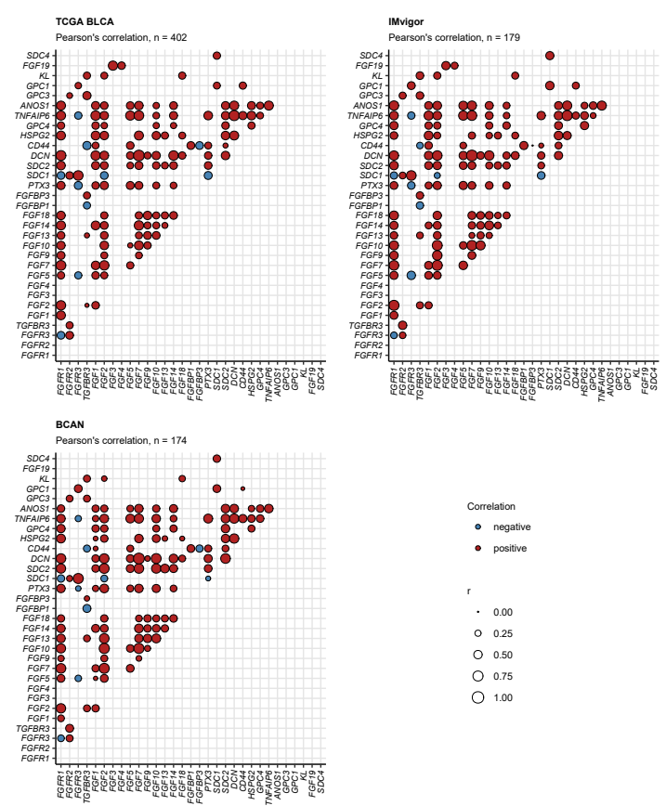

Figure 18: Correlation of mRNA levels of FGFR-, FGF-, and FGFBP-coding genes.

**Figure 18. Correlation of mRNA levels of FGFR-, FGF-, and FGFBP-coding genes.**

*Pairwise correlation of log2-transformed mRNA levels of FGF-, FGFR-, and FGFBP-coding genes was investigated in the TCGA BLCA, IMvigor, and BCAN cohorts by false discovery rate-adjusted Pearson’s test. Correlation coefficients r for significant gene pairs are depicted in bubble plots. Color of the points codes for correlation sign. Point size represents absolute values of r. Numbers of cancer samples are displayed in the plot captions.*

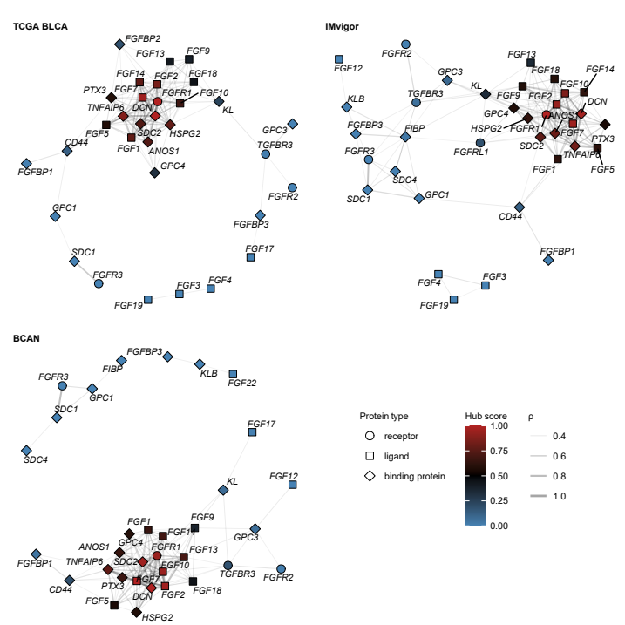

Figure 19: Co-expression networks of FGFR-, FGF-, and FGFBP-coding genes.

**Figure 19. Co-expression networks of FGFR-, FGF-, and FGFBP-coding genes.**

*Co-expression networks were constructed in the TCGA BLCA, IMvigor, and BCAN cohorts for the FGFR-, FGF-, and FGFBP-coding genes, whose expression levels correlated with Spearman’s rho $ρ≥$ 0.3. Isolated vertices of the networks were removed. The networks were visualized using the Fruchterman-Reingold algorithm. Points represent node vertices/genes, point shape codes for classification of the protein product. Point color represent hub scores, which measure the overall correlation strength. Lines represent edges, i.e. correlations between expression levels with $ρ≥$ 0.3. Line widths correspond to $ρ$ values. Note the central position, connectivity, and high hub scores of the genes coding for FGFR1, its ligands FGF2, FGF7 and FGF10, and the binding proteins SDC2, DCN, PTX3 and HSPG2 preserved in all cohorts. This suggests that signaling via FGFR1 may serve as a major driver of urothelial cancer.*

## Transcriptional and clinical significance of *FGFR3* mutations

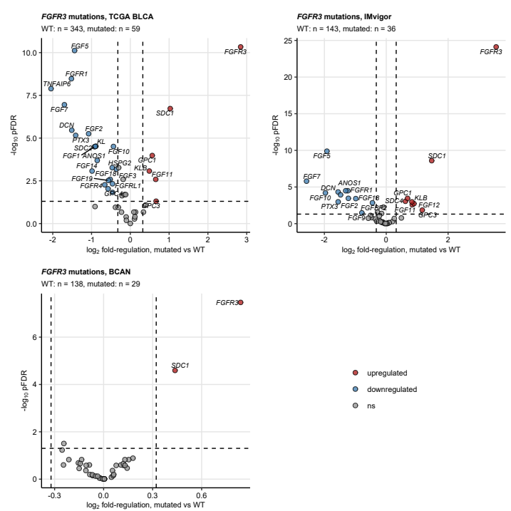

Figure 20: Expression of FGFR-, FGF-, and FGFBP-coding genes in urothelial cancers stratified by presence of FGFR3 mutations: Volcano plots.

**Figure 20. Expression of FGFR-, FGF-, and FGFBP-coding genes in urothelial cancers stratified by presence of FGFR3 mutations: Volcano plots.**

*Differences in $log_{2}$-transformed expression of FGFR-, FGF-, and FGFBP-coding genes between cancers with and without somatic mutations in the FGFR3 gene were assessed by two-tailed T test with Cohen’s d effect size metric in the TCGA BLCA, IMvigor, and NA. P values were corrected with the false discovery rate (FDR) method. Differentially regulated genes were identified by pFDR < 0.05 and at least 1.25 fold-regulation of gene expression in mutated samples as compared with WT specimens.*

$log_{2}$*fold-regulation estimates of mRNA levels in FGFR-mutated as compared with WT tumors, and FDR-corrected p values for the genes of interest are presented in Volcano plots. Each point represents a single gene; point color codes for significance and sign of expression regulation. Dashed lines represent the regulation and significance cutoffs used for identification of the differentially expressed genes. Numbers of WT and FGFR3-mutated samples are displayed in the plot captions.*

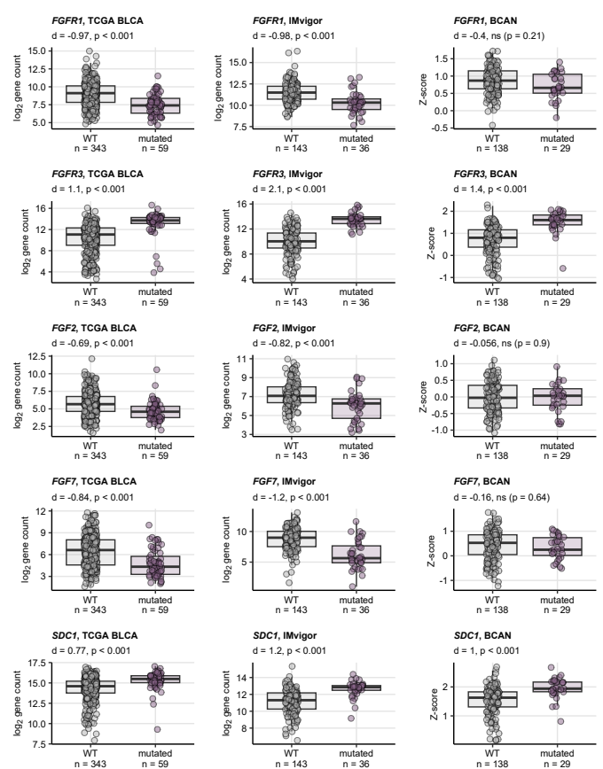

Figure 21: Expression of FGFR-, FGF-, and FGFBP-coding genes in urothelial cancers stratified by presence of FGFR3 mutations: selected differentially expressed genes.

**Figure 21. Expression of FGFR-, FGF-, and FGFBP-coding genes in urothelial cancers stratified by presence of FGFR3 mutations: selected differentially expressed genes.**

*Differences in $log_{2}$-transformed expression of FGFR-, FGF-, and FGFBP-coding genes between cancers with and without somatic mutations in the FGFR3 gene were assessed by two-tailed T test with Cohen’s d effect size metric in the TCGA BLCA, IMvigor, and NA. P values were corrected with the false discovery rate (FDR) method. Differentially regulated genes were identified by pFDR < 0.05 and at least 1.25 fold-regulation of gene expression in mutated samples as compared with WT specimens.*

*log2-transformed mRNA levels of selected genes found to be differentially regulated in at least two out of the TCGA BLCA, IMvigor, and BCAN collectives are presented in box plots. Median expression values with interquartile ranges are depicted as boxes with whiskers spanning over 150% of the interquartile ranges. Single observations are visualized as points. Effect sizes and p values are displayed in the plot captions. Numbers of analyzed cancer samples are indicated in the X axes.*

Table 7: Differential expression of FGF- and FGFR-coding genes in urothelial cancers with and without FGFR3 mutations. log2-transformed expression levels are presented as medians with interquartile ranges and ranges. Statistical significance was determined by two-tailed T test with Cohen's d effect size statistic. P values were corrected for multiple testing with the false discovery rate method. The table is available as a supplementary Excel file.

|  |
| --- |
|  |

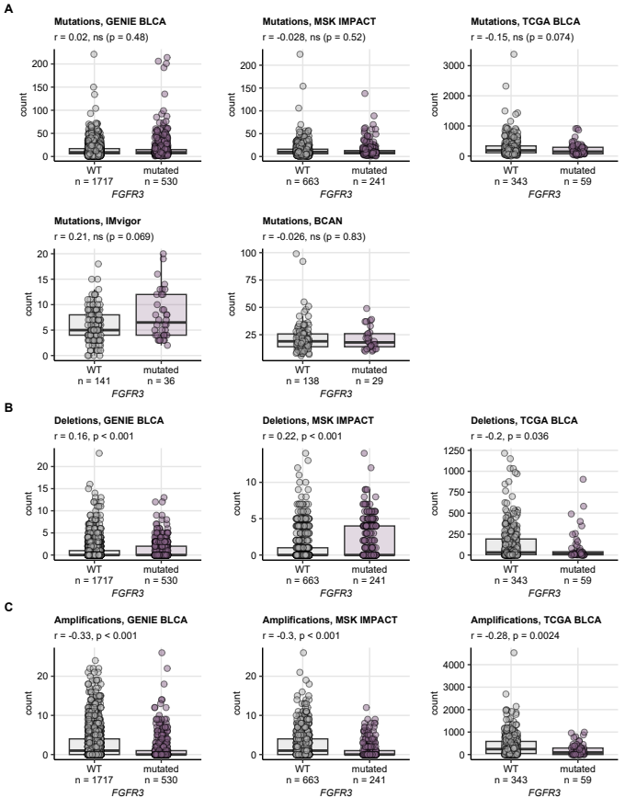

Figure 22: Total mutation burden and counts of copy number alterations in FGFR3 WT and FGFR3-mutated cancers.

**Figure 22. Total mutation burden and counts of copy number alterations in FGFR3 WT and FGFR3-mutated cancers.**

*Counts of mutations, deletions and amplifications were computed for each cancer sample based on the published information. Note, that information on deletions and amplification was not available for the IMvigor and BCAN cohorts. Counts of mutations (A), deletions, and amplifications (C, D) were compared between cancers with and without FGFR3 mutations by Mann-Whitney test with r effect size statistic. P values were adjusted for multiple testing with the false discovery rate method. Median values with interquartile ranges are shown as boxes with whiskers spanning over 150% of the interquartile ranges. Single cancer samples are visualized as points. Effect sizes and p values are displayed in the plot captions. Numbers of analyzed cancer samples are indicated in the X axes.*

Table 8: Demographic, clinical, and pathological characteristic of cancers with WT and mutated FGFR3. Numeric features are presented as medians with interquartile ranges and ranges. Qualitative variables are shown as percentages and observation counts of the categories.

| **Cohort** | **Variable** | **FGFR3 wild-type** | **FGFR3 mutated** | **Significancea** | **Effect sizea** |
| --- | --- | --- | --- | --- | --- |
| GENIE BLCA | Patients, N | 2437 | 727 |  |  |
| Age | 69 [IQR: 62 - 76] range: 18 - 89 complete: n = 2432 | 69 [IQR: 63 - 75] range: 31 - 89 complete: n = 727 | ns (p = 0.79) | r = 0.0048 |
| Gender | female: 26% (629) male: 74% (1803) complete: n = 2432 | female: 30% (217) male: 70% (510) complete: n = 727 | ns (p = 0.056) | V = 0.038 |
| Tissue | bladder: 84% (2050) non-bladder: 16% (387) complete: n = 2437 | bladder: 77% (560) non-bladder: 23% (167) complete: n = 727 | p < 0.001 | V = 0.078 |
| MSK IMPACT | Patients, N | 665 | 241 |  |  |
| Age | 67 [IQR: 59 - 73] range: 28 - 92 complete: n = 665 | 65 [IQR: 56 - 72] range: 30 - 88 complete: n = 241 | p = 0.035 | r = 0.073 |
| Gender | female: 21% (141) male: 79% (523) complete: n = 664 | female: 31% (74) male: 69% (167) complete: n = 241 | p = 0.0068 | V = 0.098 |
| Tissue | bladder: 98% (653) non-bladder: 1.8% (12) complete: n = 665 | bladder: 98% (235) non-bladder: 2.5% (6) complete: n = 241 | ns (p = 0.7) | V = 0.022 |
| Invasiveness | non-muscle invasive: 1.7% (11) muscle invasive: 98% (654) complete: n = 665 | non-muscle invasive: 19% (45) muscle invasive: 81% (196) complete: n = 241 | p < 0.001 | V = 0.31 |
| pT stage | T1: 1.7% (11) T2: 15% (102) T3: 82% (545) T4: 1.1% (7) complete: n = 665 | T1: 19% (45) T2: 37% (88) T3: 44% (106) T4: 0.83% (2) complete: n = 241 | p < 0.001 | V = 0.42 |
| TCGA BLCA | Patients, N | 343 | 59 |  |  |
| Age | 69 [IQR: 61 - 77] range: 34 - 90 complete: n = 343 | 67 [IQR: 59 - 72] range: 42 - 85 complete: n = 59 | ns (p = 0.071) | r = 0.1 |
| Gender | female: 28% (97) male: 72% (246) complete: n = 343 | female: 14% (8) male: 86% (51) complete: n = 59 | ns (p = 0.062) | V = 0.12 |
| Tissue | bladder: 100% (343) complete: n = 343 | bladder: 100% (59) complete: n = 59 |  |  |
| Invasiveness | non-muscle invasive: 0.94% (3) muscle invasive: 99% (317) complete: n = 320 | non-muscle invasive: 2% (1) muscle invasive: 98% (49) complete: n = 50 | ns (p = 1) | V = 0.035 |
| pT stage | T0: 0.31% (1) T1: 0.62% (2) T2: 29% (92) T3: 55% (176) T4: 15% (49) complete: n = 320 | T0: 0% (0) T1: 2% (1) T2: 50% (25) T3: 32% (16) T4: 16% (8) complete: n = 50 | ns (p = 0.062) | V = 0.18 |
| pN stage | N0: 63% (193) N1: 14% (42) N2: 22% (67) N3: 1.9% (6) complete: n = 308 | N0: 77% (40) N1: 5.8% (3) N2: 13% (7) N3: 3.8% (2) complete: n = 52 | ns (p = 0.17) | V = 0.13 |
| pM stage | M0: 96% (151) M1: 4.4% (7) complete: n = 158 | M0: 91% (40) M1: 9.1% (4) complete: n = 44 | ns (p = 0.47) | V = 0.085 |
| IMvigor | Patients, N | 143 | 36 |  |  |
| Gender | female: 21% (30) male: 79% (113) complete: n = 143 | female: 31% (11) male: 69% (25) complete: n = 36 | ns (p = 0.48) | V = 0.091 |
| Tissue | bladder: 89% (127) non-bladder: 11% (16) complete: n = 143 | bladder: 86% (31) non-bladder: 14% (5) complete: n = 36 | ns (p = 0.87) | V = 0.034 |
| Invasiveness | muscle invasive: 100% (143) complete: n = 143 | muscle invasive: 100% (36) complete: n = 36 |  |  |
| BCAN | Patients, N | 138 | 29 |  |  |
| Age | 67 [IQR: 59 - 73] range: 28 - 85 complete: n = 138 | 66 [IQR: 61 - 75] range: 50 - 85 complete: n = 29 | ns (p = 0.65) | r = 0.084 |
| Gender | female: 24% (33) male: 76% (104) complete: n = 137 | female: 28% (8) male: 72% (21) complete: n = 29 | ns (p = 1) | V = 0.031 |
| Tissue | bladder: 73% (101) non-bladder: 27% (37) complete: n = 138 | bladder: 76% (22) non-bladder: 24% (7) complete: n = 29 | ns (p = 1) | V = 0.023 |
| Invasiveness | muscle invasive: 74% (102) non-muscle invasive: 26% (36) complete: n = 138 | muscle invasive: 45% (13) non-muscle invasive: 55% (16) complete: n = 29 | p = 0.03 | V = 0.24 |
| pT stage | T0: 0.92% (1) Ta: 0.92% (1) Tis: 0% (0) T1: 4.6% (5) T2: 34% (37) T3: 43% (47) T4: 17% (18) complete: n = 109 | T0: 0% (0) Ta: 11% (2) Tis: 5.6% (1) T1: 11% (2) T2: 33% (6) T3: 28% (5) T4: 11% (2) complete: n = 18 | ns (p = 0.061) | V = 0.35 |
| pN stage | N0: 57% (50) N1: 15% (13) N2: 20% (17) N3: 8% (7) complete: n = 87 | N0: 57% (8) N1: 21% (3) N2: 14% (2) N3: 7.1% (1) complete: n = 14 | ns (p = 1) | V = 0.071 |
| pM stage | M0: 69% (9) M1: 31% (4) complete: n = 13 | M0: 60% (3) M1: 40% (2) complete: n = 5 | ns (p = 1) | V = 0.088 |
| aNumeric variables: Mann-Whitney test with r effect size statistic. Categorical variables: χ² test with Cramer V effect size statistic. | | | | | |

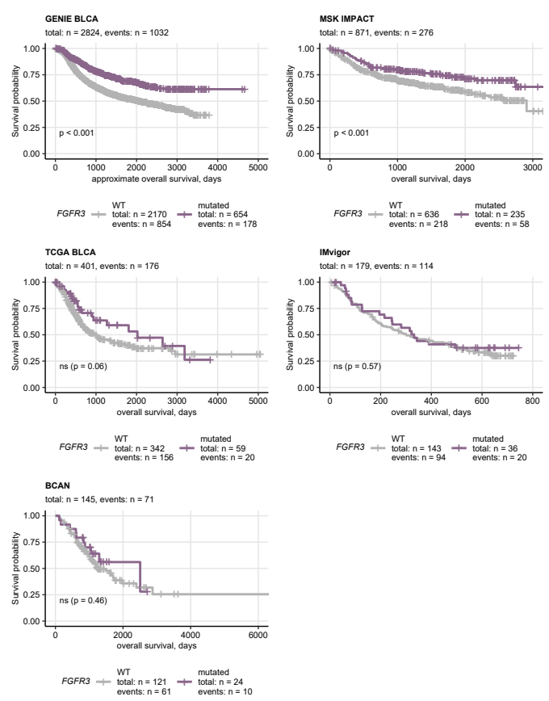

Figure 23: Overall survival of patients with FGFR3 WT and FGFR3-mutated cancers.

**Figure 23. Overall survival of patients with FGFR3 WT and FGFR3-mutated cancers.**

*Overall survival information was provided for the MSK IMPACT, TCGA BLCA, IMvigor, and BCAN study participants. Approximate overall survival was calculated for the GENIE BLCA cohort based on age at enrollment in years and age at the last follow-up or death in days. Overall survival was subsequently compared between patients with cancers with and without FGFR3 mutations. Statistical significance was determined by false discovery rate-adjusted Peto-Peto test. Fractions of surviving patients are presented in Kaplan-Meier plots. P values are indicated in the plots, numbers of observations and deaths are displayed in the plot captions. Numbers of observations and deaths in the FGFR3 mutation strata are presented in the plot legends.*

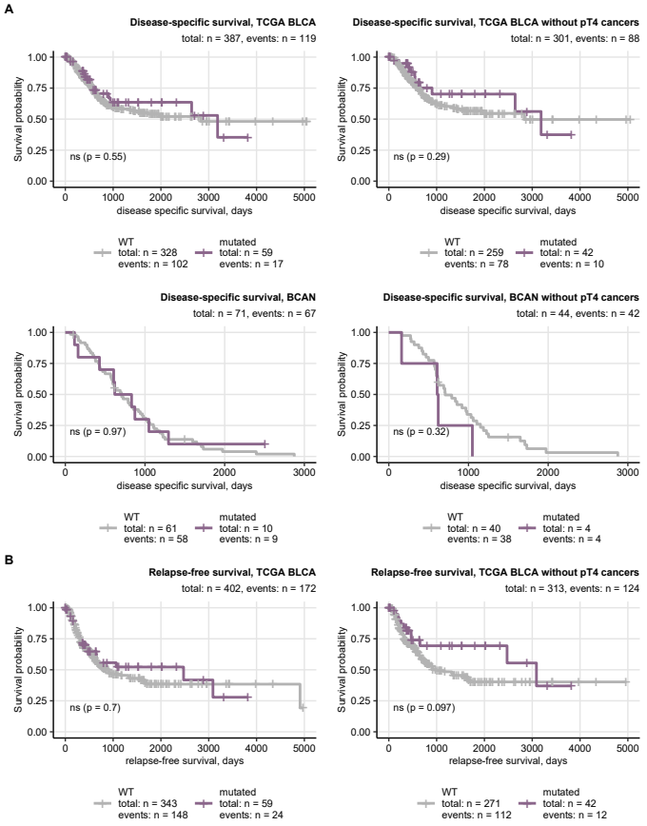

Figure 24: Disease-specific and relapse-free survival of patients with FGFR3 WT and FGFR3 mutated cancers.

**Figure 24. Disease-specific and relapse-free survival of patients with FGFR3 WT and FGFR3 mutated cancers.**

*Disease-specific survival information was provided for the TCGA BLCA and BCAN cohorts (A). Relapse-free survival was available for the TCGA BLCA collective (B). Differences in survival between patients with cancers with and without FGFR3 mutations were investigated by false discovery rate-adjusted Peto-Peto test. Fractions of surviving patients are presented in Kaplan-Meier plots. P values are indicated in the plots, numbers of observations and deaths are displayed in the plot captions. Numbers of observations and deaths in the FGFR3 mutation strata are presented in the plot legends.*

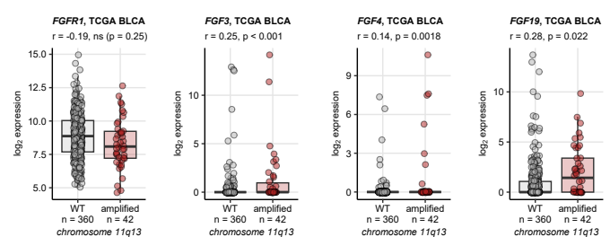

Figure 25: Expression of FGF- and FGFR-coding genes in cancers with and without amplification of the 11q13 chromosome region.

**Figure 25. Expression of FGF- and FGFR-coding genes in cancers with and without amplification of the 11q13 chromosome region.**

*Amplification of the 11q13 chromosome region with FGF3, FGF4, FGF19 and CCND genes was identified as frequent genetic alteration in urothelial carcinoma. Differences in expression of FGF- and FGFR-coding genes between cancers with and without 11q13 amplification were assessed in the TCGA BLCA cohort by Mann-Whitney test with r effect size metric. P values were corrected for multiple testing with the false discovery rate method. Median log2-transformed mRNA levels with interquartile ranges are represented by boxes with whiskers spanning over 150% of the interquartile ranges for the significantly regulated genes. Single cancer samples are visualized as points. Effect sizes and p values are displayed in the plot captions. Numbers of analyzed cancer samples are indicated in the X axes.*

## Genetic alterations and differential expression of FGFR-, FGF-, and FGFBP-coding genes in consensus molecular subtypes of urothelial cancers

Table 9: Frequency of somatic mutations and copy number variants of FGFR-, FGF-, and FGFBP-coding genes in the consensus molecular classes of urothelial cancers. The frequencies are presented as percentages of the consensus class. Statistical significance of differences between the consensus classes was determined by weighted permutation test with Cramer's V effect size statistic. P values were corrected for multiple testing with the false discovery rate method. The table is available as a supplementary Excel file.

|  |
| --- |
|  |

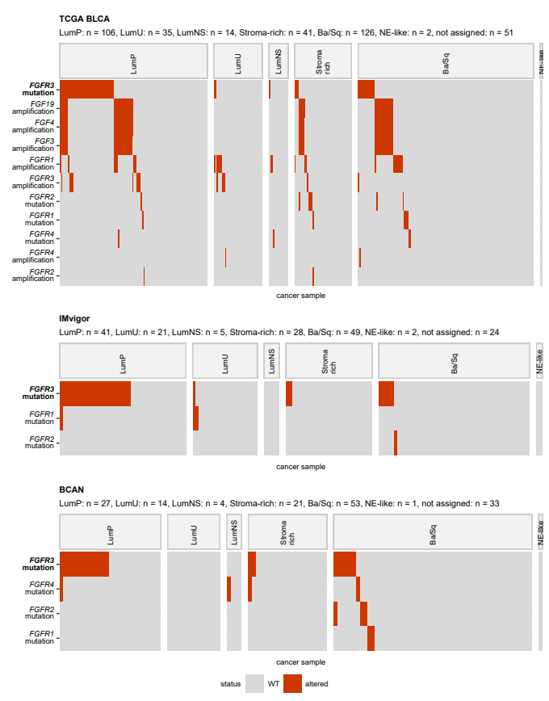

Figure 26: Alterations of FGFR-, FGF-, and FGFBP-coding genes in consensus molecular classes of urothelial cancers.

**Figure 26. Alterations of FGFR-, FGF-, and FGFBP-coding genes in consensus molecular classes of urothelial cancers.**

*Cancer samples from the TCGA BLCA, IMvigor, and BCAN data sets were assigned to the MIBC consensus molecular subtypes based on ComBat-adjusted whole-genome mRNA levels by the nearest centroid algorithm (R package consensusMIBC).* *Differences in frequency of somatic mutations and copy number variants of FGFR-, FGF-, and FGFBP-coding genes between the consensus molecular classes were assessed by weighted permutation test. P values were corrected for multiple testing with the false discovery rate method. Note that copy number variant information was not available for the IMvigor cohort.*

*Presence/absence of selected genetic alterations in the consensus molecular classes visualized in oncoplots. Alteration names with effect sizes and p values of differences between the consensus classes are indicated in the Y axis. Significant effects are highlighted with bold font. Numbers of cancer samples in the consensus classes are displayed in the plot captions.*

*LumP: luminal papillary; LumU: luminal genetically unstable; LumNS: luminal non-specified; Stroma-rich: luminal stroma-rich; Ba/Sq: basal/squamous-like; NE-like: neuroendocrine-like.*

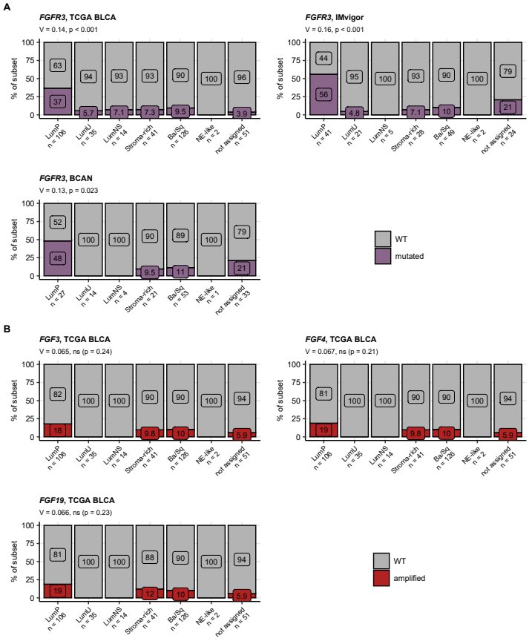

Figure 27: Frequency of somatic mutations of FGFR3 and amplification of FGF3/4/19 in consensus molecular classes of urothelial cancer.

**Figure 27. Frequency of somatic mutations of FGFR3 and amplification of FGF3/4/19 in consensus molecular classes of urothelial cancer.**

*Assignment of cancer samples to consensus molecular classes and testing for differences in genetic alterations between the consensus classes were presented in Figure 26. Percentages of FGFR3 mutations (A), and amplifications of the FGF3, FGF4 and FGF19 genes (B) in the consensus molecular classes are presented in stack plots. Effect sizes and false discovery rate-corrected p values are displayed in the plot captions. Numbers of observations in the consensus classes are indicated in the X axes.*

*LumP: luminal papillary; LumU: luminal genetically unstable; LumNS: luminal non-specified; Stroma-rich: luminal stroma-rich; Ba/Sq: basal/squamous-like; NE-like: neuroendocrine-like.*

Table 10: Expression of FGFR-, FGF-, and FGFBP-coding genes in the consensus molecular classes of urothelial cancers. log2-transformed expression levels are presented as medians with interquartile ranges and ranges. Statistical significance of differences between the molecular classes was determined by one-way ANOVA with eta-square effect size statistic. P values were corrected for multiple testing with the false discovery rate method. The table is available as a supplementary Excel file.

|  |
| --- |
|  |

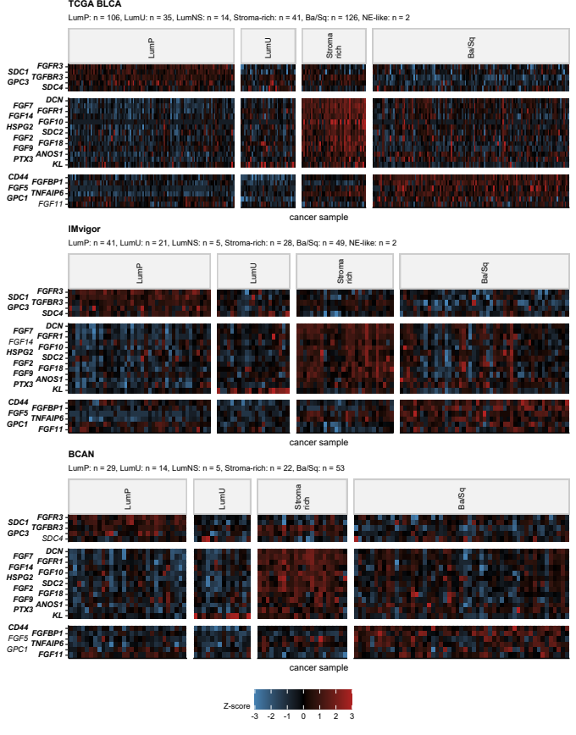

Figure 28: Differential expression of FGFR-, FGF-, and FGFR-coding genes in the consensus molecular classes of urothelial cancers.

**Figure 28. Differential expression of FGFR-, FGF-, and FGFR-coding genes in the consensus molecular classes of urothelial cancers.**

*Assignment of cancer samples from the TCGA BLCA, IMvigor, and BCAN to the consensus molecular classes was presented in Figure 26. Differences in log2-transformed mRNA levels of FGFR-, FGF-, and FGFBP-coding genes between the consensus molecular classes were assessed by one-way ANOVA with $η^{2}$ effect size statistic. Differences in $log_{2}$-transformed gene expression between a subset and luminal papillary subset (LumP) were investigated by two-tailed T test. P values were corrected for multiple testing with the false discovery rate method (FDR). Significantly differentially regulated genes were defined by p(ANOVA) < 0.05, $η^{2}≥$ 0.06, pFDR(T test) < 0.05, and at least 1.25-fold up- or downregulation in a subset as compared with LumP cancers.*

*Z-scores of $log_{2}$ expression levels of significantly differentially regulated genes shared by at least two cohorts are displayed in heat maps. Significant genes are labelled with bold font in the Y axes. Numbers of cancer samples in the consensus subtypes are indicated in the plot caption. Note: samples without reliable assignment to the consensus subtypes are not presented in the heat maps.*

*LumP: luminal papillary; LumU: luminal genetically unstable; LumNS: luminal non-specified; Stroma-rich: luminal stroma-rich; Ba/Sq: basal/squamous-like; NE-like: neuroendocrine-like.*

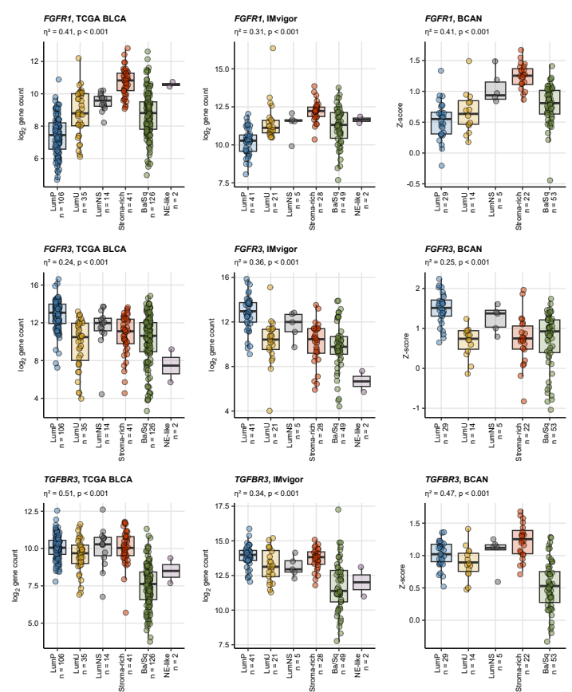

Figure 29: Differential expression of FGFR-coding genes in the consensus molecular classes of urothelial cancers.

**Figure 29. Differential expression of FGFR-coding genes in the consensus molecular classes of urothelial cancers.**

*Assignment of cancer samples from the TCGA BLCA, IMvigor, and BCAN to the consensus molecular classes was presented in Figure 26. Differences in log2-transformed mRNA levels of FGFR-, FGF-, and FGFBP-coding genes between the consensus molecular classes were assessed as presented in Figure 28. P values were corrected for multiple testing with the false discovery rate method.*

*Expression of FGFR1, FGFR3, and TGFBR3 was found to differ significantly between the consensus classes in all three cohorts. Median log2-transformed mRNA levels with interquartile ranges are depicted as boxes with whiskers spanning over 150% of the interquartile ranges. Single cancer samples are visualized as points. Effect sizes and ANOVA p values are displayed in the plot captions. Numbers of cancer samples in the consensus classes are indicated in the X axes.*

*LumP: luminal papillary; LumU: luminal genetically unstable; LumNS: luminal non-specified; Stroma-rich: luminal stroma-rich; Ba/Sq: basal/squamous-like; NE-like: neuroendocrine-like.*

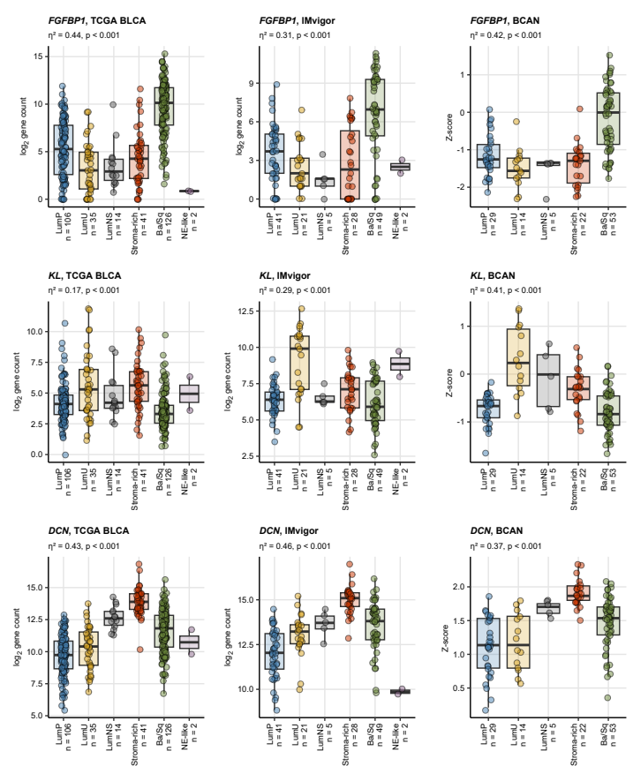

Figure 30: Differential expression of FGFBP-coding genes in the consensus molecular classes of urothelial cancers.

**Figure 30. Differential expression of FGFBP-coding genes in the consensus molecular classes of urothelial cancers.**

*Assignment of cancer samples from the TCGA BLCA, IMvigor, and BCAN to the consensus molecular classes was presented in Figure 26. Differences in log2-transformed mRNA levels of FGFR-, FGF-, and FGFBP-coding genes between the consensus molecular classes were assessed as presented in Figure 28. P values were corrected for multiple testing with the false discovery rate method.*

*Expression of FGFBP1, KL, and DCN was found to differ significantly between the consensus classes in all three cohorts. Median log2-transformed mRNA levels with interquartile ranges are depicted as boxes with whiskers spanning over 150% of the interquartile ranges. Single cancer samples are visualized as points. Effect sizes and ANOVA p values are displayed in the plot captions. Numbers of cancer samples in the consensus classes are indicated in the X axes.*

*LumP: luminal papillary; LumU: luminal genetically unstable; LumNS: luminal non-specified; Stroma-rich: luminal stroma-rich; Ba/Sq: basal/squamous-like; NE-like: neuroendocrine-like.*

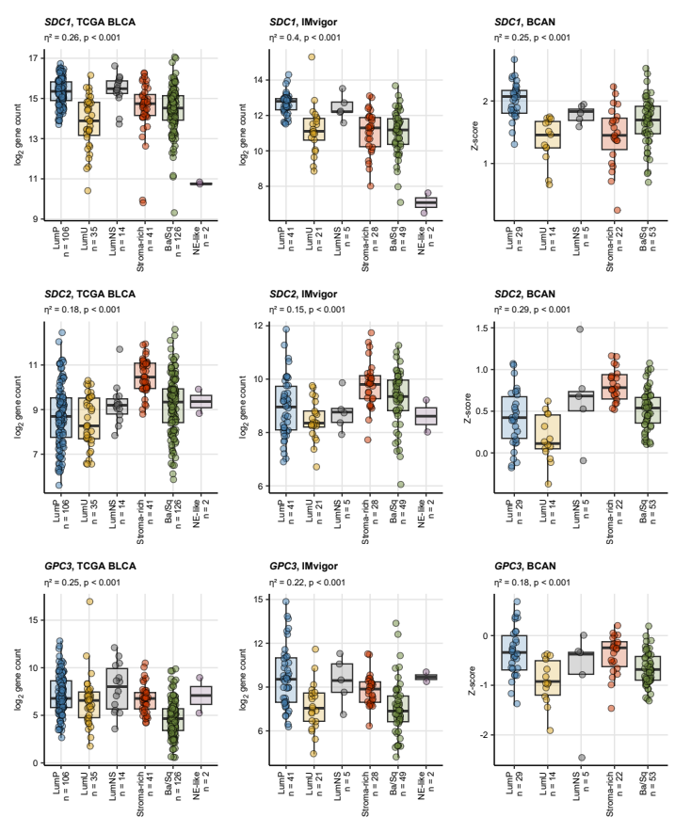

Figure 31: Differential expression of FGFBP-coding genes in the consensus molecular classes of urothelial cancers.

**Figure 31. Differential expression of FGFBP-coding genes in the consensus molecular classes of urothelial cancers.**

*Assignment of cancer samples from the TCGA BLCA, IMvigor, and BCAN to the consensus molecular classes was presented in Figure 26. Differences in log2-transformed mRNA levels of FGFR-, FGF-, and FGFBP-coding genes between the consensus molecular classes were assessed as presented in Figure 28. P values were corrected for multiple testing with the false discovery rate method.*

*Expression of SDC1, SDC2, and GPC3 was found to differ significantly between the consensus classes in at least two cohorts. Median log2-transformed mRNA levels with interquartile ranges are depicted as boxes with whiskers spanning over 150% of the interquartile ranges. Single cancer samples are visualized as points. Effect sizes and ANOVA p values are displayed in the plot captions. Numbers of cancer samples in the consensus classes are indicated in the X axes.*

*LumP: luminal papillary; LumU: luminal genetically unstable; LumNS: luminal non-specified; Stroma-rich: luminal stroma-rich; Ba/Sq: basal/squamous-like; NE-like: neuroendocrine-like.*

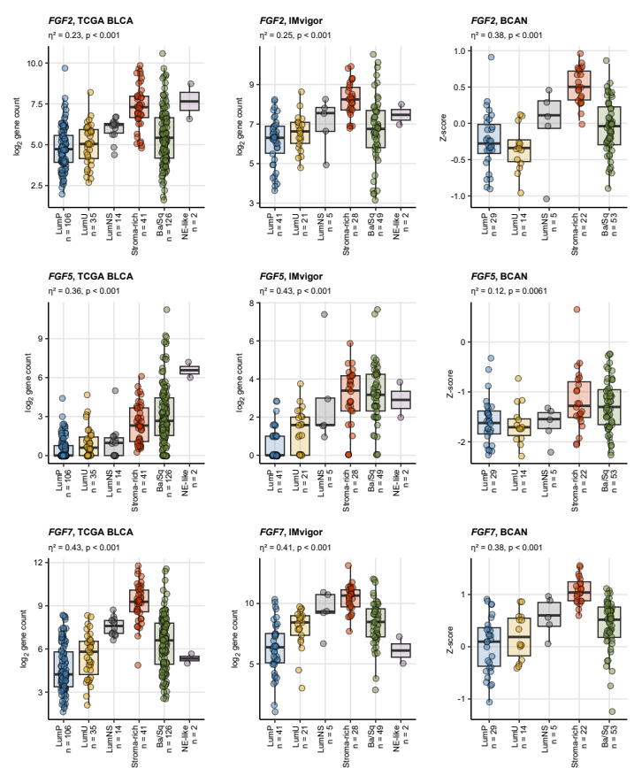

Figure 32: Differential expression of FGF-coding genes in the consensus molecular classes of urothelial cancers.

**Figure 32. Differential expression of FGF-coding genes in the consensus molecular classes of urothelial cancers.**

*Assignment of cancer samples from the TCGA BLCA, IMvigor, and BCAN to the consensus molecular classes was presented in Figure 26. Differences in log2-transformed mRNA levels of FGFR-, FGF-, and FGFBP-coding genes between the consensus molecular classes were assessed as presented in Figure 28. P values were corrected for multiple testing with the false discovery rate method.*

*Expression of FGF2, FGF5, and FGF7 was found to differ significantly between the consensus classes in at least two cohorts. Median log2-transformed mRNA levels with interquartile ranges are depicted as boxes with whiskers spanning over 150% of the interquartile ranges. Single cancer samples are visualized as points. Effect sizes and ANOVA p values are displayed in the plot captions. Numbers of cancer samples in the consensus classes are indicated in the X axes.*

*LumP: luminal papillary; LumU: luminal genetically unstable; LumNS: luminal non-specified; Stroma-rich: luminal stroma-rich; Ba/Sq: basal/squamous-like; NE-like: neuroendocrine-like.*

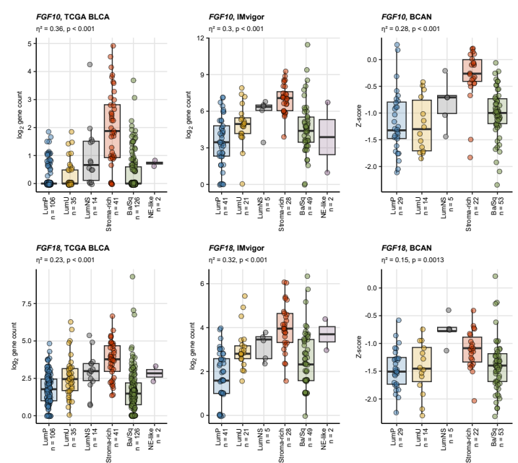

Figure 33: Differential expression of FGF-coding genes in the consensus molecular classes of urothelial cancers.

**Figure 33. Differential expression of FGF-coding genes in the consensus molecular classes of urothelial cancers.**

*Assignment of cancer samples from the TCGA BLCA, IMvigor, and BCAN to the consensus molecular classes was presented in Figure 26. Differences in log2-transformed mRNA levels of FGFR-, FGF-, and FGFBP-coding genes between the consensus molecular classes were assessed as presented in Figure 28. P values were corrected for multiple testing with the false discovery rate method.*

*Expression of FGF10 and FGF18 was found to differ significantly between the consensus classes in at least two cohorts. Median log2-transformed mRNA levels with interquartile ranges are depicted as boxes with whiskers spanning over 150% of the interquartile ranges. Single cancer samples are visualized as points. Effect sizes and ANOVA p values are displayed in the plot captions. Numbers of cancer samples in the consensus classes are indicated in the X axes.*

*LumP: luminal papillary; LumU: luminal genetically unstable; LumNS: luminal non-specified; Stroma-rich: luminal stroma-rich; Ba/Sq: basal/squamous-like; NE-like: neuroendocrine-like.*

## Differences in expression levels of FGFR-, FGF-, and FGFBP-coding genes emulate consensus molecular subsets of urothelial cancers

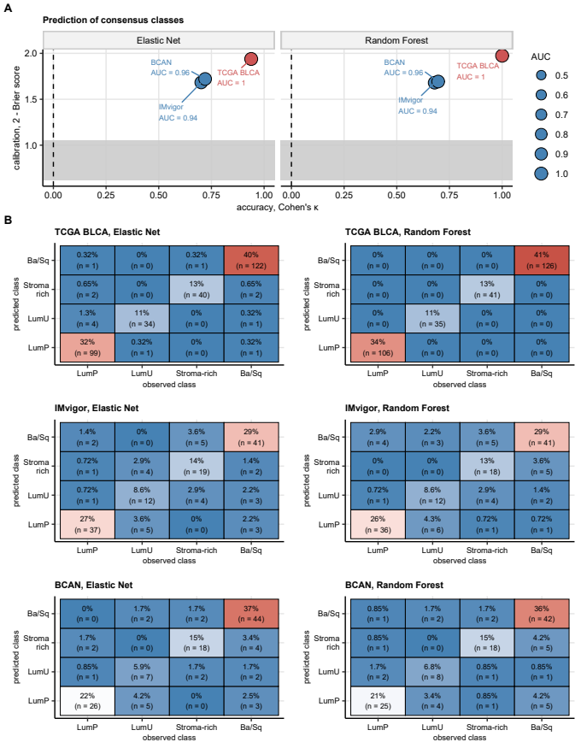

Figure 34: Prediction of molecular consensus classes of urothelial cancer by machine learning models which use expression of FGFR-, FGF-, and FGFBP-coding genes as the sole explanatory factors.

**Figure 34. Prediction of molecular consensus classes of urothelial cancer by machine learning models which use expression of FGFR-, FGF-, and FGFBP-coding genes as the sole explanatory factors.**

*Assignment of urothelial cancer samples in the TCGA BLCA, IMvigor, and BCAN cohorts to the major consensus molecular subsets (LumP, LumU, Stroma-rich, and Ba/Sq) was modeled by two independent machine learning algorithms, Elastic Net linear regression and Random Forest tree ensemble, with ComBat-processed $log_{2}$-transformed expression levels of genes coding for FGFR, FGF, and FGFBP proteins as the explanatory variables. The models were optimized (tuned) and trained in a synthetic data set derived from the TCGA BLCA collective with expansion (oversampling) of observations in the LumU and stroma-rich classes by the SMOTE algorithm.* *Performance of the models was evaluated in the non-modified TCGA BLCA data set as well as in the IMvigor and BCAN independent validation collectives; assignment to the classes by the nearest centroid classifier from consensusMIBC R package served as the ground truth.*

*(A) Numeric statistics of overall non-accidental model accuracy (Cohen’s $κ$, high values expected for a highly accurate model), overall calibration (Brier score, low scores expected for a well calibrated model), as well as sensitivity and specificity (AUC, area under the receiver-operating characteristic curve) are presented in a dot plot. Point size corresponds to AUC. Data points are labeled with the cohort names and AUC values. The dashed lines and gray regions visualize $κ$ values expected for a model that assigns to consensus molecular classes by chance.*

*(B) Accuracy of the models in particular consensus molecular classes shown in heat map representations of confusion matrices. Fields at the diagonals represent correctly classified cancer samples. The heat map tiles are labeled with percentages of all cancer samples and cancer sample counts.*

*LumP: luminal papillary; LumU: luminal genetically unstable; Stroma-rich: luminal stroma-rich; Ba/Sq: basal/squamous-like.*

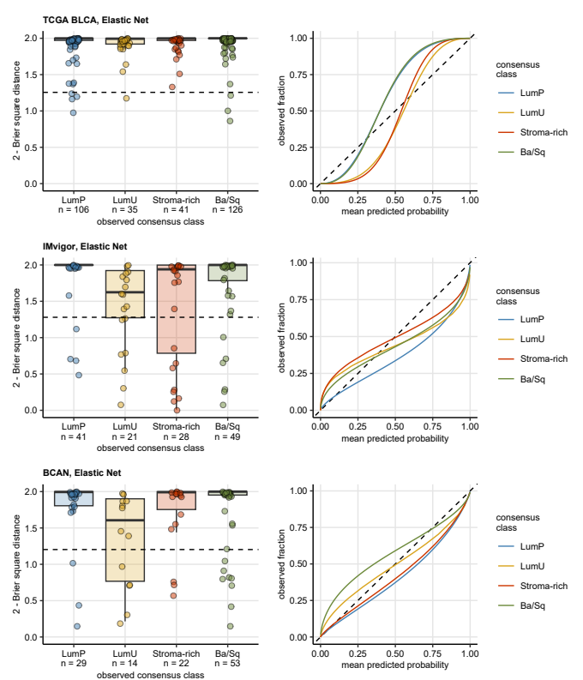

Figure 35: Calibration of the Elastic Net model of consensus molecular classes of urothelial cancers.

**Figure 35. Calibration of the Elastic Net model of consensus molecular classes of urothelial cancers.**

*The machine learning models of consensus molecular subsets with expression of FGFR-, FGF, and FGFBP genes as the sole explanatory factors were trained in a TCGA BLCA-derived data set and evaluated in the TCGA BLCA, IMvigor, and BCAN cohorts as presented in Figure 34.* *In analyses of calibration of the models, assignment to the classes by the nearest centroid classifier from consensusMIBC R package served as the ground truth.*

*Calibration of the Elastic Net model in particular consensus molecular classes was assessed by squares of differences between the predicted class probability and the actual class assignment (Brier squares). Those square distances are visualized in box plots (left), where medians with interquartile ranges are depicted as boxes with whiskers spanning over 150% of the interquartile ranges; single cancer samples are shown as points. The dashed lines represent values of Brier squares expected for a random class assignment.*

*Additionally, calibration of the Elastic Net model was investigated by modeling of the logistic relationship between mean predicted probabilities of class assignment and fractions of samples in the class. The logistic calibration curves for particular consensus classes are presented (right); line color codes for the actual consensus molecular class, the dashed lines represent ideal calibration.*

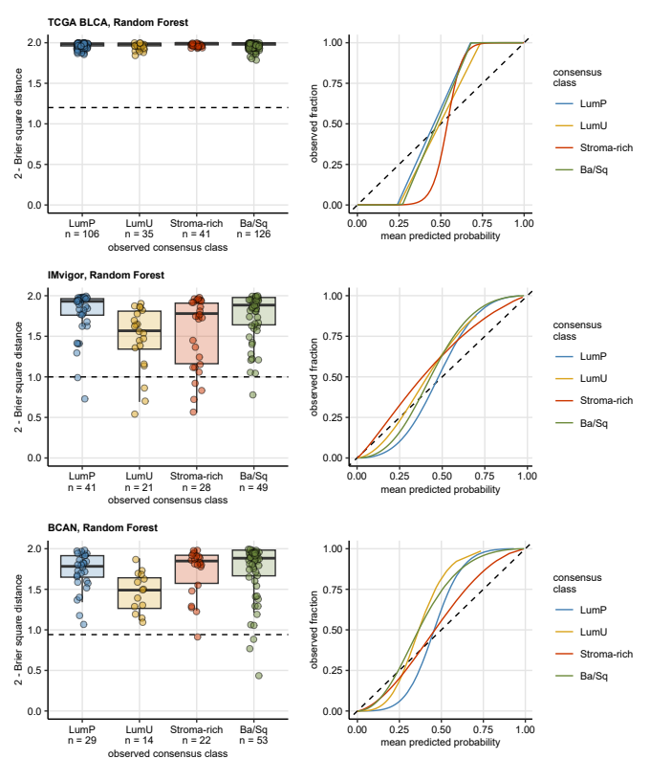

Figure 36: Calibration of the Random Forest model of consensus molecular classes of urothelial cancers.

**Figure 36. Calibration of the Random Forest model of consensus molecular classes of urothelial cancers.**

*The machine learning models of consensus molecular subsets with expression of FGFR-, FGF, and FGFBP genes as the sole explanatory factors were trained in a TCGA BLCA-derived data set and evaluated in the TCGA BLCA, IMvigor, and BCAN cohorts as presented in Figure 34.* *In analyses of calibration of the models, assignment to the classes by the nearest centroid classifier from consensusMIBC R package served as the ground truth.*

*Calibration of the Random Forest model in particular consensus molecular classes was assessed by squares of differences between the predicted class probability and the actual class assignment (Brier squares). Those square distances are visualized in box plots (left), where medians with interquartile ranges are depicted as boxes with whiskers spanning over 150% of the interquartile ranges; single cancer samples are shown as points. The dashed lines represent values of Brier squares expected for a random class assignment.*

*Additionally, calibration of the Random Forest model was investigated by modeling of the logistic relationship between mean predicted probabilities of class assignment and fractions of samples in the class. The logistic calibration curves for particular consensus classes are presented (right); line color codes for the actual consensus molecular class, the dashed lines represent ideal calibration.*

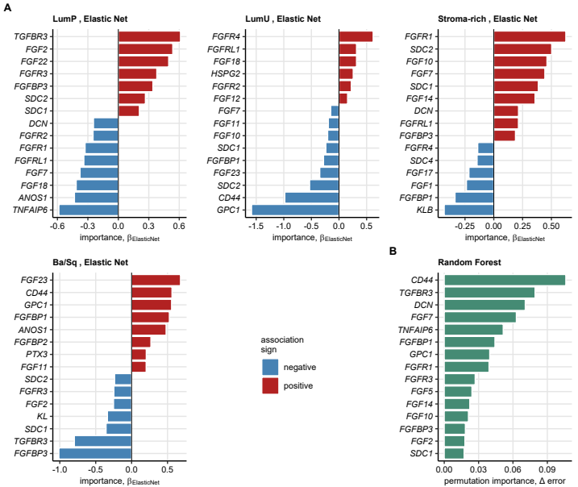

Figure 37: Importance of explanatory variables in the Elastic Net model of molecular consensus classes of urothelial cancers.

**Figure 37. Importance of explanatory variables in the Elastic Net model of molecular consensus classes of urothelial cancers.**

*The machine learning models of consensus molecular subsets with expression of FGFR-, FGF, and FGFBP genes as the sole explanatory factors were trained in a TCGA BLCA-derived data set as presented in Figure 34.* *In the Elastic Net model, absolute values of the coefficient’s $β$ translate directly to variable importance measure; high $abs\left(β\right)$ is expected for a highly influential variable for prediction of a subset. $β$ values for the top 15 most influential explanatory variables in the Elastic Net model are presented as bar plots in (A).* *For the Random Forest model, permutation importance of explanatory variables was computed as difference in out-of-bag classification errors between the genuine model and a model with the variable of interest re-shuffled at random. The differences in classification errors for the top 15 most influential explanatory variables of the Random Forest model are presented in a bar plot in (B).*

Table 11: Performance of Elastic Net and Random Forest models of LumP, LUMU, stroma-rich, and BA/Sq consensus molecular classes of urothelial cancers that uses expression of FGFR-, FGF-, and FGFBP-coding genes as the sole explanatory factors. The models were trained in the TCGA BLCA cohort, the gene expression values were ComBat-processed to minimize inter-cohort variability. Minority consensus classes were amplified by the SMOTE algorithm to improve their identification by the model. The models were evaluated in the TCBA BLCA, IMvigor, and BCAN cohorts; the consensus class assignment predicted by a nearest centroid algorithm from consensusMIBC package served as the ground truth. Metrics of model accuracy, calibration, and receiver-operating characteristic are listed.

| **Algorithm** | **Cohort** | **Accuracya** | **Kappab** | **Brier scorec** | **AUCd** | **Mean sensitivityd** | **Mean specificityd** |
| --- | --- | --- | --- | --- | --- | --- | --- |
| Elastic Net | TCGA BLCA | 0.96 | 0.94 | 0.061 | 1.00 | 0.96 | 0.99 |
| IMvigor | 0.78 | 0.70 | 0.320 | 0.94 | 0.75 | 0.93 |
| BCAN | 0.81 | 0.72 | 0.280 | 0.96 | 0.76 | 0.93 |
| Random Forest | TCGA BLCA | 1.00 | 1.00 | 0.026 | 1.00 | 1.00 | 1.00 |
| IMvigor | 0.77 | 0.68 | 0.320 | 0.94 | 0.73 | 0.92 |
| BCAN | 0.79 | 0.70 | 0.310 | 0.96 | 0.76 | 0.93 |
| aFraction of observations correctly assigned to molecular consensus classes. | | | | | | | |
| bCohen's κ. Non-accidental concordance between the actual and predicted molecular class assignment. | | | | | | | |
| cMeasure of overall model calibration. | | | | | | | |
| dReceiver-operating characteristic (ROC). AUC: area under the ROC curve. | | | | | | | |

Table 12: Coefficients of the Elastic Net model of consensus molecular classes of urothelial cancers. The Elastic Net model was developed in the TCGA BLCA cohort with expression values of genes coding for FGFR, FGF, and FGFBP proteins as the sole explanatory factors. Values of beta of the coefficients are listed.

| **Variable** | **LumP** | **LumU** | **Stroma-rich** | **Ba/Sq** |
| --- | --- | --- | --- | --- |
| *FGF1* | 0 | 0.0197 | -0.237 | 0 |
| *FGF2* | 0.536 | 0 | 0 | -0.252 |
| *FGF5* | 0 | 0 | 0 | 0.121 |
| *FGF7* | -0.377 | -0.149 | 0.443 | 0.0829 |
| *FGF9* | 0.0288 | -0.0267 | 0.0095 | -0.0117 |
| *FGF10* | 0 | -0.205 | 0.461 | 0 |
| *FGF11* | 0 | -0.193 | 0 | 0.202 |
| *FGF12* | 0 | 0.155 | -0.0118 | 0 |
| *FGF13* | 0.198 | 0 | 0 | 0 |
| *FGF14* | -0.0613 | -0.0657 | 0.358 | 0 |
| *FGF17* | 0 | 0.127 | -0.216 | 0 |
| *FGF18* | -0.415 | 0.317 | 0.0118 | 0 |
| *FGF22* | 0.496 | 0 | 0 | -0.1 |
| *FGF23* | 0 | -0.348 | 0 | 0.681 |
| *FGFR1* | -0.327 | 0 | 0.625 | 0 |
| *FGFR2* | -0.249 | 0.223 | -0.0468 | 0.073 |
| *FGFR3* | 0.379 | -0.097 | 0 | -0.247 |
| *FGFR4* | 0 | 0.619 | -0.139 | -0.181 |
| *FGFRL1* | -0.339 | 0.317 | 0.214 | -0.192 |
| *TGFBR3* | 0.612 | 0 | 0 | -0.797 |
| *FGFBP1* | 0.0909 | -0.28 | -0.336 | 0.525 |
| *FGFBP2* | -0.0457 | 0 | 0 | 0.269 |
| *FGFBP3* | 0.341 | 0 | 0.188 | -1.01 |
| *KL* | 0 | 0.117 | 0 | -0.337 |
| *KLB* | 0 | 0 | -0.43 | 0 |
| *PTX3* | -0.174 | 0 | 0 | 0.204 |
| *SDC1* | 0.207 | -0.238 | 0.386 | -0.356 |
| *SDC2* | 0.266 | -0.532 | 0.503 | -0.237 |
| *SDC4* | 0 | 0.107 | -0.145 | 0 |
| *DCN* | -0.245 | 0 | 0.214 | 0 |
| *CD44* | 0 | -0.981 | 0 | 0.562 |
| *HSPG2* | 0 | 0.258 | 0 | -0.076 |
| *GPC1* | 0 | -1.58 | 0 | 0.557 |
| *GPC3* | 0.168 | -0.0242 | 0.00239 | -0.147 |
| *GPC4* | 0.131 | 0 | -0.0519 | 0 |
| *TNFAIP6* | -0.585 | 0 | 0 | 0 |
| *FIBP* | 0 | 0 | 0 | -0.154 |
| *ANOS1* | -0.432 | 0.0179 | -0.0661 | 0.48 |

Table 13: Permutation variable importance of the Random Forest model of consensus molecular classes of urothelial cancers. The Random Forest model was developed in the TCGA BLCA cohort with expression values of genes coding for FGFR, FGF, and FGFBP proteins as the sole explanatory factors. Permutation importance was computed as differences of errors of the genuine model and models, in which the explanatory variables were re-shuffled at random.

| **Varaible** | **Permutation importance** |
| --- | --- |
| *CD44* | 0.11 |
| *TGFBR3* | 0.079 |
| *DCN* | 0.071 |
| *FGF7* | 0.063 |
| *TNFAIP6* | 0.051 |
| *FGFBP1* | 0.044 |
| *GPC1* | 0.04 |
| *FGFR1* | 0.039 |
| *FGFR3* | 0.027 |
| *FGF5* | 0.024 |
| *FGF14* | 0.022 |
| *FGF10* | 0.021 |
| *FGFBP3* | 0.018 |
| *FGF2* | 0.018 |
| *SDC1* | 0.017 |
| *SDC2* | 0.017 |
| *FGFR4* | 0.017 |
| *FGF18* | 0.015 |
| *KL* | 0.012 |
| *ANOS1* | 0.012 |
| *FGF9* | 0.011 |
| *HSPG2* | 0.011 |
| *PTX3* | 0.0088 |
| *FGF1* | 0.0087 |
| *GPC3* | 0.008 |
| *FGFRL1* | 0.0073 |
| *FGF17* | 0.0058 |
| *FGFR2* | 0.0056 |
| *KLB* | 0.0053 |
| *FGF13* | 0.0047 |
| *GPC4* | 0.0043 |
| *FGFBP2* | 0.0042 |
| *FGF11* | 0.004 |
| *FGF12* | 0.004 |
| *SDC4* | 0.0029 |
| *FIBP* | 0.0021 |
| *FGF22* | 0.0017 |
| *FGF23* | 0.00081 |

## Prognostic significance of differential expression of FGFR-, FGF-, and FGF-coding genes

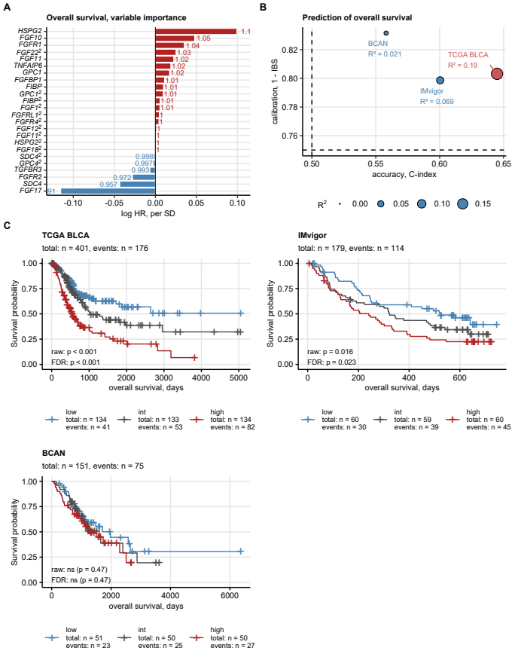

Figure 38: Development and evaluation of an Elastic Net Cox model of overall survival with expression of FGFR-, FGF-, and FGFBP-coding genes as explanatory factors.

**Figure 38. Development and evaluation of an Elastic Net Cox model of overall survival with expression of FGFR-, FGF-, and FGFBP-coding genes as explanatory factors.**

*Overall survival was modeled as a function of expression of genes coding for FGFR, FGF, and FGFBP proteins by Elastic Net Cox regression. The Elastic Net model was trained in the TCGA BLCA cohort; first- and second-order terms of ComBat-processed $log_{2}$-transformed expression levels of the genes of interest served as explanatory factors. Performance of the model was evaluated in the training data set as well as in the IMvigor and BCAN independent validation collectives.*

*(A) Non-zero coefficients of the Elastic Net Cox model represented by hazard ratios (HR), i.e. fold-difference in risk per one standard deviation of $log_{2}$ gene expression value.*

*(B) Numeric statistics of model accuracy (Harrell’s concordance index [C-index], high values expected for a highly accurate model), overall calibration (integrated Brier score [IBS], low values expected for a well calibrated models), and explanatory performance ($R^{2}$) shown in a dot plot. Points are labeled with the cohort names and $R^{2}$ values. Point size codes for $R^{2}$. The dashed lines represent values of C-index and IBS expected for a model that predicts survival at random.*

*(C) Overall survival in urothelial cancer patients stratified by tertiles of linear predictor scores of the Elastic Net model. Statistical significance of differences in survival between the tertiles is determined by Peto-Peto test corrected for multiple testing with the false discovery rate (FDR) method. Fractions of surviving patients are visualized with Kaplan-Meier plots. Total numbers of patients and deaths are displayed in the plot captions. Numbers of patients and deaths in the tertiles are indicated in the plot legends. Raw and FDR-corrected p values are shown in the plots.*

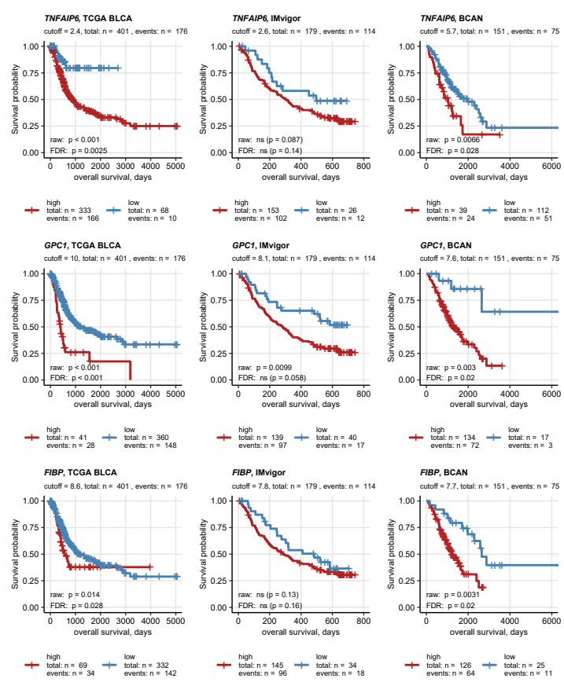

Figure 39: Candidate transcriptional markers of overall survival among the genes coding for FGFR, FGF, and FGFBP proteins.

**Figure 39. Candidate transcriptional markers of overall survival among the genes coding for FGFR, FGF, and FGFBP proteins.**

*Urothelial cancer patients in the TCGA BLCA, IMvigor, and BCAN cohorts were stratified by ComBat-processed -transformed expression levels of FGFR-, FGF-, and FGFBP-coding genes. The stratification cutoffs for division into high and low expressors were motivated by the maxima of log-rank statistic. Statistical significance of differences in overall survival between the high and low expressors was determined by Peto-Peto test adjusted for multiple comparison with the false discovery rate method (FDR). Candidate survival markers were identified by pFDR < 0.05 in at least two cohorts.*

*Fractions of surviving patients in the high and low expression strata of TNFAIP6, GPC1, and FIBP genes are presented in Kaplan-Meier plots. Stratification cutoffs, and total numbers of patients and deaths are displayed in the plot captions. Numbers of patients and deaths in the expression strata are indicated in the plot legends. Raw and FDR-adjusted p values are shown in the plots.*

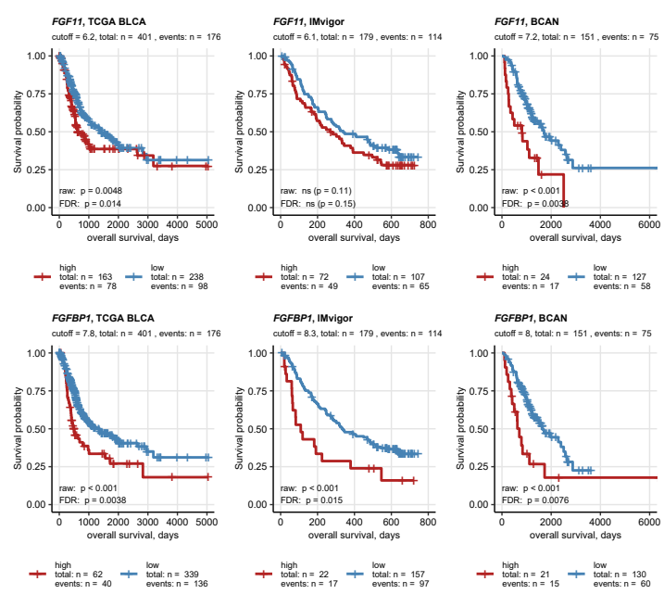

Figure 40: Candidate transcriptional markers of overall survival among the genes coding for FGFR, FGF, and FGFBP proteins.

**Figure 40. Candidate transcriptional markers of overall survival among the genes coding for FGFR, FGF, and FGFBP proteins.**

*Urothelial cancer patients in the TCGA BLCA, IMvigor, and BCAN cohorts were stratified by ComBat-processed -transformed expression levels of FGFR-, FGF-, and FGFBP-coding genes. The stratification cutoffs for division into high and low expressors were motivated by the maxima of log-rank statistic. Statistical significance of differences in overall survival between the high and low expressors was determined by Peto-Peto test adjusted for multiple comparison with the false discovery rate method (FDR). Candidate survival markers were identified by pFDR < 0.05 in at least two cohorts.*

*Fractions of surviving patients in the high and low expression strata of FGF11 and FGFBP1 genes are presented in Kaplan-Meier plots. Stratification cutoffs, and total numbers of patients and deaths are displayed in the plot captions. Numbers of patients and deaths in the expression strata are indicated in the plot legends. Raw and FDR-adjusted p values are shown in the plots.*

Table 14: Performance of an Elastic Net Cox model using expression of FGFR-, FGF-, and FGFBP-coding genes as explanatory factors at prediction of overall survival. The Elastic Net model was trained in the TCGA BLCA cohort with ComBat-processed log2-transformed expression values as firs- and second-order terms. Metrics of concordance, explanatory performance, and overall calibration are summarized.

| **Cohort** | **Patients, N** | **Events, N** | **Concordance index** | **R-square** | **Integrated Brier score** |
| --- | --- | --- | --- | --- | --- |
| TCGA BLCA | 401 | 176 | 0.64 | 0.19 | 0.2 |
| IMvigor | 179 | 114 | 0.6 | 0.069 | 0.2 |
| BCAN | 151 | 75 | 0.56 | 0.021 | 0.17 |

Table 15: Non-zero coefficients of the Elastic Net Cox model of overall survival with FGFR-, FGF-, and FGFBP-coding genes as explanatory factors.

| **Gene symbol** | **Term order** | **Coefficient beta** | **Hazard ratioa** |
| --- | --- | --- | --- |
| *HSPG2* | first | 0.0994 | 1.1 |
| *FGF10* | first | 0.048 | 1.05 |
| *FGFR1* | first | 0.0354 | 1.04 |
| *FGF22* | second | 0.0253 | 1.03 |
| *FGF11* | first | 0.0226 | 1.02 |
| *TNFAIP6* | first | 0.0189 | 1.02 |
| *GPC1* | first | 0.0174 | 1.02 |
| *FGFBP1* | first | 0.0113 | 1.01 |
| *FIBP* | first | 0.01 | 1.01 |
| *GPC1* | second | 0.00971 | 1.01 |
| *FIBP* | second | 0.00592 | 1.01 |
| *FGF1* | second | 0.00573 | 1.01 |
| *FGFRL1* | second | 0.00493 | 1 |
| *FGFR4* | second | 0.00447 | 1 |
| *FGF12* | second | 0.00161 | 1 |
| *FGF11* | second | 0.00091 | 1 |
| *HSPG2* | second | 0.000761 | 1 |
| *FGF18* | second | 0.000759 | 1 |
| *SDC4* | second | -0.00201 | 0.998 |
| *GPC4* | second | -0.00281 | 0.997 |
| *TGFBR3* | first | -0.00682 | 0.993 |
| *FGFR2* | first | -0.028 | 0.972 |
| *SDC4* | first | -0.0435 | 0.957 |
| *FGF17* | first | -0.115 | 0.891 |
| aFold-difference in risk for one standard deviation of log2 gene expression values. | | | |

Table 16: Univariable, model-free analysis of overall survival in urothelial cancer patients stratified by expression of FGFR-, FGF-, and FGFR-coding genes. Patients were stratified as low and high expressors of a gene by a cutoff value that corresponds to the maximum log rank statistics. Statistical significance of differences in overall survival between low and high expressors was determined by Peto-Peto test corrected for multiple comparisons with the false discovery rate (FDR) method. The stratification cutoffs, numbers of high and low expressors, numbers of events in the strata, median survival times with 95% confidence intervals, as well as raw and FDR-corrected p values are summarized. The results are shown for the genes with significant effects in at least two out of the TCGA, IMvigor, and BCAN cohorts.

| **Gene symbol** | **Cohort** | **Expression strata** | **Patients, N** | **Events, N** | **Median overall survival, days** | **Raw significance** | **FDR significance** |
| --- | --- | --- | --- | --- | --- | --- | --- |
| *FGF11* | BCAN | high | 24 | 17 | 810 [95% CI: 350 to NA] | p < 0.001 | p = 0.0038 |
| low | 127 | 58 | 1700 [95% CI: 1300 to 2600] | p < 0.001 | p = 0.0038 |
| IMvigor | high | 72 | 49 | 270 [95% CI: 190 to 390] | ns (p = 0.11) | ns (p = 0.15) |
| low | 107 | 65 | 340 [95% CI: 250 to 580] | ns (p = 0.11) | ns (p = 0.15) |
| TCGA BLCA | high | 163 | 78 | 620 [95% CI: 550 to 1000] | p = 0.0048 | p = 0.014 |
| low | 238 | 98 | 1400 [95% CI: 1000 to 2000] | p = 0.0048 | p = 0.014 |
| *FGFBP1* | BCAN | high | 21 | 15 | 710 [95% CI: 420 to NA] | p < 0.001 | p = 0.0076 |
| low | 130 | 60 | 1700 [95% CI: 1300 to 2600] | p < 0.001 | p = 0.0076 |
| IMvigor | high | 22 | 17 | 110 [95% CI: 64 to 550] | p < 0.001 | p = 0.015 |
| low | 157 | 97 | 330 [95% CI: 280 to 480] | p < 0.001 | p = 0.015 |
| TCGA BLCA | high | 62 | 40 | 510 [95% CI: 390 to 1000] | p < 0.001 | p = 0.0038 |
| low | 339 | 136 | 1300 [95% CI: 940 to 2000] | p < 0.001 | p = 0.0038 |
| *FIBP* | BCAN | high | 126 | 64 | 1200 [95% CI: 1000 to 1700] | p = 0.0031 | p = 0.02 |
| low | 25 | 11 | 2600 [95% CI: 2300 to NA] | p = 0.0031 | p = 0.02 |
| IMvigor | high | 145 | 96 | 290 [95% CI: 210 to 400] | ns (p = 0.13) | ns (p = 0.16) |
| low | 34 | 18 | 480 [95% CI: 270 to NA] | ns (p = 0.13) | ns (p = 0.16) |
| TCGA BLCA | high | 69 | 34 | 570 [95% CI: 450 to NA] | p = 0.014 | p = 0.028 |
| low | 332 | 142 | 1300 [95% CI: 940 to 1900] | p = 0.014 | p = 0.028 |
| *GPC1* | BCAN | high | 134 | 72 | 1300 [95% CI: 1100 to 1700] | p = 0.003 | p = 0.02 |
| low | 17 | 3 |  | p = 0.003 | p = 0.02 |
| IMvigor | high | 139 | 97 | 280 [95% CI: 200 to 350] | p = 0.0099 | ns (p = 0.058) |
| low | 40 | 17 |  | p = 0.0099 | ns (p = 0.058) |
| TCGA BLCA | high | 41 | 28 | 400 [95% CI: 270 to 590] | p < 0.001 | p < 0.001 |
| low | 360 | 148 | 1300 [95% CI: 950 to 2000] | p < 0.001 | p < 0.001 |
| *TNFAIP6* | BCAN | high | 39 | 24 | 1000 [95% CI: 710 to NA] | p = 0.0066 | p = 0.028 |
| low | 112 | 51 | 2000 [95% CI: 1500 to 2600] | p = 0.0066 | p = 0.028 |
| IMvigor | high | 153 | 102 | 300 [95% CI: 240 to 400] | ns (p = 0.087) | ns (p = 0.14) |
| low | 26 | 12 | 500 [95% CI: 240 to NA] | ns (p = 0.087) | ns (p = 0.14) |
| TCGA BLCA | high | 333 | 166 | 870 [95% CI: 710 to 1300] | p < 0.001 | p = 0.0025 |
| low | 68 | 10 |  | p < 0.001 | p = 0.0025 |

## Genetic subsets of urothelial carcinoma

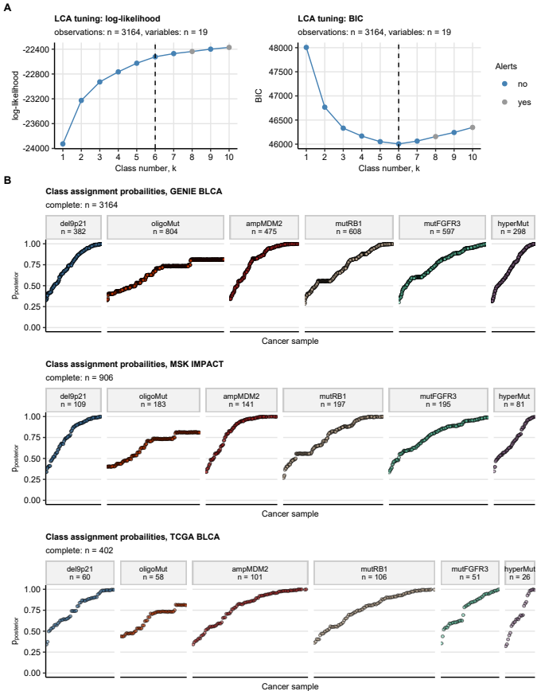

Figure 41: Development of genetic subsets of urothelial carcinoma in the GENIE BLCA training cohort. Prediction of the genetic subset assignment for the MSK and TCGA BLCA samples.

**Figure 41. Development of genetic subsets of urothelial carcinoma in the GENIE BLCA training cohort. Prediction of the genetic subset assignment for the MSK and TCGA BLCA cohort samples.**

*The genetic subsets of urothelial cancers were developed in the GENIE BLCA training cohort by latent class modeling with binary indexes (presence/absence) of genetic alterations present in at least 5% of samples as modeling factors. Presence of FGF3, FGF4, FGF19, or CCND1 amplification was subsumed under 11q13 amplification prior to the modeling. Presence of CDKN2A, CDKN2B, or MTAP deletions was subsumed under 9p21 deletion prior to the modeling.*

*(A) Selection of the genetic subset number in the GENIE BLCA training cohort based on log-likelihood and Bayesian Information Criterion (BIC). Note the minimal BIC for the 6-class model, which is subsequently used for definition of the genetic subsets.*

*(B) The 6-class model was trained in the GENIE BLCA cohort and used for assignment of cancer samples from the MSK IMPACT and TCGA BLCA test collectives to the genetic subsets. Class assignment probabilities (posterior p) of single cancer samples are visualized in scatter plots. Note that high posterior p indicate high confidence at class assignment and stability of the modeling solution. Total observation numbers are displayed in the plot captions. Numbers of samples in the genetic subsets are indicated in the plot facets.*

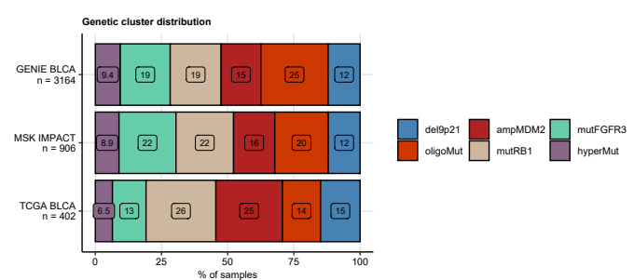

Figure 42: Distribution of sizes of the genetic subsets in the training GENIE BLCA cohort, and the MSK and TCGA BLCA test collectives.

**Figure 42. Distribution of sizes of the genetic subsets in the training GENIE BLCA cohort, and the MSK and TCGA BLCA test collectives.**

*Genetic subsets were developed in the GENIE BLCA cohort and predicted for cancers samples in the MSK IMPACT and TCGA BLCA collectives as presented in Figure 41. Sizes of the genetic subsets expressed as percentages of cancer samples in the cohort are presented in a stack plot.*

Table 17: Frequency of the most frequent somatic mutations and copy number alterations in the genetic subsets of urothelial cancers. The frequencies are presented as percentages of samples with genetic alterations in the genetic subsets. Differences between the genetic subsets were assessed by chi-squared test with Cramer's V effect size statistic. P values were corrected for multiple testing with the false discovery rate method. The table is available as a supplementary Excel file.

|  |
| --- |
|  |

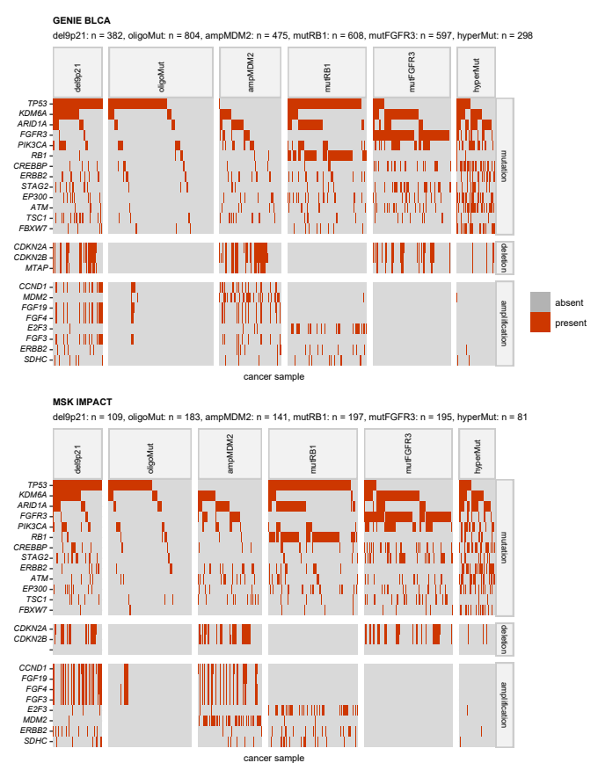

Figure 43: Distribution of the most frequent somatic mutations and copy number alterations in the genetic subsets of urothelial cancers in the GENIE BLCA and MSK cohorts.

**Figure 43. Distribution of the most frequent somatic mutations and copy number alterations in the genetic subsets of urothelial cancers in the GENIE BLCA and MSK cohorts.**

*Differences in frequency of the most common somatic mutations and copy number variants ( $≥$ 5% of samples) between the genetic subsets of urothelial cancers were assessed by test with Cramer’s V effect size statistic. P values were corrected for multiple testing with the false discovery rate method. Presence of the genetic features in the genetic subsets was presented in a heat map. Significant alterations are highlighted in the Y axis with bold font. Numbers of analyzed cancer samples in the subsets are displayed in the plot captions.*

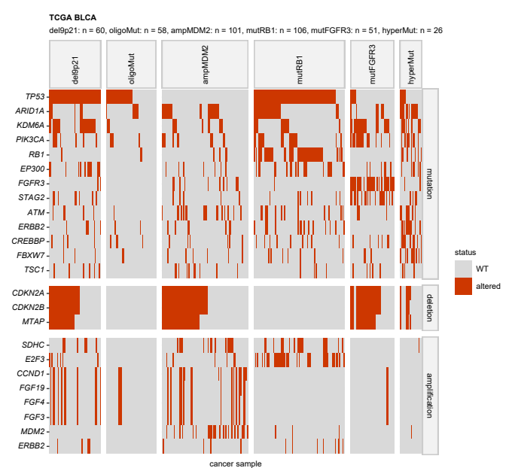

Figure 44: Distribution of the most frequent somatic mutations and copy number alterations in the genetic subsets of urothelial cancers in the TCGA BLCA cohort.

**Figure 44. Distribution of the most frequent somatic mutations and copy number alterations in the genetic subsets of urothelial cancers in the TCGA BLCA cohort.**

*Differences in frequency of the most common somatic mutations and copy number variants ( $≥$ 5% of samples) between the genetic subsets of urothelial cancers were assessed by test with Cramer’s V effect size statistic. P values were corrected for multiple testing with the false discovery rate method. Presence of the genetic features in the genetic subsets was presented in a heat map. Significant alterations are highlighted in the Y axis with bold font. Numbers of analyzed cancer samples in the subsets are displayed in the plot captions.*

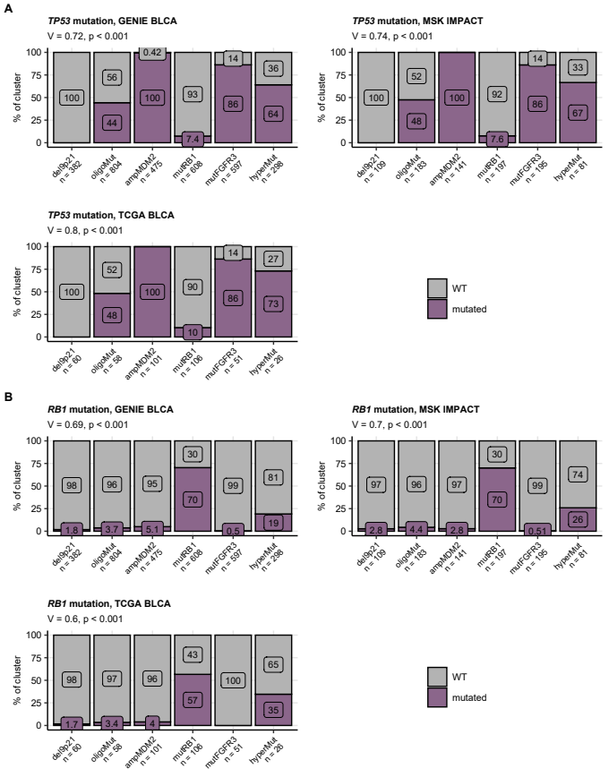

Figure 45: Frequency of somatic mutations of TP53 and RB1 in the genetic subsets of urothelial cancers.

**Figure 45. Frequency of somatic mutations of TP53 and RB1 in the genetic subsets of urothelial cancers.**

*Differences in frequency of TP53 and RB1 mutations between the genetic subsets of urothelial cancers were assessed by $χ^{2}$ test with Cramer’s V effect size statistic. P values were corrected for multiple testing with the false discovery rate method. Percentages of the mutations in the genetic subsets are presented in stack plots. Effect sizes and p values are displayed in the plot captions. Numbers of cancer samples in the subsets are indicated in the X axes.*

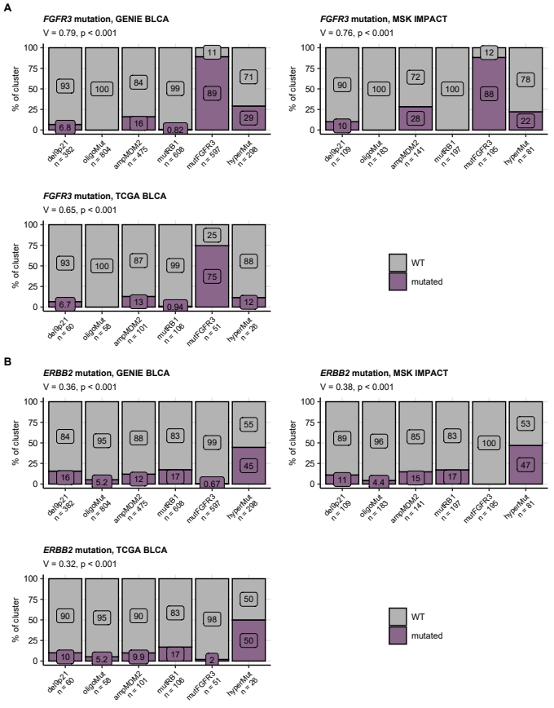

Figure 46: Frequency of somatic mutations of FGFR3 and ERBB2 in the genetic subsets of urothelial cancers.

**Figure 46. Frequency of somatic mutations of FGFR3 and ERBB2 in the genetic subsets of urothelial cancers.**

*Differences in frequency of FGFR3 and ERBB2 mutations between the genetic subsets of urothelial cancers were assessed by $χ^{2}$ test with Cramer’s V effect size statistic. P values were corrected for multiple testing with the false discovery rate method. Percentages of the mutations in the genetic subsets are presented in stack plots. Effect sizes and p values are displayed in the plot captions. Numbers of cancer samples in the subsets are indicated in the X axes.*

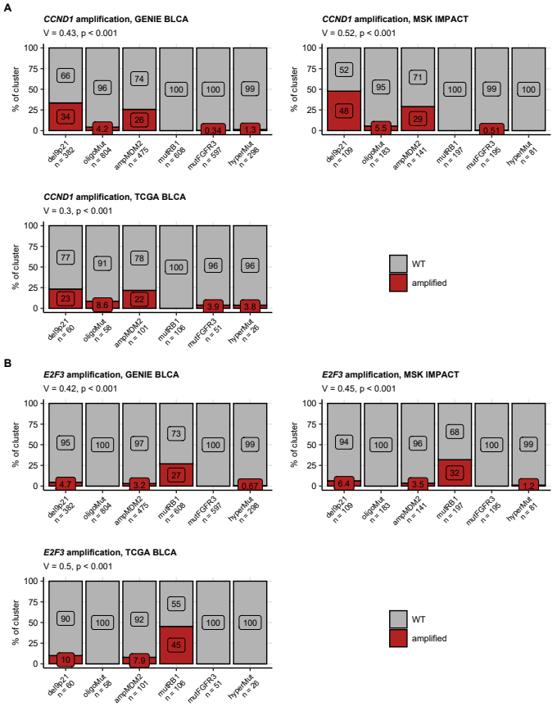

Figure 47: Frequency of amplifications of CCND1 and E3F3 in the genetic subsets of urothelial cancers.

**Figure 47. Frequency of amplifications of CCND1 and E3F3 in the genetic subsets of urothelial cancers.**

*Differences in frequency of CCND1 (hallmark alteration for 11q13 chromosome region amplification) and E2F3 amplifications between the genetic subsets of urothelial cancers were assessed by $χ^{2}$ test with Cramer’s V effect size statistic. P values were corrected for multiple testing with the false discovery rate method. Percentages of the copy number variants in the genetic subsets are presented in stack plots. Effect sizes and p values are displayed in the plot captions. Numbers of cancer samples in the subsets are indicated in the X axes.*

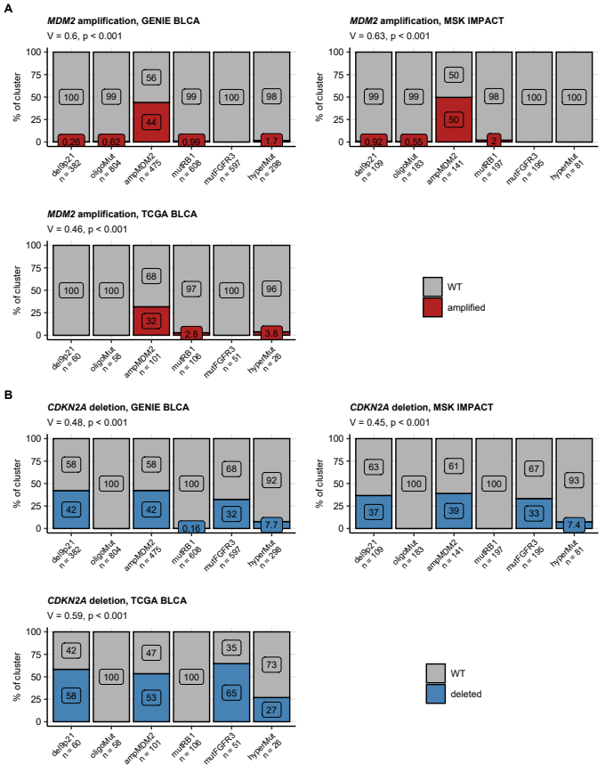

Figure 48: Frequency of amplifications of MDM2 and deletions of CDKN2A in the genetic subsets of urothelial cancers.

**Figure 48. Frequency of amplifications of MDM2 and deletions of CDKN2A in the genetic subsets of urothelial cancers.**

*Differences in frequency of MDM2 amplifications and CDKN2A deletions (characteristic for 9p21 chromosome region deletion) between the genetic subsets of urothelial cancers were assessed by $χ^{2}$ test with Cramer’s V effect size statistic. P values were corrected for multiple testing with the false discovery rate method. Percentages of the copy number variants in the genetic subsets are presented in stack plots. Effect sizes and p values are displayed in the plot captions. Numbers of cancer samples in the subsets are indicated in the X axes.*

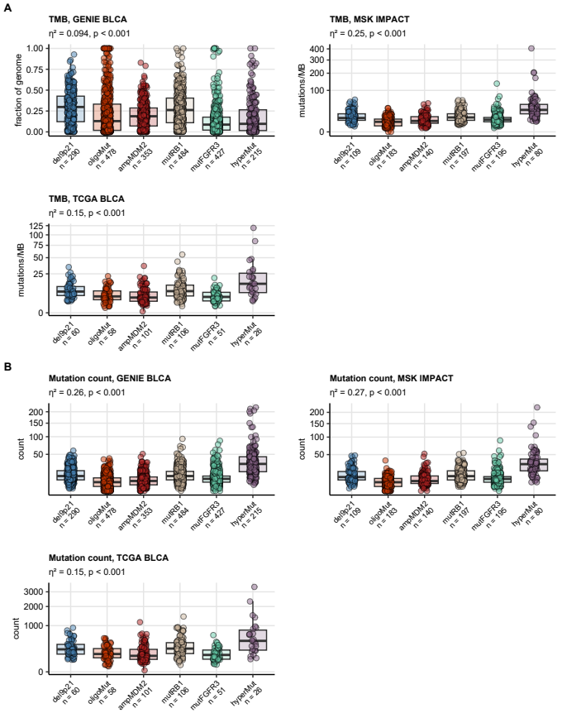

Figure 49: Total mutation burden and counts of mutations in protein-coding genes in the genetic subsets of urothelial cancers.

**Figure 49. Total mutation burden and counts of mutations in protein-coding genes in the genetic subsets of urothelial cancers.**

*Total mutation burdens (TMB) were provided for the GENIE BLCA, MSK IMPACT, and TCGA BLCA cohorts by the study authors. Counts of mutations were computed for each cancer sample based on the published information. TMB and counts of mutations were compared between the genetic subsets of urothelial cancers by Kruskal-Wallis test with $η^{2}$ effect size statistic. P values were adjusted for multiple testing with the false discovery rate method. Median values with interquartile ranges are shown as boxes with whiskers spanning over 150% of the interquartile ranges. Single cancer samples are visualized as points. Effect sizes and p values are displayed in the plot captions. Numbers of analyzed cancer samples are indicated in the X axes.*

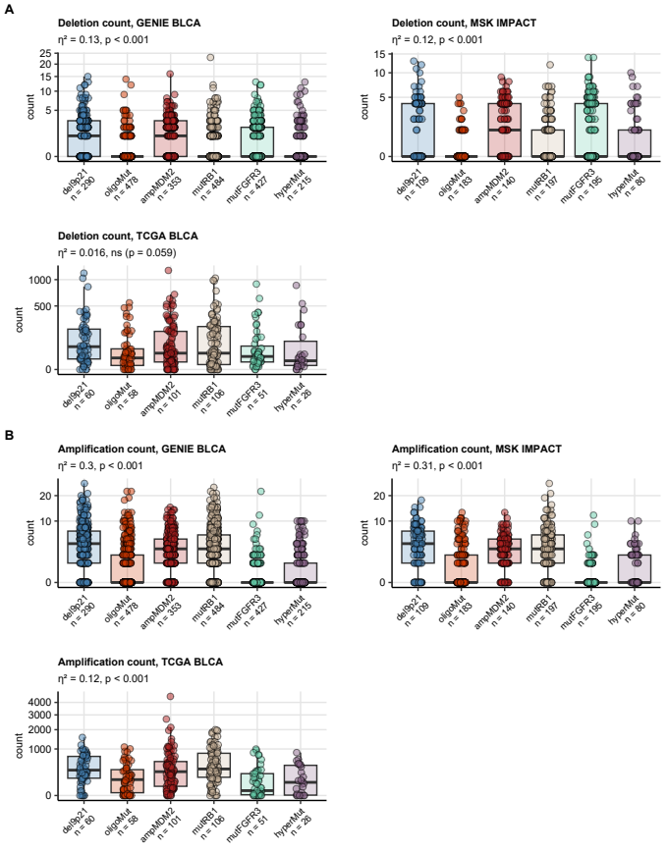

Figure 50: Counts of gene deletions and amplifications in the genetic subsets of urothelial cancers.

**Figure 50. Counts of gene deletions and amplifications in the genetic subsets of urothelial cancers.**

*Counts of deletions and amplifications were computed for cancer samples in the GENIE BLCA, MSK IMPACT, and TCGA BLCA based on the published information, and were compared between the genetic subsets of urothelial cancers by Kruskal-Wallis test with $η^{2}$ effect size statistic. P values were adjusted for multiple testing with the false discovery rate method. Median values with interquartile ranges are shown as boxes with whiskers spanning over 150% of the interquartile ranges. Single cancer samples are visualized as points. Effect sizes and p values are displayed in the plot captions. Numbers of analyzed cancer samples are indicated in the X axes.*

Table 18: Expression of FGF-, FGFR-, and FGFBP-coding genes in the genetic subsets of urothelial cancers of the TCGA BLCA cohort. log2-transformed expression levels are presented as medians with interquartile ranges and ranges. Statistical significance of differences between the genetic subsets was determined by one-way ANOVA with eta-square effect size statistic. P values were corrected for multiple testing with the false discovery rate method. The table is available as a supplementary Excel file.

|  |
| --- |
|  |

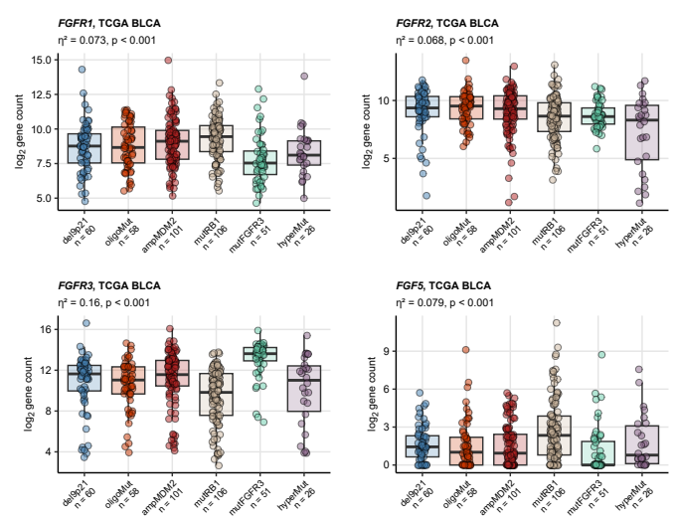

Figure 51: Differential expression of FGFR- and FGF-coding genes in the genetic subsets of urothelial cancers.

**Figure 51. Differential expression of FGFR- and FGF-coding genes in the genetic subsets of urothelial cancers.**

*Differences in log2-transformed mRNA levels of FGFR-, FGF-, and FGFBP-coding genes were compared between the genetic subsets of urothelial cancers in the TCGA BLCA cohort by one-way ANOVA with $η^{2}$ effect size statistic. Differences in expression of FGFR1, FGFR2, FGFR3, and FGF5 were found significant. Median log2-transformed expression values with interquartile ranges are depicted as boxes with whiskers spanning over 150% of the interquartile ranges. Single cancer samples are visualized as points. Effect sizes and p values are displayed in the plot captions. Numbers of analyzed cancer samples are indicated in the X axes.*

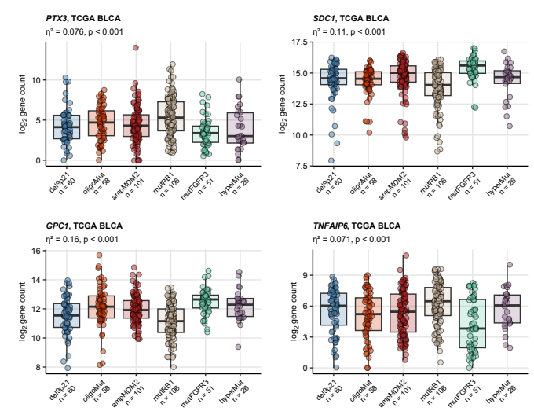

Figure 52: Differential expression of FGFBP-coding genes in the genetic subsets of urothelial cancers.

**Figure 52. Differential expression of FGFBP-coding genes in the genetic subsets of urothelial cancers.**

*Differences in log2-transformed mRNA levels of FGFR-, FGF-, and FGFBP-coding genes were compared between the genetic subsets of urothelial cancers in the TCGA BLCA cohort by one-way ANOVA with $η^{2}$ effect size statistic. Differences in expression of PTX3, SDC1, GPC1, and TNFAIP were found significant. Median log2-transformed expression values with interquartile ranges are depicted as boxes with whiskers spanning over 150% of the interquartile ranges. Single cancer samples are visualized as points. Effect sizes and p values are displayed in the plot captions. Numbers of analyzed cancer samples are indicated in the X axes.*

Table 19: Demographic, clinical, and pathological characteristic of the genetic subsets of urothelial cancers. Numeric features are presented as medians with interquartile ranges and ranges. Qualitative variables are shown as percentages and observation counts of the categories.

| **Cohort** | **Variable** | **del9p21** | **oligoMut** | **ampMDM2** | **mutRB1** | **mutFGFR3** | **hyperMut** | **Significancea** | **Effect sizea** |
| --- | --- | --- | --- | --- | --- | --- | --- | --- | --- |
| GENIE BLCA | Samples, N | 382 | 804 | 475 | 608 | 597 | 298 |  |  |
| Age | 70 [IQR: 64 - 78] range: 35 - 89 complete: n = 382 | 67 [IQR: 59 - 75] range: 18 - 89 complete: n = 802 | 70 [IQR: 63 - 76] range: 18 - 89 complete: n = 473 | 69 [IQR: 62 - 75] range: 25 - 89 complete: n = 607 | 69 [IQR: 62 - 76] range: 33 - 89 complete: n = 597 | 71 [IQR: 64 - 77] range: 18 - 89 complete: n = 298 | p < 0.001 | η² = 0.011 |
| Gender | female: 24% (93) male: 76% (289) complete: n = 382 | female: 29% (232) male: 71% (570) complete: n = 802 | female: 28% (131) male: 72% (342) complete: n = 473 | female: 21% (128) male: 79% (479) complete: n = 607 | female: 32% (191) male: 68% (406) complete: n = 597 | female: 24% (71) male: 76% (227) complete: n = 298 | p < 0.001 | V = 0.085 |
| Tissue | bladder: 85% (323) non-bladder: 15% (59) complete: n = 382 | bladder: 79% (633) non-bladder: 21% (171) complete: n = 804 | bladder: 81% (386) non-bladder: 19% (89) complete: n = 475 | bladder: 93% (564) non-bladder: 7.2% (44) complete: n = 608 | bladder: 79% (472) non-bladder: 21% (125) complete: n = 597 | bladder: 78% (232) non-bladder: 22% (66) complete: n = 298 | p < 0.001 | V = 0.14 |
| MSK IMPACT | Samples, N | 109 | 183 | 141 | 197 | 195 | 81 |  |  |
| Age | 65 [IQR: 59 - 73] range: 35 - 87 complete: n = 109 | 65 [IQR: 58 - 72] range: 28 - 87 complete: n = 183 | 67 [IQR: 60 - 72] range: 38 - 91 complete: n = 141 | 67 [IQR: 60 - 72] range: 37 - 92 complete: n = 197 | 65 [IQR: 56 - 72] range: 30 - 88 complete: n = 195 | 69 [IQR: 62 - 75] range: 31 - 89 complete: n = 81 | p = 0.038 | η² = 0.0082 |
| Gender | female: 25% (27) male: 75% (82) complete: n = 109 | female: 23% (43) male: 77% (140) complete: n = 183 | female: 19% (26) male: 81% (114) complete: n = 140 | female: 18% (36) male: 82% (161) complete: n = 197 | female: 34% (66) male: 66% (129) complete: n = 195 | female: 21% (17) male: 79% (64) complete: n = 81 | p = 0.0084 | V = 0.14 |
| Tissue | bladder: 99% (108) non-bladder: 0.92% (1) complete: n = 109 | bladder: 98% (180) non-bladder: 1.6% (3) complete: n = 183 | bladder: 96% (136) non-bladder: 3.5% (5) complete: n = 141 | bladder: 99% (196) non-bladder: 0.51% (1) complete: n = 197 | bladder: 96% (188) non-bladder: 3.6% (7) complete: n = 195 | bladder: 99% (80) non-bladder: 1.2% (1) complete: n = 81 | ns (p = 0.18) | V = 0.091 |
| Invasiveness | non-muscle invasive: 0% (0) muscle invasive: 100% (109) complete: n = 109 | non-muscle invasive: 4.9% (9) muscle invasive: 95% (174) complete: n = 183 | non-muscle invasive: 0.71% (1) muscle invasive: 99% (140) complete: n = 141 | non-muscle invasive: 0% (0) muscle invasive: 100% (197) complete: n = 197 | non-muscle invasive: 23% (44) muscle invasive: 77% (151) complete: n = 195 | non-muscle invasive: 2.5% (2) muscle invasive: 98% (79) complete: n = 81 | p < 0.001 | V = 0.36 |
| pT stage | T1: 0% (0) T2: 13% (14) T3: 86% (94) T4: 0.92% (1) complete: n = 109 | T1: 4.9% (9) T2: 19% (34) T3: 75% (137) T4: 1.6% (3) complete: n = 183 | T1: 0.71% (1) T2: 22% (31) T3: 76% (107) T4: 1.4% (2) complete: n = 141 | T1: 0% (0) T2: 5.6% (11) T3: 94% (186) T4: 0% (0) complete: n = 197 | T1: 23% (44) T2: 39% (76) T3: 37% (73) T4: 1% (2) complete: n = 195 | T1: 2.5% (2) T2: 30% (24) T3: 67% (54) T4: 1.2% (1) complete: n = 81 | p < 0.001 | V = 0.29 |
| TCGA BLCA | Samples, N | 60 | 58 | 101 | 106 | 51 | 26 |  |  |
| Age | 72 [IQR: 61 - 78] range: 44 - 90 complete: n = 60 | 64 [IQR: 58 - 74] range: 34 - 90 complete: n = 58 | 70 [IQR: 62 - 77] range: 43 - 90 complete: n = 101 | 69 [IQR: 62 - 77] range: 49 - 89 complete: n = 106 | 67 [IQR: 58 - 72] range: 42 - 86 complete: n = 51 | 70 [IQR: 64 - 76] range: 54 - 80 complete: n = 26 | ns (p = 0.26) | η² = 0.015 |
| Gender | female: 28% (17) male: 72% (43) complete: n = 60 | female: 31% (18) male: 69% (40) complete: n = 58 | female: 30% (30) male: 70% (71) complete: n = 101 | female: 25% (26) male: 75% (80) complete: n = 106 | female: 18% (9) male: 82% (42) complete: n = 51 | female: 19% (5) male: 81% (21) complete: n = 26 | ns (p = 0.86) | V = 0.1 |
| Invasiveness | non-muscle invasive: 0% (0) muscle invasive: 100% (55) complete: n = 55 | non-muscle invasive: 1.9% (1) muscle invasive: 98% (52) complete: n = 53 | non-muscle invasive: 0% (0) muscle invasive: 100% (93) complete: n = 93 | non-muscle invasive: 2% (2) muscle invasive: 98% (96) complete: n = 98 | non-muscle invasive: 2.1% (1) muscle invasive: 98% (46) complete: n = 47 | non-muscle invasive: 0% (0) muscle invasive: 100% (24) complete: n = 24 | ns (p = 0.86) | V = 0.098 |
| pT stage | T0: 0% (0) T1: 0% (0) T2: 44% (24) T3: 45% (25) T4: 11% (6) complete: n = 55 | T0: 1.9% (1) T1: 0% (0) T2: 28% (15) T3: 58% (31) T4: 11% (6) complete: n = 53 | T0: 0% (0) T1: 0% (0) T2: 31% (29) T3: 48% (45) T4: 20% (19) complete: n = 93 | T0: 0% (0) T1: 2% (2) T2: 21% (21) T3: 58% (57) T4: 18% (18) complete: n = 98 | T0: 0% (0) T1: 2.1% (1) T2: 45% (21) T3: 38% (18) T4: 15% (7) complete: n = 47 | T0: 0% (0) T1: 0% (0) T2: 29% (7) T3: 67% (16) T4: 4.2% (1) complete: n = 24 | ns (p = 0.26) | V = 0.14 |
| pN stage | N0: 58% (28) N1: 12% (6) N2: 25% (12) N3: 4.2% (2) complete: n = 48 | N0: 63% (32) N1: 12% (6) N2: 22% (11) N3: 3.9% (2) complete: n = 51 | N0: 68% (64) N1: 16% (15) N2: 15% (14) N3: 1.1% (1) complete: n = 94 | N0: 59% (57) N1: 12% (12) N2: 27% (26) N3: 2.1% (2) complete: n = 97 | N0: 71% (32) N1: 8.9% (4) N2: 18% (8) N3: 2.2% (1) complete: n = 45 | N0: 80% (20) N1: 8% (2) N2: 12% (3) N3: 0% (0) complete: n = 25 | ns (p = 0.86) | V = 0.1 |
| pM stage | M0: 97% (31) M1: 3.1% (1) complete: n = 32 | M0: 92% (22) M1: 8.3% (2) complete: n = 24 | M0: 94% (51) M1: 5.6% (3) complete: n = 54 | M0: 93% (41) M1: 6.8% (3) complete: n = 44 | M0: 94% (32) M1: 5.9% (2) complete: n = 34 | M0: 100% (14) M1: 0% (0) complete: n = 14 | ns (p = 0.89) | V = 0.092 |
| aNumeric variables: Kruskal-Wallis test with η² effect size statistic. Categorical variables: χ² test with Cramer V effect size statistic. | | | | | | | | | |

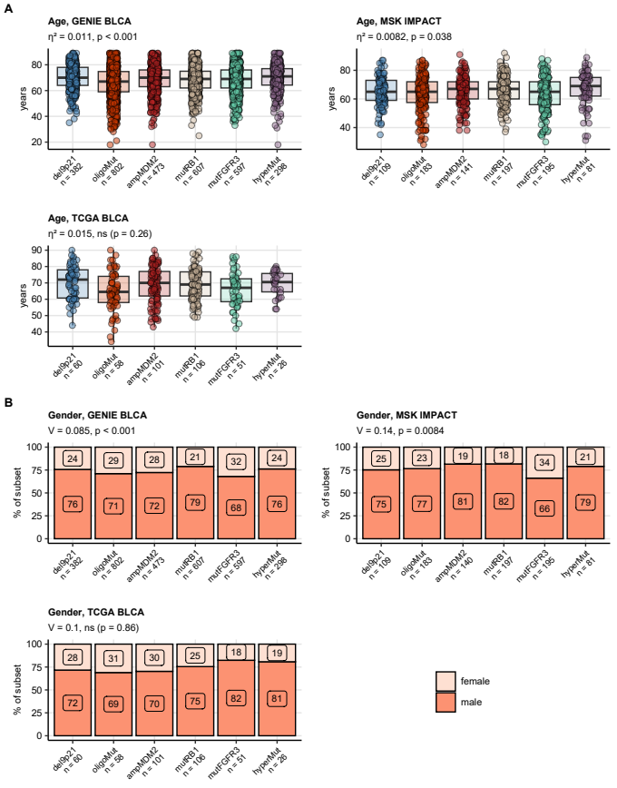

Figure 53: Age and gender in the genetic subsets.

**Figure 53. Age and gender in the genetic subsets.**

*Differences in age (A) and gender (B) between the genetic subsets of urothelial cancers in the GENIE BLCA and TCGA BLCA were investigated by Kruskal-Wallis test and $χ^{2}$ test, respectively. $η^{2}$ and Cramer’s V served as effect size metrics. P values were corrected for multiple testing with the false discovery rate method. Median age with the interquartile range is presented in box plots with whiskers spanning over 150% of the interquartile range and single cancer patients visualized as points. Percentages of women and men in the genetic subsets are shown in stack plots. Effect sizes and p values are displayed in the plot captions. Numbers of observations in the genetic subsets are indicated in the X axes.*

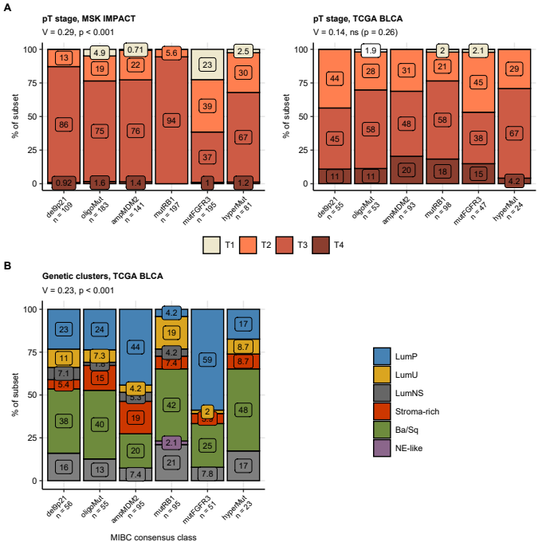

Figure 54: Pathological tumor stage and consensus molecular class distribution in the genetic subsets of urothelial cancers.

**Figure 54. Pathological tumor stage and consensus molecular class distribution in the genetic subsets of urothelial cancers.**

*Differences in distribution of pathological tumor stages (A) and consensus molecular classes (B) between the genetic subsets were investigated by $χ^{2}$ test with Cramer’s V effect size statistic. P values were adjusted for multiple testing with the false discovery rate method. Percentages of pathological stages and consensus classes within the genetic subsets are presented in stack plots. Effect sizes and p values are displayed in the plot captions. Numbers of complete observations are indicated in the X axes.*

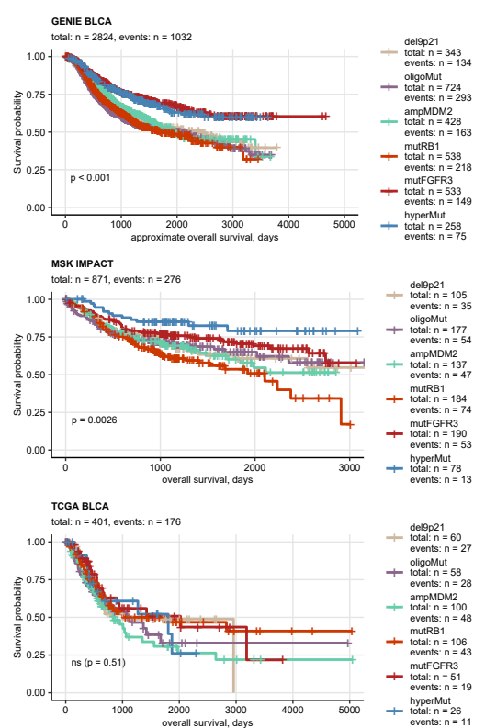

Figure 55: Overall survival in the genetic subsets of urothelial cancers.

**Figure 55. Overall survival in the genetic subsets of urothelial cancers.**

*Overall survival information was provided for the GENIE BLCA, MSK IMPACT, and TCGA BLCA study participants. Approximate overall survival was calculated for the GENIE BLCA cohort based on age at enrollment in years and age at the last follow-up or death in days. Overall survival was subsequently compared between the genetic subsets by false discovery rate-corrected Peto-Peto test. Fractions of surviving patients are presented in Kaplan-Meier plots. P values for globals differences in survival between the subsets are indicated in the plots, numbers of observations and deaths are displayed in the plot captions. Numbers of observations and deaths in the FGFR3 mutation strata are presented in the plot legends.*

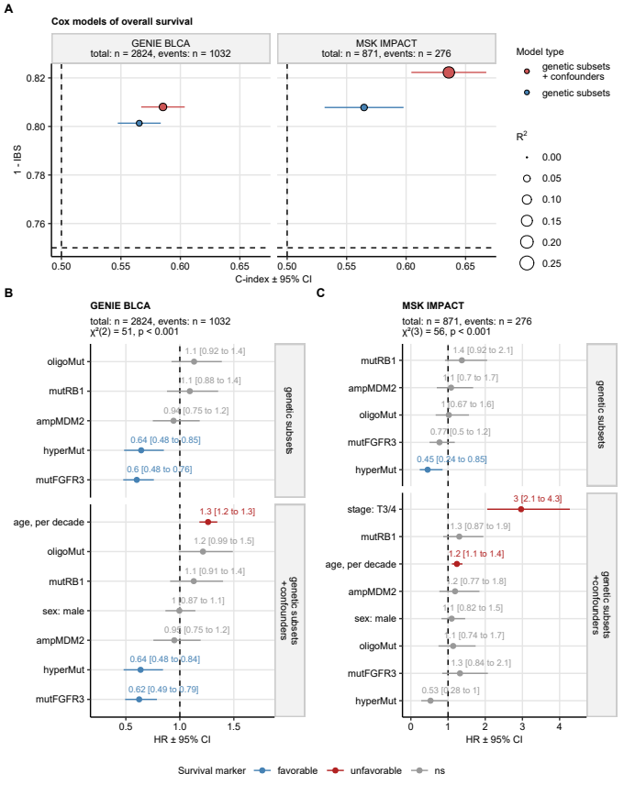

Figure 56: Cox modeling of overall survival in the genetic subsets of urothelial carcinoma.

**Figure 56. Cox modeling of overall survival in the genetic subsets of urothelial carcinoma.**

*Overall survival (MSK IMPACT) and approximate overall survival (GENIE BLCA) was modeled as a function of genetic subset assignment alone or as a function of genetic subset assignment and clinical confounders (GENIE BLCA: age and gender, MSK IMPACT: age, gender, and pathological tumor stage) with Cox proportional hazard regression. Significance of the genetic subset term was investigated by likelihood ratio test (LRT) between the model with genetic subset assignment only and the model with genetic subset assignment and clinical confounders as explanatory factors.*

*(A) Numeric statistics of performance of Cox models with genetic subset assignment and Cox models with genetic subset assignment and clinical confounders as explanatory factors. Concordance between the observed and predicted survival was assessed by Harrell’s concordance index (high values: good concordance), model calibration was investigated by integrated Brier score (IBS; low values: good calibration), and fraction of survival variance explained by the model was gauged by R^2 statistic. The statistic values are visualized in a bubble plot with point color coding for model type and point size representing R^2. Numbers of complete observations and deaths are indicated in the plot facets.*

*(B, C) Cox model coefficient estimates expressed as hazard ratios (HR). HR with 95% confidence intervals are visualized with Forest plots faceted by model type. Numbers of complete observations and deaths, and results of LRT are presented in the plot captions.*

## Model of FGFR signaling in urothelial cancer

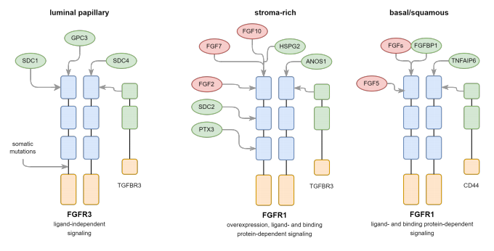

Figure 57: Proposed scheme of FGFR signaling in urothelial cancers.

**Figure 57. Proposed scheme of FGFR signaling in urothelial cancers.**

# Methods

## Software

Data handling and analysis was accomplished with R version 4.2.3. For general transformation tasks for matrix, tabular, and text data, base R, *tidyverse* package bundle (32), *rlang* (33), [*trafo*](https://github.com/PiotrTymoszuk/trafo), and *stringi* (34) were utilized. General data visualization tasks were performed with *ggplot2* (35), *cowplot* (36), and *flextable* (37). R packages specific for particular analysis and visualization steps are referenced below.

## Data sources

Five genomic and transcriptomic collectives of urothelial carcinoma patients were evaluated in the current report: the urothelial cancer subset of the GENIE cohort referred to as GENIE BLCA (14), the MSK IMPACT collective (15), the bladder cancer TCGA collective of muscle-invasive urothelial cancers referred to as TCGA BLCA (16,17), the IMvigor cohort of chemotherapy-resistant cancers treated subsequently with immunotherapy (18), and the BCAN cohort of metastatic cancer patients administered systemic chemotherapy (19).

The GENIE BLCA cohort (14) includes n = 3164 cases of bladder and urinary tract cancers selected by oncotree classification ‘BLAD’, ‘BLCA’, ‘BLSC’, ‘UA’, ‘UAD’, ‘UCA’, ‘UCU’, ‘UPA’, ‘URCA’, ‘USCC’, or ‘UTUC’. The available data sets for the GENIE BLCA cohort included basic clinical information (age at sequencing in years, sex, follow-up in days, mortality), total mutation burden (TMB) expressed as fraction of genome, detailed information on location, variant type, nucleotide sequence and protein residues affected by somatic mutations, as well as 0/1 coded absence/presence of gene deletions and amplifications. Approximate overall survival was computed as the time interval between the last follow-up in days and age at sequencing in years. In case of multiple samples per participant, the earliest sample, i.e. the specimen with the lowest ID, was included in the current analysis. The GENIE BLCA data sets were fetched from the [cBioportal API](https://www.cbioportal.org/) with tools provided by the *cbioportalR* package (38) and formatted with in-house developed R scripts.

The MSK IMPACT collective consisted of n = 906 patients with predominantly muscle-invasive urothelial cancers (15).  
In case of multiple samples available for a patient, the sample with the lowest ID was included in the analysis. The clinical information included entries on participants age, gender, overall survival, cancer pathological stage, and cancer treatment. The mutation data set included detailed information on mutation nucleotide sequence, variant type, and affected protein residues. The copy number variant data were provided in 0/1 coded presence of gene deletions and amplifications. The data sets for the MSK impact study were downloaded from [cBioportal](https://www.cbioportal.org/) and implemented in R with in-house developed scripts.

Data sets for the TCGA BLCA cohort (16,17) was fetched from the [cBioportal](https://www.cbioportal.org/) repository with in-house developed scripts for n = 402 predominantly muscle-invasive urothelial cancer patients. The clinical information consisted of demographic variables (e.g. age, sex, BMI, smoking history), pathological features (e.g. pathological staging, histology, grade, extracapsular extension), survival information (overall, tumor-specific and relapse-free survival), and TMB expressed as mutation count per MB. The somatic mutation data set included detailed information on location, variant type, nucleotide sequence and affected protein residues. The copy number variant data set consisted of 0/1 coded presence of gene amplifications and deletions. The expression data set for the TCGA BLCA collective consisted of $log_{2}\left(x+1\right)$-transformed RSEM-normalized gene-integrated transcript counts obtained by bulk cancer RNA sequencing.

The IMvigor data set included a subset of 179 bladder and ureter muscle non-invasive and muscle-invasive cancers of the IMvigor 210 trial subjected to RNAseq and DNA sequencing (18,39). The study participants were treated with an anti-PD-L1 drug (atezolizumab) following platinum chemotherapy. The clinical data set included basic demographic, clinical and pathological features, best overall response (complete/partial response [CR/PR], stable/progressive disease [SD/PD]), overall survival, and TMB quantified as mutation count per MB. The mutation data set consisted of 0/1 coded basic information on presence of any somatic mutations in a particular gene. The expression data set consisted of $log_{2}\left(x+1\right)$-transformed gene-integrated transcript counts obtained by bulk cancer RNA sequencing. The IMvigor data sets were obtained from the R package *IMvigor210CoreBiologies*.

The BCAN study information was extracted from [cBioportal](https://www.cbioportal.org/) and consisted of demographic and clinical information, staging of primary tumors, overall and disease-specific survival, RNA sequencing expression Z scores of bulk cancer samples, as well as detailed somatic mutation data of bulk cancer specimens. This collective consisted of metastatic cancers, treated in most patients by systemic chemotherapy. The biological material was collected both in urogenital tract and at distant metastatic sites.

For molecular subset assignment and machine learning modeling tasks, $log_{2}$-transformed gene expression levels were processed by ComBat (R package *sva* and [*htGLMNET*](https://github.com/PiotrTymoszuk/htGLMNET)) (40) to correct for the inter-cohort variability.

Assignment of the TCGA BLCA, IMvigor, and BCAN cancer samples to consensus molecular classes was done with the nearest centroid algorithm fed with ComBat-normalized whole-genome log_2 mRNA or Z-score expression levels (R package *consensusMIBC*) (2).

The following genes coding for FGFR, FGFF, and FGFBP (FGF-binding proteins) were investigated in the current report (1,3–13):

* FGF genes: *FGF1*, *FGF2*, *FGF3*, *FGF4*, *FGF5*, *FGF6*, *FGF7*, *FGF8*, *FGF9*, *FGF10*, *FGF11*, *FGF12*, *FGF13*, *FGF14*, *FGF17*, *FGF18*, *FGF19*, *FGF20*, *FGF21*, *FGF22*, and *FGF23*
* FGFR genes: *FGFR1*, *FGFR2*, *FGFR3*, *FGFR4*, *FGFRL1*, and *TGFBR3*
* FGFBP genes: *FGFBP1*, *FGFBP2*, *FGFBP3*, *KL*, *KLB*, *PTX3*, *SDC1*, *SDC2*, *SDC4*, *DCN*, *CD44*, *HSPG2*, *GPC1*, *GPC3*, *GPC4*, *TNFAIP6*, *FIBP*, and *ANOS1*

Those genes were returned by a systematic search of literature at [PubMed](https://pubmed.ncbi.nlm.nih.gov/) as well as a screening of physical interaction partners of FGFR and FGF proteins at [UniProt](https://www.uniprot.org/), [STRING](https://string-db.org/), [BioGRID](https://thebiogrid.org/), and [IntAct](https://www.ebi.ac.uk/intact).

JSON files with domain structures of FGFR1 (ID: P11362), FGFR2 (ID: P21802), FGFR3 (ID: P22607), and FGFR4 (ID: P22455) proteins were downloaded from [UniProt](https://www.uniprot.org/) and processed with the *jsonlite* package (41).

For verification of expression of the FGFR-, FGF-, and FGFBP-coding genes at protein level, we resorted to the [Human Protein Atlas (HPA) repository](https://www.proteinatlas.org/), which stores results of immunohistochemical (IHC) staining. Entries of the HPA database were retrieved as XML documents, from which patient information, staining quantification, and URLs to IHC images for the genes of interest was retrieved (R package *xml2*) (42). Protein expression in the IHC samples was expressed as the IHC score defined as a product of staining (1: negative to 4: high), staining intensity (1: negative to 4: strong), and quantity of positive cells (1: none to 4: >75%).

## Descriptive statistics, statistical inference, and effect size

If not indicated otherwise, descriptive statistics for quantitative variables included median, interquartile range, and range. Descriptive statistic for qualitative variables were percentage and count within categories. Differences of means or medians of qualitative variables were investigated by Mann-Whitney, two-tailed T test, Kruskal-Wallis test, and one-way ANOVA, depending on the number of analysis groups and normality of distribution of the variable. Correlation was assessed by Pearson’s correlation test. Effect size of differences in variable levels, distribution, and correlation was assessed with the following statistics (43):

* biserial r for differences between two groups, non-parametric tests: small for r < 0.2, medium for 0.2 $≤$ r < 0.4, large for r $≥$ 0.4
* Cohen’s d for differences between two groups, parametric tests: small for d < 0.5, medium for 0.5 $≤$ d < 0.8, large for d $≥$ 0.8
* $η^{2}$ for differences between three or more groups: small for $η^{2}$ < 0.06, moderate for 0.06 $≤$ $η^{2}$ < 0.14, large for $η^{2}≥$ 0.14
* Cramer’s V for comparison of category frequencies of a numeric variable: small for V < 0.2, medium for 0.2 $≤$ V < 0.4, large for V $≥$ 0.4
* Pearson’s r for correlation, parametric tests: small for r < 0.3, medium for 0.3 $≤$ r < 0.5, large for r $≥$ 0.5
* Spearman’s $ρ$ for correlation, non-parametric tests: small for $ρ$ < 0.3, medium for 0.3 $≤$ $ρ$ < 0.5, large for $ρ$ $≥$ 0.5

Hypothesis testing results were adjusted for multiple comparisons separately for each analysis step and investigated cohort with the false discovery rate method (FDR) (44). Differences with p < 0.05 were considered statistically significant. Statistical hypothesis testing was accomplished with the development packages [*fastTest*](https://github.com/PiotrTymoszuk/fastTest) and [*ExDA*](https://github.com/PiotrTymoszuk/ExDA) which partly employ statistical tools of base R, *stats*, *rstatix*, and *rcompanion* (45,46).

## Differences in rates of genetic alterations

Differences in rates of genetic alterations between analysis groups of interest were investigated either by $χ^{2}$ test with Cramer’s V effect size metric (package [*fastTest*](https://github.com/PiotrTymoszuk/fastTest)) or by weighted permutation test (package [*perich*](https://github.com/PiotrTymoszuk/perich)). In the later case, the actual frequency of a genetic alteration was compared with the expected frequency obtained in n = 1000 - 10000 permutations weighted by counts of all genetic alterations in the cancer samples. This testing procedure yielded an effect size statistic called enrichment score (ES) defined as the ratio of the actual to the expected genetic alteration number in an analysis groups. By iterating over the permutations, 95% confidence intervals of ES and p values for the ES $≤$ 0 null hypothesis were computed.

## Differential gene expression

Differences in $log_{2}$-transformed expression levels of FGF-, FGFR-, and FGFBP-coding genes between cancers with and without *FGFR3* mutations were assessed by Welch’s two-tailed T test with Cohen’s d effect size statistic (function f_t_test(), package [*fastTest*](https://github.com/PiotrTymoszuk/fastTest)). The differentially expressed genes were identified by FDR-corrected p < 0.05 and at least 1.25-fold up- or downregulation as compared with WT tumors.

Differences in $log_{2}$-transformed transcript levels of the genes of interest between consensus molecular classes or genetic subsets of urothelial cancers were explored with a two step procedure. In the first step, differences of expression levels between the analysis groups were assessed by one-way ANOVA with $η^{2}$ effect size statistic. In the second step, differences between an analysis class and the baseline (luminal papillary cancers for the consensus classes, del9p21 subset for the genetic subsets) were evaluated by Welch’s two-tailed T test with Cohen’s d effect size. The significantly differentially regulated genes were defined by pFDR(ANOVA) < 0.05, $η^{2}≥$ 0.06, pFDR(T test) < 0.05, and at least 1.25-fold up- or downregulation as compared with the baseline.

In the differential expression analyses, functions f_one_anova() and f_t_test() from [*fastTest*](https://github.com/PiotrTymoszuk/fastTest) package were used.

## Co-occurrence of genetic features

Co-occurrence analysis was performed in two settings: (1) for the most common genetic features (mutations, amplifications, deletions) present in at least 5% of cancer samples in all cohorts and (2) for all available mutations, amplifications, and deletions of FGF- and FGFR-coding genes. Co-occurrence of genetic features was investigated by Jaccard’s similarity coefficient J and Jaccard’s distance computed with the $D=1−J$ formula. Significance of co-occurrence, i.e. $J>0$ , was assessed by bootstrap test with B = 10000 iterations. Mutual co-occurrence (e.g. between *FGFR3* mutations and *RB1* mutations) was depicted as a heat map of contingency table.

For visualization of co-occurrence of multiple genetic features in two-dimensional Euclidean space, matrices of pairwise Jaccard’s distances were subjected to multi-dimensional scaling (MDS). Subsequently, the genetic features of interest were displayed in scatter plots with point size corresponding to the general frequency of the genetic alteration.

Co-occurrence analysis was done with [*clustTools*](https://github.com/PiotrTymoszuk/clustTools) and *jaccard* R packages (47).

## Gene-co-regulation networks

Co-expression networks of the FGF-, FGFR-, and FGFBP-coding genes were constructed in form of weighted graphs for pairwise correlations of the expression levels with Spearman’s $ρ≥$ 0.3 (function as_iGraph(), package [*graphExtra*](https://github.com/PiotrTymoszuk/graphExtra) with wrapper tools for *igraph*) (48). Isolated vertices were removed with prune_degree() function. The following vertex importance statistics (48) were computed with summary() method called for the network objects: degree (number of directly connected neighbor nodes), hub score (eigenvector of the affinity matrix, i.e. an overall strength of correlations), and betweenness (number of the shortest paths between all pairs of vertices that pass through the vertex). The networks were visualized with Fruchterman - Reingold algorithm by calling plot() method (49).

## Machine learning modeling of consensus molecular subsets of urothelial cancers with expression of FGFR-, FGF-, and FGFBP-coding genes as explanatory factors

To check if and how differences in expression of the FGFR-, FGF-, and FGFBP-coding genes of interest emulate the consensus molecular classification proposed by Kamoun and colleagues (2), we resorted to machine learning modeling with two independent algorithms, multinomial regularized Elastic Net regression (20,21) and Random Forest tree ensemble (22,23).

The models were developed in a data set derived from the TCGA BLCA collective; the consensus molecular class assignment by the nearest centroid classifier of *consensusMIBC* R package served as the modeling response. ComBat-processed $log_{2}$ expression levels of the genes of interest were used as the sole explanatory factors. In order to improve recognition of the minority consensus classes, the LumU (luminal unstable) and Stroma-rich subsets, we amplified their observations by over-sampling with the SMOTE algorithm (function smote(), package *performanceEstimation*) (24–26). The Elastic Net model of consensus molecular classes was optimized (tuned) and trained in the SMOTE-amplified training data set with a wrapper around functions cv.glmnet() and glmnet() from *glmnet* package (20). The optimal values of the regularization parameter $λ$ = 0.00377 was found by minimizing the Elastic Net model’s deviance in 200 repeats 10-fold cross-validation. The Random Forest model of consensus molecular subsets was tuned and trained inn the SMOTE-amplified training data set with a wrapper around ranger() function from *ranger* package (22). The optimal set of parameters that control behavior of the Random Forest model, mtry = 5 (number of randomly chosen variables per tree learner), minimal node size = 1, and Gini splitting rule was found by minimizing the out-of-bag classification error (23). The final Random Forest model was an ensemble of 500 tree learners.

Performance of the machine learning models was evaluated by comparing the predicted and actual consensus molecular class in the unmodified TCGA BLCA data set, as well as in the IMvigor and BCAN independent validation cohorts. The consensus classification returned by the *consensusMIBC* R package nearest centroid tool was assumed the ground truth. The following numeric statistics of model performance were computed: overall accuracy (fraction of cancer samples with correct consensus molecular class prediction), Cohen’s $κ$ (non-accidental concordance between the predicted and actual class, high $κ$ expected for a highly accurate model) (50), Brier score (metric of overall model calibration, low Brier scores expected for a well calibrated model) (51,52), and receiver-operating characteristic measures such as area under the curve (AUC, measure of overall sensitivity and specificity). Those evaluation metrics were computed with multiClassSummary() function from *caret* package (53) and an in-house developed function that calculates Brier scores for the models of interest and a nonsense model predicting the classes at random. Additionally, accuracy of prediction for single consensus molecular classes was assessed by inspection of the confusion matrices.

Calibration of the machine learning models at predictions of particular consensus molecular classes was assessed with two approaches. First, we compared squares of differences between the predicted class assignment probabilities and the binarized actual class assignment (1: the class of interest, 0: any other consensus molecular class) or ‘Brier squares’ between the consensus molecular classes. Second, we modeled and visualized logistic relationship between the mean predicted class assignment probability and the actual fraction of observations in the class with tools from *CalibrationCurves* R package (54).

For the Elastic Net model, absolute $β$ values of the model coefficients serve as direct variable importance metrics; they were extracted from the model with coef() method. For the Random Forest model, permutation variable importance proposed by Breiman (23) was computed as the difference in out-of-bag classification error of the genuine model and a model with the particular explanatory variable re-shuffled at random (function importance(), package *ranger*).

## Model-free survival analysis

Differences in overall, disease-specific, and relapse-free survival between patients stratified by genetic features such as *FGFR3* mutations, genetic subsets, or gene expression cutoffs determined by the maxima of log-rank statistic (function surv_cutpoint(), package *survminer*) were investigated with Peto-Peto test. Fractions of surviving patients were visualized with Kaplan-Meier plots. Survival analyses and visualizations were done with packages *survival* and *survminer* (55,56).

## Modeling of overall survival as a function of expression of FGFR-, FGF-, and FGFBP-coding genes

Effects of differential expression of the FGFR-, FGF-, and FGFBP-coding genes on overall survival was modeled in the TCGA BLCA, IMvigor, and BCAN cohort by Elastic Net Cox regression (21,57). The Elastic Net Cox model was trained in the TCGA BLCA collective with ComBat-processed $log_{2}$ expression levels of the genes of interest. The optimal value of the regularization parameter $λ$ = 0.0527 was found by minimizing the model deviance in 200-repeats 10-fold cross-validation (a wrapper around cv.glmnet() and glmnet() function, package *glmnet*) (20). The Elastic Net Cox model was subsequently used for computation of linear predictor scores in the training cohort, and the IMvigor and BCAN validation collectives (method predict(), *glmnet* package). For evaluation of the predictive performance, overall survival was modeled as a function of the linear predictor scores by canonical Cox regression (58,59). Overall performance of those Cox models was metered by Harrell’s C index (high values: good concordance between the predicted and observed survival), integrated Brier score (IBS; low values: good model calibration), and R2 as a measure of survival variance explained by the model (method summary()) (60–62). Additionally, we compared overall survival of cancer patients stratified by tertiles of the linear predictor scores by Peto-Peto test and visualized with Kaplan-Meier plots. The linear predictor Cox models were constructed, checked for the proportional hazard assumption, and evaluated with tools provided by R packages *survival* (56,63) and [*coxExtensions*](https://github.com/PiotrTymoszuk/coxExtensions). To obtain variable importance measures, non-zero coefficients of the Elastic Net Cox model were extracted and expressed as hazard ratios (method coef()).

## Modeling of survival in genetic subsets of urothelial cancer

For each of the GENIE BLCA and MSK IMPACT cohorts, two types of Cox proportional hazard models of overall survival were constructed: (1) a model with genetic subset assignment as a sole explanatory factor, and (2) a model with genetic subset assignment and clinically relevant confounders (GENIE BLCA: age and gender, MSK IMPACT: age, gender, and pathological tumor stage). Those Cox models were constructed, checked for the proportional hazard assumption and evaluated with tools provided by R packages *survival* (56,63) and [*coxExtensions*](https://github.com/PiotrTymoszuk/coxExtensions) essentially as outlined above for the Elastic Net Cox regression. Significance of the genetic subset term and its independence from clinical confounders was determined by likelihood ratio test between the model with subset assignment and the model with cluster assignment and clinical confounders as explanatory factors (function anova()). Estimates of model coefficients were retrieved with summary() method.

## Genetic subsets of urothelial cancers

Definition and evaluation of genetic subsets of urothelial cancers was done for the GENIE BLCA training cohort, and the MSK IMPACT and TCGA BLCA test collectives, for which both mutation and copy number variant data were provided.

Genetic subsets of urothelial cancers were developed for the GENIE BLCA training cohort by latent class modeling (64,65). The explanatory variables were binary indexes (presence/absence) of genetic alterations present in at least 5% of samples in all collectives. Presence of FGF3, FGF4, FGF19, or CCND1 amplification was subsumed under 11q13 amplification prior to the modeling. Presence of CDKN2A, CDKN2B, or MTAP deletions was subsumed under 9p21 deletion prior to the modeling. The latent class models were fit with R function tune_lca() (package [*polcaExtra*](https://github.com/PiotrTymoszuk/polcaExtra)) with the maximal iteration number set to 3000 and numbers of replicates, i.e. random starts of the modeling procedure, set to 5. Selection of the optimal subset number was motivated by the minimum of Bayesian Information Criterion (BIC). With this selection criterion, a six-subset model was chosen for definition of the genetic subsets. The genetic subsets were were named after their characteristic gene and chromosome alterations.

Subsequently, assignment of cancer samples in the MSK IMPACT and TCGA BLCA test collectives to the genetic subsets was predicted by conditional subset assignment probabilities using predict() method from [*polcaExtra*](https://github.com/PiotrTymoszuk/polcaExtra) package. Quality of the subset assignment in the training and test collective was assessed by a visual inspection of the class assignment probabilities (posterior p) and by comparison of frequency of the subset-defining genetic genetic features between the subsets ( $χ^{2}$ test with Cramer’s V effect size statistic).

# Data and code availability

Data from publicly available sources were analyzed. The R analysis pipeline is available as a [GitHub repository](https://github.com/PiotrTymoszuk/FGFR-BLCA)

# References

1. Korc M, Friesel R. The Role of Fibroblast Growth Factors in Tumor Growth. *Current Cancer Drug Targets* (2009) 9: doi: [10.2174/156800909789057006](https://doi.org/10.2174/156800909789057006)

2. Kamoun A, Reyniès A de, Allory Y, Sjödahl G, Robertson AG, Seiler R, Hoadley KA, Groeneveld CS, Al-Ahmadie H, Choi W, et al. A Consensus Molecular Classification of Muscle-invasive Bladder Cancer. *European urology* (2020) 77:420. doi: [10.1016/J.EURURO.2019.09.006](https://doi.org/10.1016/J.EURURO.2019.09.006)

3. Turati M, Giacomini A, Rezzola S, Maccarinelli F, Gazzaroli G, Valentino S, Bottazzi B, Presta M, Ronca R. The natural FGF-trap long pentraxin 3 inhibits lymphangiogenesis and lymphatic dissemination. *Experimental hematology & oncology* (2022) 11: doi: [10.1186/S40164-022-00330-W](https://doi.org/10.1186/S40164-022-00330-W)

4. Bennett KL, Jackson DG, Simon JC, Tanczos E, Peach R, Modrell B, Stamenkovic I, Plowman G, Aruffo A. CD44 isoforms containing exon V3 are responsible for the presentation of heparin-binding growth factor. *The Journal of cell biology* (1995) 128:687–698. doi: [10.1083/JCB.128.4.687](https://doi.org/10.1083/JCB.128.4.687)

5. Gubbiotti MA, Vallet SD, Ricard-Blum S, Iozzo RV. Decorin interacting network: A comprehensive analysis of decorin-binding partners and their versatile functions. *Matrix biology : journal of the International Society for Matrix Biology* (2016) 55:7. doi: [10.1016/J.MATBIO.2016.09.009](https://doi.org/10.1016/J.MATBIO.2016.09.009)

6. Mundhenke C, Meyer K, Drew S, Friedl A. Heparan Sulfate Proteoglycans as Regulators of Fibroblast Growth Factor-2 Receptor Binding in Breast Carcinomas. *The American Journal of Pathology* (2002) 160:185. doi: [10.1016/S0002-9440(10)64362-3](https://doi.org/10.1016/S0002-9440(10)64362-3)

7. Midorikawa Y, Ishikawa S, Iwanari H, Imamura T, Sakamoto H, Miyazono K, Kodama T, Makuuchi M, Aburatani H. Glypican-3, overexpressed in hepatocellular carcinoma, modulates FGF2 and BMP-7 signaling. *International journal of cancer* (2003) 103:455–465. doi: [10.1002/IJC.10856](https://doi.org/10.1002/IJC.10856)

8. Leali D, Inforzato A, Ronca R, Bianchi R, Belleri M, Coltrini D, Di Salle E, Sironi M, Norata GD, Bottazzi B, et al. Long pentraxin 3/tumor necrosis factor-stimulated gene-6 interaction a biological rheostat for fibroblast growth factor 2-mediated angiogenesis. *Arteriosclerosis, Thrombosis, and Vascular Biology* (2012) 32:696–703. doi: [10.1161/ATVBAHA.111.243998/-/DC1](https://doi.org/10.1161/ATVBAHA.111.243998/-/DC1)

9. Xie Y, Su N, Yang J, Tan Q, Huang S, Jin M, Ni Z, Zhang B, Zhang D, Luo F, et al. FGF/FGFR signaling in health and disease. (2020) 5: doi: [10.1038/s41392-020-00222-7](https://doi.org/10.1038/s41392-020-00222-7)

10. Hagihara K, Watanabe K, Chun J, Yamaguchi Y. Glypican-4 is an FGF2-binding heparan sulfate proteoglycan expressed in neural precursor cells. *Developmental Dynamics* (2000) 219: doi: [10.1002/1097-0177(2000)9999:9999<::AID-DVDY1059>3.0.CO;2-#](https://doi.org/10.1002/1097-0177(2000)9999:9999<::AID-DVDY1059>3.0.CO;2-)

11. Pan J, Ho M. Role of glypican-1 in regulating multiple cellular signaling pathways. *American Journal of Physiology - Cell Physiology* (2021) 321:C846. doi: [10.1152/AJPCELL.00290.2021](https://doi.org/10.1152/AJPCELL.00290.2021)

12. Mohammadi M, Olsen SK, Ibrahimi OA. Structural basis for fibroblast growth factor receptor activation. *Cytokine & growth factor reviews* (2005) 16:107–137. doi: [10.1016/J.CYTOGFR.2005.01.008](https://doi.org/10.1016/J.CYTOGFR.2005.01.008)

13. Hu Y, Guimond SE, Travers P, Cadman S, Hohenester E, Tumbull JE, Kim SH, Bouloux PM. Novel mechanisms of fibroblast growth factor receptor 1 regulation by extracellular matrix protein anosmin-1. *The Journal of biological chemistry* (2009) 284:29905–29920. doi: [10.1074/JBC.M109.049155](https://doi.org/10.1074/JBC.M109.049155)

14. Sweeney SM, Cerami E, Baras A, Pugh TJ, Schultz N, Stricker T, Lindsay J, Del Vecchio Fitz C, Kumari P, Micheel C, et al. AACR Project GENIE: Powering Precision Medicine through an International Consortium. *Cancer discovery* (2017) 7:818–831. doi: [10.1158/2159-8290.CD-17-0151](https://doi.org/10.1158/2159-8290.CD-17-0151)

15. Clinton TN, Chen Z, Wise H, Lenis AT, Chavan S, Donoghue MTA, Almassi N, Chu CE, Dason S, Rao P, et al. Genomic heterogeneity as a barrier to precision oncology in urothelial cancer. *Cell Reports* (2022) 41: doi: [10.1016/j.celrep.2022.111859](https://doi.org/10.1016/j.celrep.2022.111859)

16. Liu J, Lichtenberg T, Hoadley KA, Poisson LM, Lazar AJ, Cherniack AD, Kovatich AJ, Benz CC, Levine DA, Lee AV, et al. An Integrated TCGA Pan-Cancer Clinical Data Resource to Drive High-Quality Survival Outcome Analytics. *Cell* (2018) 173:400–416.e11. doi: [10.1016/J.CELL.2018.02.052](https://doi.org/10.1016/J.CELL.2018.02.052)

17. Robertson AG, Kim J, Al-Ahmadie H, Bellmunt J, Guo G, Cherniack AD, Hinoue T, Laird PW, Hoadley KA, Akbani R, et al. Comprehensive Molecular Characterization of Muscle-Invasive Bladder Cancer. *Cell* (2017) 171:540–556.e25. doi: [10.1016/J.CELL.2017.09.007](https://doi.org/10.1016/J.CELL.2017.09.007)

18. Balar AV, Galsky MD, Rosenberg JE, Powles T, Petrylak DP, Bellmunt J, Loriot Y, Necchi A, Hoffman-Censits J, Perez-Gracia JL, et al. Atezolizumab as first-line therapy in cisplatin-ineligible patients with locally advanced and metastatic urothelial carcinoma: a single-arm, multicentre, phase 2 trial. *Lancet (London, England)* (2017) 389:67. doi: [10.1016/S0140-6736(16)32455-2](https://doi.org/10.1016/S0140-6736(16)32455-2)

19. Damrauer JS, Beckabir W, Klomp J, Zhou M, Plimack ER, Galsky MD, Grivas P, Hahn NM, O’Donnell PH, Iyer G, et al. Collaborative study from the Bladder Cancer Advocacy Network for the genomic analysis of metastatic urothelial cancer. *Nature communications* (2022) 13: doi: [10.1038/S41467-022-33980-9](https://doi.org/10.1038/S41467-022-33980-9)

20. Friedman J, Hastie T, Tibshirani R. Regularization paths for generalized linear models via coordinate descent. *Journal of Statistical Software* (2010) 33:1–22. doi: [10.18637/jss.v033.i01](https://doi.org/10.18637/jss.v033.i01)

21. Zou H, Hastie T. Regularization and variable selection via the elastic net. *Journal of the Royal Statistical Society Series B: Statistical Methodology* (2005) 67:301–320. doi: [10.1111/j.1467-9868.2005.00503.x](https://doi.org/10.1111/j.1467-9868.2005.00503.x)

22. Wright MN, Ziegler A. ranger: A Fast Implementation of Random Forests for High Dimensional Data in C++ and R. *Journal of Statistical Software* (2017) 77:1–17. doi: [10.18637/JSS.V077.I01](https://doi.org/10.18637/JSS.V077.I01)

23. Breiman L. Random forests. *Machine Learning* (2001) 45:5–32. doi: [10.1023/A:1010933404324](https://doi.org/10.1023/A:1010933404324)

24. Torgo L. An Infra-Structure for Performance Estimation and Experimental Comparison of Predictive Models in R. (2014) <https://arxiv.org/abs/1412.0436v4>

25. Chawla NV, Bowyer KW, Hall LO, Kegelmeyer WP. SMOTE: Synthetic Minority Over-sampling Technique. *Journal of Artificial Intelligence Research* (2002) 16:321–357. doi: [10.1613/JAIR.953](https://doi.org/10.1613/JAIR.953)

26. Torgo L. performanceEstimation: An Infra-Structure for Performance Estimation of Predictive Models. (2016) doi: [10.32614/CRAN.PACKAGE.PERFORMANCEESTIMATION](https://doi.org/10.32614/CRAN.PACKAGE.PERFORMANCEESTIMATION)

27. Moura S, Hartl I, Brumovska V, Calabrese PP, Yasari A, Striedner Y, Bishara M, Mair T, Ebner T, Schütz GJ, et al. Exploring FGFR3 Mutations in the Male Germline: Implications for Clonal Germline Expansions and Paternal Age-Related Dysplasias. *Genome Biology and Evolution* (2024) 16: doi: [10.1093/gbe/evae015](https://doi.org/10.1093/gbe/evae015)

28. Tassi E, Al-Attar A, Aigner A, Swift MR, McDonnell K, Karavanov A, Wellstein A. Enhancement of fibroblast growth factor (FGF) activity by an FGF-binding protein. *The Journal of biological chemistry* (2001) 276:40247–40253. doi: [10.1074/JBC.M104933200](https://doi.org/10.1074/JBC.M104933200)

29. Beer HD, Bittner M, Niklaus G, Munding C, Max N, Goppelt A, Werner S. The fibroblast growth factor binding protein is a novel interaction partner of FGF-7, FGF-10 and FGF-22 and regulates FGF activity: implications for epithelial repair. *Oncogene* (2005) 24:5269–5277. doi: [10.1038/SJ.ONC.1208560](https://doi.org/10.1038/SJ.ONC.1208560)

30. Urakawa I, Yamazaki Y, Shimada T, Iijima K, Hasegawa H, Okawa K, Fujita T, Fukumoto S, Yamashita T. Klotho converts canonical FGF receptor into a specific receptor for FGF23. *Nature 2006 444:7120* (2006) 444:770–774. doi: [10.1038/nature05315](https://doi.org/10.1038/nature05315)

31. Goetz R, Beenken A, Ibrahimi OA, Kalinina J, Olsen SK, Eliseenkova AV, Xu C, Neubert TA, Zhang F, Linhardt RJ, et al. Molecular Insights into the Klotho-Dependent, Endocrine Mode of Action of Fibroblast Growth Factor 19 Subfamily Members. *Molecular and Cellular Biology* (2007) 27:3417. doi: [10.1128/MCB.02249-06](https://doi.org/10.1128/MCB.02249-06)

32. Wickham H, Averick M, Bryan J, Chang W, McGowan L, François R, Grolemund G, Hayes A, Henry L, Hester J, et al. Welcome to the Tidyverse. *Journal of Open Source Software* (2019) 4:1686. doi: [10.21105/joss.01686](https://doi.org/10.21105/joss.01686)

33. Henry L, Wickham Hadley. rlang: Functions for Base Types and Core R and ’Tidyverse’ Features. (2022) <https://cran.r-project.org/web/packages/rlang/index.html>

34. Gagolewski M, Tartanus B. Package ’stringi’. (2021) <https://cran.r-project.org/web/packages/stringi/index.html http://cran.ism.ac.jp/web/packages/stringi/stringi.pdf>

35. Wickham Hadley. *ggplot2: Elegant Graphics for Data Analysis*. 1st ed. New York: Springer-Verlag (2016). [https://ggplot2.tidyverse.org](https://ggplot2.tidyverse.org/)

36. Wilke CO. *Fundamentals of Data Visualization: A Primer on Making Informative and Compelling Figures*. 1st ed. Sebastopol: O’Reilly Media (2019).

37. Gohel D. flextable: Functions for Tabular Reporting. (2022) <https://cran.r-project.org/web/packages/flextable/index.html>

38. Whiting K. cbioportalR: R package to wrap cBioPortal’s API to pull data from public or private cBioPortal databases. (2024) <https://github.com/karissawhiting/cbioportalR>

39. Mariathasan S, Turley SJ, Nickles D, Castiglioni A, Yuen K, Wang Y, Kadel EE, Koeppen H, Astarita JL, Cubas R, et al. TGF $β$ attenuates tumour response to PD-L1 blockade by contributing to exclusion of T cells. *Nature 2018 554:7693* (2018) 554:544–548. doi: [10.1038/nature25501](https://doi.org/10.1038/nature25501)

40. Leek JT, Johnson WE, Parker HS, Jaffe AE, Storey JD. The sva package for removing batch effects and other unwanted variation in high-throughput experiments. *Bioinformatics* (2012) 28:882. doi: [10.1093/BIOINFORMATICS/BTS034](https://doi.org/10.1093/BIOINFORMATICS/BTS034)

41. Ooms J. A Simple and Robust JSON Parser and Generator for R [R package jsonlite version 1.8.8]. (2023) <https://cran.r-project.org/package=jsonlite>

42. Wickham H, Hester J, Ooms J. xml2: Parse XML. (2023) doi: [10.32614/CRAN.PACKAGE.XML2](https://doi.org/10.32614/CRAN.PACKAGE.XML2)

43. Cohen J. Statistical Power Analysis for the Behavioral Sciences. *Statistical Power Analysis for the Behavioral Sciences* (2013) doi: [10.4324/9780203771587](https://doi.org/10.4324/9780203771587)

44. Benjamini Y, Hochberg Y. Controlling the False Discovery Rate: A Practical and Powerful Approach to Multiple Testing. *Journal of the Royal Statistical Society: Series B (Methodological)* (1995) 57:289–300. doi: [10.1111/j.2517-6161.1995.tb02031.x](https://doi.org/10.1111/j.2517-6161.1995.tb02031.x)

45. Mangiafico S. rcompanion: Functions to Support Extension Education Program Evaluation. (2022) <https://cran.r-project.org/package=rcompanion>

46. Kassambara A. rstatix: Pipe-Friendly Framework for Basic Statistical Tests. (2021) <https://cran.r-project.org/package=rstatix>

47. Chung NC, Miasojedow B, Startek M, Gambin A. jaccard: Test Similarity Between Binary Data using Jaccard/Tanimoto Coefficients. (2018) <https://cran.r-project.org/web/packages/jaccard/index.html>

48. Csardi G, Nepusz T. The igraph software package for complex network research. *InterJournal* (2006) Complex Sy:1695. [https://igraph.org](https://igraph.org/)

49. Briatte F, Bojanowski M, Canouil M, Charlop-Powers Z, Fisher JC, Johnson K, Rinker T. ggnetwork: Geometries to Plot Networks with ’ggplot2’. (2021) <https://cran.r-project.org/package=ggnetwork>

50. McHugh ML. Interrater reliability: the kappa statistic. *Biochemia Medica* (2012) 22:276. doi: [10.11613/bm.2012.031](https://doi.org/10.11613/bm.2012.031)

51. Brier GW. VERIFICATION OF FORECASTS EXPRESSED IN TERMS OF PROBABILITY. *Monthly Weather Review* (1950) 78:1–3. doi: [10.1175/1520-0493(1950)078<0001:vofeit>2.0.co;2](https://doi.org/10.1175/1520-0493(1950)078<0001:vofeit>2.0.co;2)

52. Goldstein-Greenwood J. A Brief on Brier Scores | UVA Library. (2021) <https://library.virginia.edu/data/articles/a-brief-on-brier-scores> [Accessed September 5, 2023]

53. Kuhn M. Building predictive models in R using the caret package. *Journal of Statistical Software* (2008) 28:1–26. doi: [10.18637/jss.v028.i05](https://doi.org/10.18637/jss.v028.i05)

54. Campo BDC. Towards reliable predictive analytics: a generalized calibration framework. (2023) doi: [10.48550/arXiv.2309.08559](https://doi.org/10.48550/arXiv.2309.08559)

55. Kassambara A, Kosinski M, Biecek P. survminer: Drawing Survival Curves using ’ggplot2’. (2016) <https://cran.r-project.org/package=survminer>

56. Therneau TM, Grambsch PM. *Modeling Survival Data: Extending the Cox Model*. 1st ed. New York: Springer Verlag (2000).

57. Simon N, Friedman J, Hastie T, Tibshirani R. Regularization Paths for Cox’s Proportional Hazards Model via Coordinate Descent. *Journal of Statistical Software* (2011) 39:1–13. doi: [10.18637/JSS.V039.I05](https://doi.org/10.18637/JSS.V039.I05)

58. Simon RM, Subramanian J, Li MC, Menezes S. Using cross-validation to evaluate predictive accuracy of survival risk classifiers based on high-dimensional data. *Briefings in Bioinformatics* (2011) 12:203–214. doi: [10.1093/bib/bbr001](https://doi.org/10.1093/bib/bbr001)

59. Sonnweber T, Tymoszuk P, Steringer-Mascherbauer R, Sigmund E, Porod-Schneiderbauer S, Kohlbacher L, Theurl I, Lang I, Weiss G, Löffler-Ragg J. The combination of supervised and unsupervised learning based risk stratification and phenotyping in pulmonary arterial hypertension—a long-term retrospective multicenter trial. *BMC Pulmonary Medicine* (2023) 23:143. doi: [10.1186/S12890-023-02427-2](https://doi.org/10.1186/S12890-023-02427-2)

60. Harrell FE, Lee KL, Mark DB. Multivariable prognostic models: Issues in developing models, evaluating assumptions and adequacy, and measuring and reducing errors. *Statistics in Medicine* (1996) 15:361–387. doi: [10.1002/(SICI)1097-0258(19960229)15:4<361::AID-SIM168>3.0.CO;2-4](https://doi.org/10.1002/(SICI)1097-0258(19960229)15:4<361::AID-SIM168>3.0.CO;2-4)

61. Royston P, Group C. Explained variation for survival models. *Stata Journal* (2006) 6:83–96. doi: [10.1177/1536867X0600600105](https://doi.org/10.1177/1536867X0600600105)

62. Graf E, Schmoor C, Sauerbrei W, Schumacher M. Assessment and comparison of prognostic classification schemes for survival data. *Statistics in Medicine* (1999) 18:2529–2545. doi: [10.1002/(sici)1097-0258(19990915/30)18:17/18<2529::aid-sim274>3.0.co;2-5](https://doi.org/10.1002/(sici)1097-0258(19990915/30)18:17/18<2529::aid-sim274>3.0.co;2-5)

63. Grambsch PM, Therneau TM. Proportional Hazards Tests and Diagnostics Based on Weighted Residuals. *Biometrika* (1994) 81:515. doi: [10.2307/2337123](https://doi.org/10.2307/2337123)

64. Weller BE, Bowen NK, Faubert SJ. Latent Class Analysis: A Guide to Best Practice. *Journal of Black Psychology* (2020) 46:287–311. doi: [10.1177/0095798420930932/ASSET/IMAGES/LARGE/10.1177_0095798420930932-FIG1.JPEG](https://doi.org/10.1177/0095798420930932/ASSET/IMAGES/LARGE/10.1177_0095798420930932-FIG1.JPEG)

65. Linzer DA, Lewis JB. poLCA: An R package for polytomous variable latent class analysis. *Journal of Statistical Software* (2011) 42:1–29. doi: [10.18637/jss.v042.i10](https://doi.org/10.18637/jss.v042.i10)